***OUR LADY OF AFRICA JUNIOR SCHOOL-BUKASA***

***PRIMARY FIVE***

***MATHEMATICS***

***LESSON NOTES***

***TEACHER’S NAME: …………………………………………………………..***

***CLASS: ………………………………………………………………………….***

***STREAM: …………………………………… YEAR: ……………………….***

***TABLE OF CONTENT.***

|  |  |  |
| --- | --- | --- |
| ***NO*** | ***TOPIC*** | ***PAGE*** |
| ***TERM ONE.*** | | |
| ***1*** | ***SETS*** | ***3-23*** |
| ***2*** | ***PROBABILITY*** | ***24-29*** |
| ***3*** | ***NUMERATION SYSTEMS AND PLACE VALUES.*** | ***30-47*** |
| ***4*** | ***ROMAN NUMERALS*** | ***48-53*** |
| ***5*** | ***ROUNDING OFF*** | ***54-56*** |
| ***6*** | ***OPERATIONS ON WHOLE NUMBERS*** | ***57-76*** |
| ***7*** | ***BASES*** | ***77-90*** |
| ***8*** | ***FINITE SYSTEM*** | ***90-96*** |
| ***9*** | ***DIVISIBILITY TEST*** | ***97-98*** |
| ***10*** | ***LCM AND GCF*** | ***98-101*** |
| ***11*** | ***TYPES OF NUMBERS*** | ***101-103*** |
| ***12*** | ***PRIME FACTORISATION*** | ***104-113*** |
| ***13*** | ***SQUARE AND SQUARE ROOT*** | ***113-118*** |
| ***TERM TWO.*** | | |
| ***14*** | ***FRACTIONS*** | ***119-148*** |
| ***15*** | ***DECIMALS FRACTIONS*** | ***149-159*** |
| ***16*** | ***INTEGERS*** | ***160-173*** |
| ***17*** | ***GEOMETRY (CONSTRUCTION)*** | ***173-186*** |
| ***18*** | ***GEOMETRY (ANGLES ON A COMPASS)*** | ***187-194*** |
| ***19*** | ***GEOMETRY (CALCULATIONS)*** | ***195-206*** |
| ***20*** | ***STATISTICS*** | ***207-215*** |
| ***21*** | ***GRAPHS AND INTERPRETATION OF DATA*** | ***216-227*** |
| ***TERM THREE.*** | | |
| ***22*** | ***TIME*** | ***228-240*** |
| ***23*** | ***DISTANCE, TIME AND SPEED*** | ***241-245*** |
| ***24*** | ***MONEY*** | ***246-261*** |
| ***25*** | ***MEASUREMENTS (CONVERSION OF UNITS)*** | ***262-270*** |
| ***26*** | ***AREA OF SHADED PARTS AND COMBINED FIGURES*** | ***271-280*** |
| ***27*** | ***VOLUME AND CAPACITY*** | ***281-290*** |
| ***28*** | ***ALGEBRA*** | ***291-308*** |
| ***29*** | ***CORRECTIONS AND FINDINGS*** | ***309*** |

**SET CONCEPT**

**A set.**

A set is a collection of well-defined elements or members

Review on the following

- Equal sets

- Un equal sets

- Equivalent sets

- Non equivalent sets

**INTERSECTION SETS (Ո)**

A set of common elements found in two or more sets.

The symbol for intersection is **Ո**

**Example I**

Given set A = {a, b, c, e, f, g}

B = {b, d, e, f, g}

Find A n B

A n B = {b, e, f, g}

**Example II**

Set K = {a, e, i, o, u}

B= {a, b, c, d, e, f, g, h, i}

(i) Find (i) K n B = {a, e, i)

(ii) n(KnB) = 3

**Examples III**

K = {Odd numbers less than 10}

M = {prime numbers less than}

(i) List members of K

K = {1, 3, 5, 7, 9}

M = {2, 3, 5, 7}

(ii) Find AnB = {3, 5, 7}

(iii) n(AnB) = 3

**Activity**

1. Given set B = {1, 2, 3, 4, 5, 6} and K = {3, 4, 5, 6, 7, 8, 9}

List members of (ii) A n B

Find n(AnB)

2. P = {0, 1, 2, 3, 4, 5}

Q = {0, 2, 4, 6, 8}

Find (i) PnQ

(ii) n(PnQ)

3. Given set m = {vowel letters}

B = {a, b, c, d, e}

Find (i) MnB)

(ii) n(MnB)

4. Set Q = {Even numbers less than 12}

B= {4, 6, 8, 9, 10, 12}

Find (i) QnB

(ii) n(QnB)

5. Set H = {Odd numbers less than 13}

M= {2, 3, 4, 5, 6, 7, 8, 9}

Find (i) HnM

(ii) n(MnH)

**UNION SETS**

A union set is a set with all members of given sets.

**Note:**

Common members of two or more sets are written once.

The symbol for Union **U**

1. Given M = {orange, mangoes, pawpaw}

K = {tomatoes, peas, pineapples}

Find MuK = {oranges, mangoes, pawpaw, tomatoes, peas, pineapples)

2. Set H = {4, 6, 8, 9, 10, 12, 14}

B = {0, 2, 4, 6, 8, 9, 10, 12, 14}

Find HUB = {0, 2, 4, 6, 8, 9, 10, 12, 14}

n(HUB) = 9

3. Set W = {Prime numbers less than 13}

P= {Odd number less than 13}

Find (i) WuP

(ii) n(WUP)

**Soln**

W= {2, 3, 5, 7, 11}

P= {1, 3, 5, 7, 9, 11}

WUP = {1, 2, 3, 5, 7, 9, 11}

n(WUP) = 7

**Activities**

1. Set M= {1, 2, 3, 4, 5, 6, 7}

K = {1, 2, 3, 4, 5, 8, 9, 10}

Find MUK

2. Set H = {composite numbers less than 12}

B= {Prime numbers less than 13}

Find (i) HUB

(ii) n(HUB)

3. Set R = {Even numbers less than 14}

H= {counting numbers less than 12}

Find (i) RUH

(ii) n(RUH)

4. Set M = {Natural numbers less than 10}

B = {1, 3, 5, 7, 9}

Find (i) MUB

(ii) n(MUB)

5. Set R = {1, 4, 9,16, 25, 36}

H = {0, 2, 4, 6, 8, 10, 12}

Find (i) RUH

(ii) n(RUH)

**UNIVERSAL SETS ( )**

A universal set is a set which contains of all elements from which other sets are formed.

The set symbol for universal set is

Example 1

Set M = {1, 2, 3, 4, 5}

Q = {4, 6, 8, 9}

B = {4, 8, 9}

 ( ) = {1, 2, 3 , 4, 5, 6, 7 , 8 , 9}

**DIFFERENCE OF SETS**

Is a set of elements that belong to only one set.

Examples

1. Given set K = {5, 6, 7, 8, 9, 10, 11, 12}

B = {2, 3, 5, 7, 11, 13}

What is (i) K – B? (members of set K only)

**Soln**

K – B = {6, 8, 9, 10, 12}

B – K = {2, 3, 13}

2. Given the E= {Whole numbers less than 10} and

P = {Prime numbers between 1 and 12}

Find (i) P – E

(ii) E – P

**Soln**

E = {0, 1, 2, 3, 4, 5, 6, 7, 8, 9}

P= {2, 3, 5, 7, 11}

1. P – E = {11}

n (P- E) = 1

E – P = {0, 1, 4, 6, 8, 9}

n (E – P) = 6

3. Given that set Q= {0, 2, 6, 8, 9,10}

M = {1, 2, 3, 4, 6, 11, 13}

Find (i) Q – M

(ii) n (Q – M)

1. M – Q
2. n (M – Q)

Soln

1. Q – M = {0, 8, 9, 10}
2. n (Q – M) = 4
3. M – Q = {1, 3, 11, 13}

n (M – Q) = 4

**Activity**

1. T = {a, b, c, d, e}

S = {a, e, i, o, u}

Find

1. T - S
2. S – T

2. Set H = {all even numbers less than 10}

L = {all odd numbers less than 10}

(a) How many elements are in K – L?

(b) List down all members of L – K?

3. Given that M = {d, n, p, r, t, y} and

N = {c, d, k, m, n, x, v}

1. List all the members of M and N

(b) Find (i) M – N

(ii) n (M – N)

(c) (iii) N – M

(iv) n (N – M)

4. Given that E = {whole numbers less than 16}

And A = {Odd numbers less than 16}

(a) List the members of E and members of A

E = { } A = { }

(b) Find (i) A – E

(ii) E - A

**COMPLEMENT OF SETS**

Complement of a set means a set of members that don’t belong to a given set.

It is a set of elements outside the mentioned set.

Given A**I**, this is read as A complement.

**Examples** 1

Given that: P = {4, 3, 6, 7, 9} and

Q = {1, 2, 3, 5, 7}

Write down members of PI (complement of set P)

PI = {1, 2, 5}

n(P1) = 3

**Examples II**

Given M = {0, 4, 6, 8, 9}

H = {1, 2, 4, 6, 10, 12}

Find m1 = {1, 2, 10, 12}

HI = {0, 8, 9}

**Examples III**

Given N = {4, 6, 8, 9, 10, 12}

R = {0, 2, 4, 6, 8, 10}

Find the compliment of set R

**Soln**

R**I** = {9, 12}

(ii) Find N**I** = {0, 2}

**Activity**

1. Given A = {1, 2, 3, 4, 5, 7, 9}

B = {0, 2, 4, 6, 8}

Find (i) A1

(ii) B1

2. Given set H = {prime members less than 10}

K = {odd numbers less than 10}

Find the complement of set K.

3. Set M = {4, 6, 8, 9, 10, 12}

K = {2, 4, 6, 8, 11, 12}

(a) Find the complement of set M.

(b) Find the complement of set K.

4. Set R = {1, 3, 5, 7, 9,11}

M= {1, 2, 3, 4, 5, 10, 12}

Find (i) R**I**

(ii) M**I**

5. Below is avenn diagram. Use it to answer questions that follow.

A B

a f

d g

b e h

(i) Find (ii) A1

(ii) (AnB)1

(iii) B1

**PARTS OF AVENN DIAGRAM**

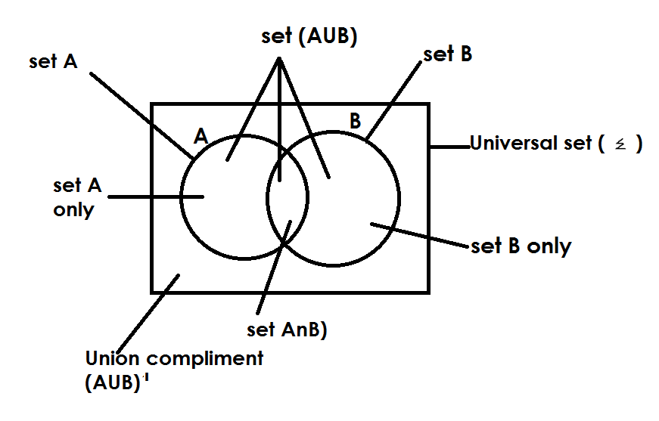

**DESCRIBING SHADED PARTS OF VENN DIAGRAM**

**EXAMPLES**

1) A B 2) **A B**

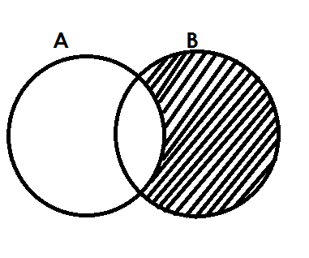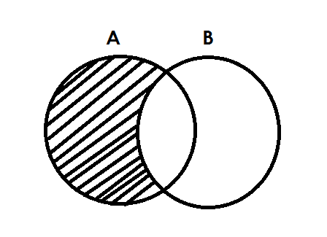 Set A Set B

3) 4)

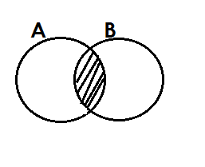 A only / A - B / B1  B only / B – A / A1

5) **A B** 6)

A n B

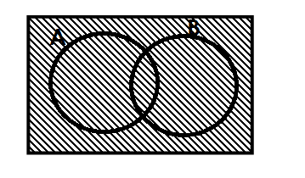7) 8)

A A

(AUB)1 Universal set

9) 10)

B**I**  A**I**

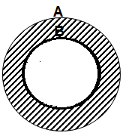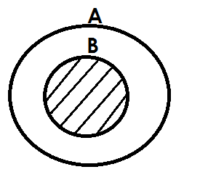 11) 12)

Set B /AnB A only / B**I**

**ACTIVITY**

1. Describe each of the shaded regions in the venn diagrams below.

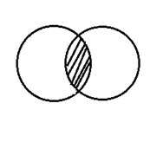(a) P Q (b) K M

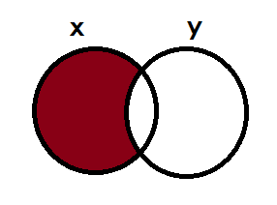

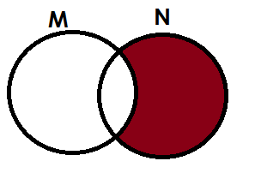(c) (d)

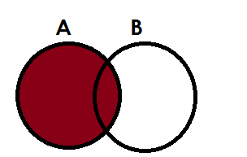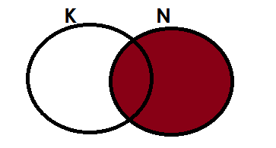(e) (f)

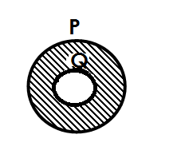

(g) (h) **x**

**y**

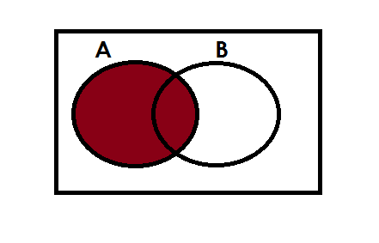(i) (j)

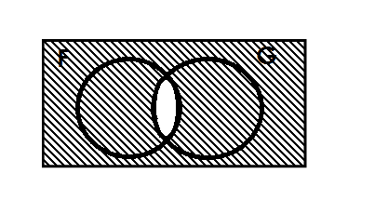(k) (l)

H

**LISTING AND FINDING NUMBER OF ELEMENTS IN A GIVEN SET**

1. Set A = {all factors of 12}

B= {All even members less than 10}

a. Find

(i) A

A = {1, 2, 3, 4, 6, 12}

(ii) B

B = {0, 2, 4, 6, 8}

(iii) (AnB)

AnB = {2, 4, 6}

(iv) AUB

AUB = {1, 2, 3, 4, 6, 12, 0, 8}

b. Find n (A n B)**I**

(AnB)1 = {0, 8, 1, 3, 12}

n (AnB )1 = 5

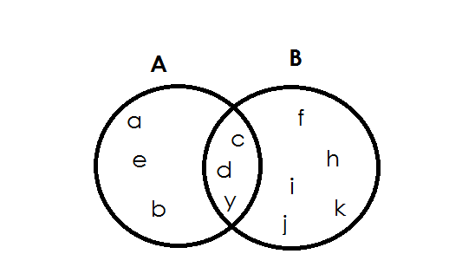2. The venn diagram below shows set A and B.

Find

(i) A

Soln

A = {a, b, e, c, d, y}

(ii) (AnB)1

Soln

(AnB)1 = {a, e, b, f, h, I, j, k}

n (AnB) = 8

(ii) (B – A)

**soln**

B – A = {f, h, I, j, k}

n (B – A) = 5

**ACTIVITY**

1.Given set P = {All multiples of 4 less than 25}

Q = {All factors of 16}

Find (i) P

(ii) Q

(iii) PnQ

(iv) n(PUQ)

2. Given that E= {whole numbers less than 10}

P = {Prime numbers between 1 and 12}

Find (i) E

(ii) n(P)

(iii) n(EnP)

(iv) n(EUP)

3. If set A = {1, 2, 3, 4, 5, 6, 7, 8, 11}

B = {2, 3, 4, 5, 8, 9, 10, 11}

Find (i) AnB

(ii) n(AUB)

(iii) n(A – B)

4. Below is set A and K

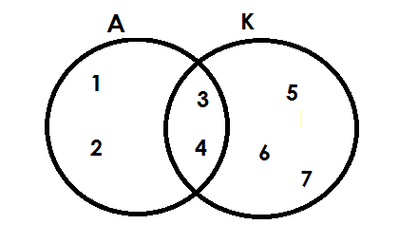

Find

1. A
2. K
3. AnK
4. (AnK)1
5. n(AUK)
6. n(A)1

5. Use the venn diagram below to answer questions.

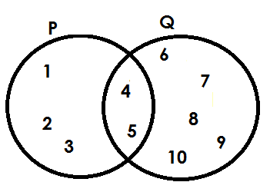

Find (i) P

(ii) Q1

(iii) n(P)1

(iv) n(PnQ)1

**FINDING NUMBER OR ELEMENT ON A VENN DIAGRAM GIVEN GROUPED DATA**

**Note**:

While finding number of elements given grouped data, do not list, we just add.

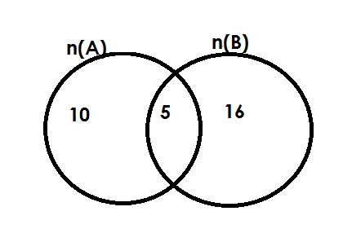Below is set A and B.

Find n (A)

**Soln**

1. n(A) = 10 + 5

= 15

1. n(B)

**Soln**

n(B) = 10 + 15

= 21

(ii) n(AnB)

**Soln**

n(AnB) = 5

1. n(AnB)1

**Soln**

n(AnB)1 = 10 + 16

=2 6

(v) n(AUB)

**Soln**

n(AUB) = 10 + 5 = 16

=31

**Example II**

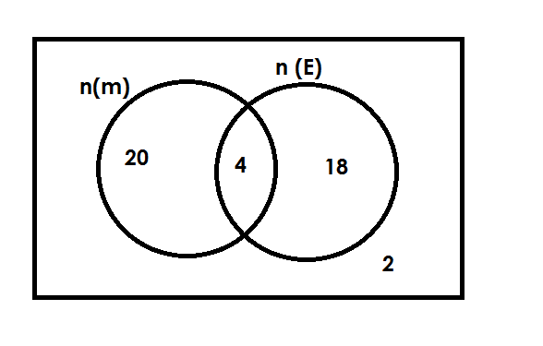The venn diagram below show number of pupils who like Math and English(E)

(a) How many pupils like math (M)

**Soln**

n(m) = 20 + 4

= 24

(b) How many pupils do not like English?

**Soln**

n(E)1 = 20 + 2

= 22

(c) How many pupils like only one subject?

**Soln**

Only one = 20 + 18

= 38

(d) Find the number of pupils in the whole class.

Soln

 n( ) = 20 + 4 + 18 + 12

= 44

**Activity.**

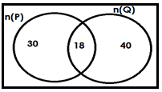1. Below is set P and Q

Find (i) n(P)

(ii) n(PnQ)

(iii) n(PnQ)1

(iv) n(PUQ)

(v) n(P)1

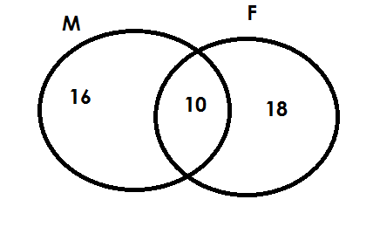2. Below is a set showing number of pupils who like meat (M) and Fish(F)

(a) How many pupils like meat?

(b) Find the number of pupils who like fish?

(c) How many pupils like meant only?

(d) How many pupils are in the whole group?

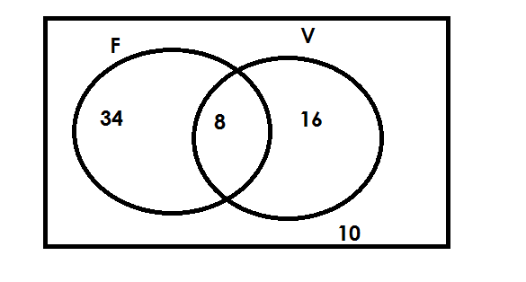3. The venn diagram below show number of pupils who play football (F) and Volley(V)

(a) How many pupils play football?

(b) How many pupils play volley ball?

(c) Find the number of pupils who play only one game.

(d) How many pupils do not play volley ball?

(e) How many pupils do not play football?

(f) How many pupils are in the whole class?

**REPRESENTING INFORMATION ON A VENN DIAGRAMS**

**A. Given ungrouped information.**

**Examples**

1. Give that set A = {1, 2, 3, 4, 5, 6, 7, 8, 9} and

Set B = {All even number less that 12}

a. Find B

B = {0, 2, 4, 6, 8, 12}

b. Show set A and B on a venn diagram.

Soln

A = {1, 2 , 3, 4 , 5, 6 , 7, 8 , 9}

B = {0, 2 , 4 , 6 , 8 ,10}

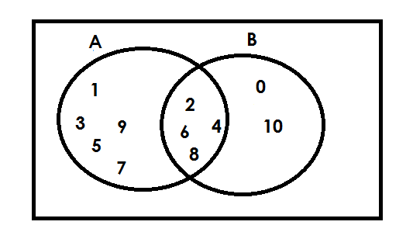

**Examples**

2. If set P = {all prime number less than 12} and

Set K = {all factor of 20}

P = {2, 3, 5, 7, 11}

K = {1, 2, 4, 5, 10, 20}

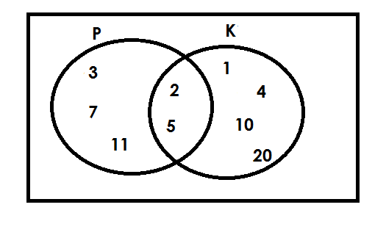

**Activity**

1. Given that T = {Odd numbers less that 10}

U = {odd numbers between 6 and 12}

Show the two sets T and U on a venn diagram.

2. R = {the first five letters of the English alphabets}

S = {vowels in the English alphabet}

Represent set R and Set S on the venn diagram.

3. Set K = {all multiples of 4 less than 25} and

Set T = {even numbers less than 13}

Represent the above information on the venn diagram.

4. Set M= {all factors of 12} and set N = {all multiples of 3 less than 20}

Show set M and set N on a venn diagram.

5. If J = {3, 6, 9, 12} and set K = {all even numbers less than 10}

(a) Find K.

(b) Represent se J and set K on a venn diagram.

6. Given that E = {whole numbers less that 16} and

A = {odd numbers less than 16}

(a) List the members of E

(b) List the members of set A.

**B) Given grouped data**

**Examples**

1. Given that n(A) = 20, n(B) = 15, n(AUB) =10

Show the above information on a venn diagram.

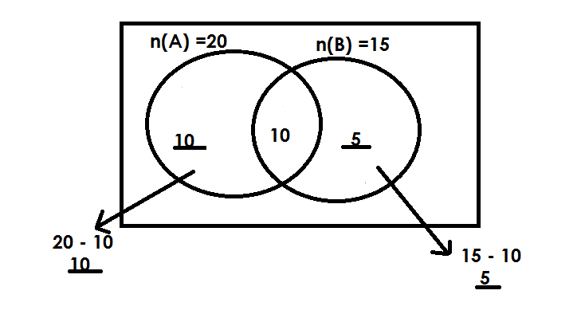 **Soln**

(b) Find n(AUB)

**Soln**

n(AUB) = 10 + 10 + 5

= 25

**Examples II**

2. In a class, 30 pupils like Maths (M), 24 pupils like English(E) and 8 pupils like both subjects.

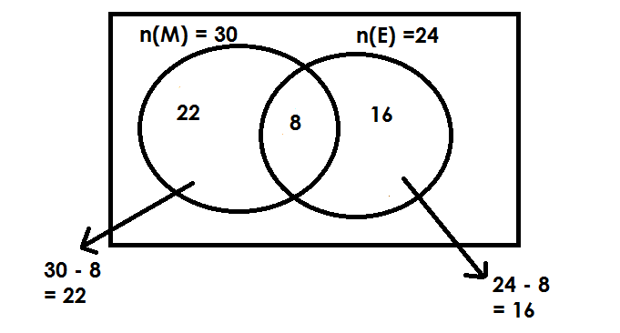a. Complete the venn diagram

(b) How many like math only?

**Soln**

N(M)only = 30 – 8

= 22

2. How many like only one subject?

**Soln**

Only one subject

= 22 + 16

= 38 pupils

**Activity**

1. Given that n(A) = 15, n(B) = 20 and n(AnB) = 9.

a. Draw a venn diagram to represent the above information.

2. The number of pupils who do RE (R) are 26 and the number of pupils who do Art (A) are 30. If there are 16 pupils who do both subjects,

Draw a venn diagram and find out how many pupils do only one subject.

3. If n (M) = 25, n(N) = 20 and n(MnN) = 8.

a. Draw a venn diagram to represent the above information.

(b) Find

(i) n (M – N)

(ii) n (N – M)

(iii) n (N U M)

**SUBSETS**

A subset is a set that can be obtained /formed from any given set.

A symbol for subset is ⊆ (is a subset of)

**Venn diagram about subsets**

**Examples**

Draw a venn diagram to show that all girls are female (F)

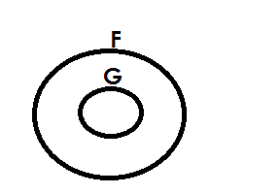 **Soln**

**Examples**

Draw a venn diagram to show that

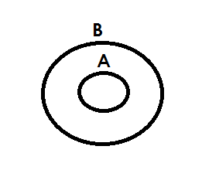 A = A n B

Soln

**Example III**

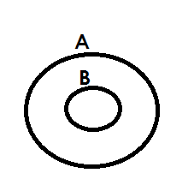 Draw a venn diagram to show that A = AUB

**Activity**

1. Draw a venn diagram to show that all hens(h) are birds(b).

2. Draw a venn diagram to show that all boys(B) are males(M).

3. Draw a venn diagram to show that all goats are are animals.

4. Draw a venn diagram to show that P = PnQ

5. With the help of a venn dram, show that n(K) = n (PUK)

**LISTING SUBSETS**

**Note**:

* An empty set is a subset of every set.
* A given set is a subset of itself.
* Equal sets are not subsets of a given set. e.g. {a, b} and {b, a} since they are taken to be the same.

**Examples**

1. Given that set A = {P}. List all subsets on set A.

**Soln**

{ } , {P}

2. If set P = {1, 2}. List all subsets in set T.

**Soln**

{ } , {1}, {2}, {1, 2}

3. Set Q = {m, a, n}. List all subsets in set Q.

**Soln**

{ }, {m}, {a}, {m, a}, {m, n}, {a, n}, {m, a, n}

**Activity**

1. List all subsets in sets A. If A = { }

2. List all subsets in set Q given that Q = [X, Y}

3. List all subsets in set B with { , , }

4. Given that P is {Mary, Amos, Tony}, write down all subsets of P.

5. Given that M = {cow, goat} write all the subsets of set M.

6. List all subsets is set K if K = { }

**FINDING NUMBERS OF SUBSETS**

No. of subsets = 2**n**

Where 2 shows that number of subsets are in power of 2.

“n” is the number of elements in a given set.

**Examples**

1. Given that A = { }

**Soln**

No. of subsets = 2n

= 20

= 1 subset

2. If set K = {4}, find number of subsets in k.

No. of subsets = 2n

= 23

= 2 x 2 x 2

= 8 subsets

**Activity**

1. Find the number of subsets of set P, given that P = {1, 2, 3, 4}

2. Set Y = {Toad, Frog} Find the number of subset Y.

3. Find the number of subsets of sets X if n(X) = 5.

4. How many subsets are in set W if W = {a}

5. Find the number of subsets in a set with 4 elements.

6. Find the number of subsets in Q given that n(Q) = 1.

7. Use the venn diagram below to answer questions that follow.

a) Find number of subsets in K**I**

b) How many subsets are in set P n K?

c) Find number of subsets in P**I**

**PROBABILITY**

Probability is a measure of chance.

**Note**:

Probability is not reduced.

**Formula**;

Probability = n (D. C)

n (T.C)

Where

D.C Desired chances

T.C Total chances

**TOSSING A COIN**

A coin has two faces ie

1. Head (H)

2. Tail (T)

**Examples**

1. A coin was tossed once. What was the probability of a head showing up?  
 Prob = n (D.C)

n (T.C)

D.C = Head

T.C = 1

T.C = Head, Tail

n (T.C) = 2

Prob = 1

2

**Activity**

1. Richard tossed a coin once. What is the probability that a head shows up?

2. A girl tossed a coin once. What is the probability that a tail shows up?

**ROLLING A DIE**

A die has faces numbered; 1, 2, 3, 4, 5, 6

Pro = n (D.C)

N (T.C)

**Examples**

1. A die was rolled once. What is the probability that,

a) An even number appears on top?

D.C = 2, 4, 6

n (D.C) = 3

T.C = 1, 2, 3, 4, 5, 6

n (T.C) = 6

Prob = 3

6

b) An odd number appears on top.

D.C = 1, 3, 5

n (D.C) = 3

T.C = 1, 2, 3, 4, 5, 6

n (T.C) = 6

Prob =

c) A number greater than 2.

D.C = 3, 4, 5, 6

n (D.C) = 4

T.C = 1, 2, 3, 4, 5, 6

n (T.C) = 6

Prob =

**Activity**

1. A die was tossed once. What is the probability of that?

(a) a prime number appears?

(b) a multiple of 2 appears on top?

(c) a number less than 6 appears top?

(d) a square number appears on top?

(e) a composite number appears on top?

**FINDING PROBABILITY GIVEN ITEMS**

**Examples**

1. In a box, there are 4 black pens and 5 red pens. Find the probability of picking a red pen at random.

**Soln**

n (D.C) = 4

n (T.C) = 4 + 5

= 9

Prob =

2. A bag has 6 red shirts and 5 white shirts. If Mukasa picks one shirt at random from the bag. What is the probability of picking a white shirt?

**Soln**

n (D.C) = 5

n (T.C) = 5 + 6

= 11

Prob =

3. In a class, there are 20 boys and girls. What is the probability of picking a boy to be the class captain?

Soln

Prob = n (D.C)

n (T.C)

n (D.C) = 20

n (T.C) = 30 + 20

 = 50

Prob = 20

50

**Activity**

1. In a basket, there are 6 ripe mangoes and 3 green one Judith picks one mangoes from the bag without looking. What is the probability that she picks a ripe mango?

2. The letters of the word KAMULI were cut separately and put in a bag. What is the probability of picking at random,

a) a vowel?

b) K?

c) a consonant?

3. In a box these are 2 red pens and 3 black pens. What is the probability that a red pen is picked at random from the box?

4. A bag contains 4 blue places and 5 white plates. What is the probability of picking a white plate from the bag?

5. A box contains fruits, 4 passions fruits, 3 oranges and 2 mangoes. What is the chance that an orange fruit is picked from the box at random?

6. What is the probability of picking a black pen from the tin which contains 3 red pens and 6 black pens?

**FINDING PROBABILITY GIVEN DAYS OF THE WEEK**

**Note**:

A week has 7 days. I.e Monday, Tuesday, Wednesday, Thursday, Fridays, Saturday, Sunday.

n (T.C) = 7

1.What is the probability that Musa will go to town on a day which starts with letter S

**Soln**

Prob = n (D.C)

n (T.C)

D.C = Saturday, Sunday

n (D.C) = 2

n (T.C) = 7

Prob =

**Examples**

2. Anthony is going to London. What is the probability that is going on a Tuesday?

**Soln**

D.C = Tuesday

n (D.C) = 1

n (T.C) = 7

Prob =

**Activity**

1. Mr.Kitoko is going for a wedding. What is the probability that he is going on a day which begins with letter T?

2. Agnes is pregnant. If she is expected to give birth next week, what is the probability that she will give birth on Monday?

3. We shall write exams next week. What is the probability that we shall write on a day which begin with letter S?

**FINDING PROBABILITY GIVEN MONTH OF THE YEAR**

**NOTE**:

A year has 12 months i.e January, February, March, April, May, June, July, August, September, October, November and December.

Number of total chances is 12.

**Example I**

We shall go to Kampala next year, what is the probability the we shall go in a month starting with letter J?

D.C = January, June , July

n (D.C) = 3

n (TC) = 7

Prob = n (D.C)

n (T.C)

=

**Example ll**

Matame is wedding next year, what is the probability that she will wed in April.

D.C = April

n (D.C) = 1

n (T.C) = 12

Prob = n (D.C)

n (T.C)

=

**Activity**

1. Primary leaving examination will be done next year, what is the probability that the examination will be done in the month starting with letter J?

2. What is the probability that Uganda will receive heavy rainfall in the month starting with letter “m”?

3. All government teachers will be paid next year, what is the probability that the payment will be than in the first 3 month of the year.

4. The official election of president will take place next year, what is the probability that will take place in the month starting with letter A?

5. A pregnant mother will give birth next year. What is the probability that it will be in the month of May?

**FINDING PROBABILITY INVOLVING FRACTIONS**

**Example I**

The probability that he will pass his examination is . What is the probability that he will fail?

**Soln**

Passing =

Failing = 1 -

***= -***

***=***

**Example II**

The probability that we shall get food tomorrow is 0.8 what is the probability that we shall not get.

Getting = 0.8

Not getting = 1 – 0.8

=

=

= 0.2

**Activity**

1. The probability that it will rain today is . What is the probability that it will not rain?

2. The probability of passing exams is find the probability of failing.

3. The probability that school in Uganda will reopen next month due to covid 19 pandemic is . What is the probability that the schools will not open?

4. The probability that Musa will pass an interview is 0.4. What is the probability that he will not pass it?

5. The chance that president Museveni will be voted back in power is 0.6. What is the probability that he will not be voted into power?

**WHOLE NUMBERS.**

**NUMERATION SYSTEMS AND PLACE VALUES.**

**Finding place valves of whole numbers.**

A place valves is a position of a digit in a given number.

**Example I**

Find the place value of each digition the number below.

5 4 6 8 9 10

**Soln**

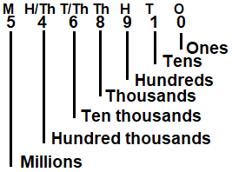

**Example II**

What is the place value of the underlined digits in 4 8 9 4 7 2

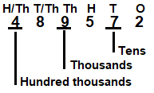**Soln**

**Activity**

1. What is the place valUe of each of the digits in the following.

(a) 5403 (b) 72483 (c) 169542

(d) 623,589 (e) 1689143 (f) 942376

(2) What is the place value of the underlined digits in the following.

(a) 1 4 83 (b) 964324 (c) 79462

(d) 38946 (e) 76421 (f) 846241

**FINDING VALUE OF DIGITS IN WHOLE NUMBERS.**

A value is a product of a digit and its place value.

**Example I**

Find the each of the digits in 4 6 8 2 4 5 9

**Soln**

**M HT TTH TH H T O**

**4 6 8 2 4 5 9**

**9 x 1 = 9**

**5 x 10 = 50**

**4 x 100 = 400**

**2 x 1000 = 2000**

**8 x 10, 000 = 80,000**

**6 x 100, 0000= 600,000**

**4 x 1000, 000= 4, 000, 000**

**Example II**

What is the value of the underlined digits in 19 8 4 0 3 6?

**M H/Th T/Th Th H T O**

1 9 8 4 0 3 6

0 X 100 = 0

8 X 10,000 = 80,000

**Activity**

1. What is the value of each of the following digits?

(a) 4 03 (b) 97036 (c) 342634 (d) 90786

2. What is the value of the underlined digit.

(a) 3 0 4 (b) 97043 (c) 4 0 3007

3. What is the value of the underlined digit.

(a) 4097 (b) 99043 (c) 102973

4. Expand 406 using value.

**EXPANDING WHOLE NUMBERS**

(A) **USING PLACES VALUES.**

(a) Expand 7437 using place values.

**TH H T O**

7 4 3 7

= (7 X 1000) + (4 X 100) + (3 X 10) + (7 X 1)

(b) Express 697,636 in expanded form using place values

**HTH TTH TH H T O**

6 9 7 6 3 6

= (6 X100,000) + (9 X 10,000) + (7 X 1000) + 6 X 100) + (3 X 10) + (6 X 1)

**ACTIVITY**

1. Expand 9464 using place values.

2. Express 46,367 in expanded from using place values.

3. Expand the following numbers using place values.

(a) 369 (b) 489,630 (c) 346,001 (d) 496,304 (e) 496,346

(B) **USING VALUES**

**Examples**

1. Expand 4051 using values.

**Soln**

**TH H T O**

4 0 5 1

= (4 x 1000) + (0 x 100) + (5 x 10) + (1 x 1)

= 4000 + 0 + 50 + 1

2. Write 817,036 in expanded form using values.

**Soln**

**HTH TTH TH T H O**

8 1 7 0 3 6

= (8 X 100, 000 + (1 X 10, 000) + (7 X 10, 000) + (0 X 100) + (3 X 10) + (6 X 1)

= 800,000 + 10,000 + 7,000 + 0 + 30 + 6

3. Expand 90760 using values.

**Soln**

**T/Th TH H T O**

9 0 7 6 0

= (9 X 10,000) + (0 X 1000) + (7 X 100) + (6 X 10) + (0 X 1)

= 90,000 + 0 + 700 + 60 + 0

**Activity**

1. Expand 3049 using values.

2. Express 90347 in expanded form using values.

3. Expand the following numbers.

(a) 304 (b) 4906 (c) 490,763

(d) 396,003 (e) 96,364 (f) 304,304

**EXPANDING NUMBERS USING POWERS / INDICES/ EXPONENTS**

**Examples.**

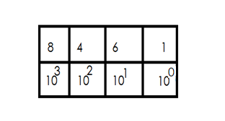1. Expand 8461 using powers

= (8 x 10 3) + (4 x 10 2) + (6 x 101) + (1 x 100)

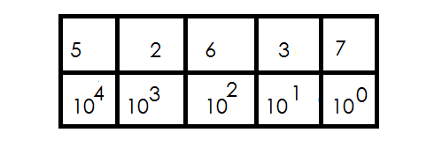2. Express 52637 in expanded form using exponents.

= (5 x 10 4) + (2 x 103) + (6 x 102) + (3 x101) + (7 x100)

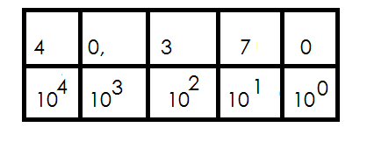3. Expand 40,370 using exponents indices.

= (4 x 104) + (0 x 103) + (3 x 102) + (7 x101) + (0 x 100)

**Activity**

1. Expand 304 using powers.

2. Express 46,763 in expanded form using exponents.

3. Expand 503466 using indices.

4. Expand the following numbers using powers.

(a) 30,467 (b) 340,067

(c) 490,363 (d) 963,679

**FINDING EXPANDED NUMBER**

**Examples**

1. Express (5 x 100000) + (6 x10000) + (9 x1000) + (4 x 10) as single number.

**Soln**

= 500,000 + 60,000 + 9,000 + 40

500,000

60,000

9, 000

+ 40

569,040

2. What number has been expanded to give: 40,000 + 9000+ 800 + 2?

40,000

9,000

800

+ 2

49,802

3. Write the expanded number in short

= (2 x 10 4) + (8 x 103) + (5 x 102) + (3 x 100)

= (2 x 10 x 10 x 10 x 10) + (8 x 10 x 10 x 10) + (5 x10 x 10) + (3 x 1)

= (2 x 10000) + (8 x 1000) + (5 x 100) + (3 x1)

= 20000 + 8000 + 5 00 + 3

20,000

8,000

500

+ 3

28,503

4. What number was expanded to give. (3 x 10,000) + (2 x 10)

**Soln**

30, 000 + 20

30, 000

+ 20

30,020

5. What number was expanded to give.

= (3 x 10**4**) + (5 x 10**2**) + (4 x 100)

= (3 x 10 x 10 x 10 x 10) + (5 x10 x 10) + (4 x1)

= (3 x 10,000) + (5 x100) + (4 x1)

= 30,000 + 500 + 4

30,000

500

+ 4

30,504

**Activity**

1. What number has been expanded to give.

(a) (9 x 1000) + (3 x 100) + (2 x10) + (1 x 1)

(b) (8 x 100,000) + (7 x 10,000) + (2 x 100) + (2 x 1)

(c) (5 x 100,000) + (6 x 100) + (4 x 1)

2. Write the expanded number in short.

(a) 30,000 + 900 + 3

(b) 9,000,000 + 700,000 + 40

3. What number was expanded to give.

(a) (9 x 103) + (4 x102) + (2 x 101) + (5 x 100)

(b) (6 x 104) + (4 x102) + (3 x101) + (0 x100)

(c) (9 x 104) + (3 x 101) + (4 x100)

**WRITING FIGURES IN WORDS**

**Examples**

1. Write 36,948 in words.

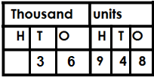 **Soln**

Thirty-six thousand, nine hundred forty-eight.

2. Write 730,609 in words.

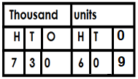 **Soln.**

Seven hundred thirty thousand, six hundred nine.

3. Write 1,403,604 in words

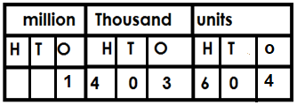 **Soln**

One million, four hundred three thousand, six hundred four.

**Activity**

Write the following in words.

(a) 409 (b) 9463

(c) 97,063 (d) 376489

(e) 17,036 (f) 963468

**WRITING NUMBER WORDS IN FIGURES**

1. Write Twelve thousand four in figures.

Twelve thousand 12,000

Four. + 4

12,004

2. Write five hundred twenty – one in figure

Five hundred 500

Twenty-one + 21

521

3. Write four hundred three thousand six hundred twenty in figures.

Four hundred three thousand 403,000

Six hundred. 600

Twenty. + 20

403, 620

4. Write in figures: Five million, four hundred four thousand, seven hundred sixteen

Five million. 5,000,000

Five hundred five thousand. 505,000

Five hundred. 500

Fifteen. + 15

5,505, 515

**Activity**

Write the following in figures

(a) Eleven thousand, six hundred eleven.

(b) Eighteen thousand, five hundred twenty-six.

(c) Ninety – seven thousand, eighteen.

(d) One hundred fifty thousand twenty.

(e) One hundred thousand, one

(f) One hundred one thousand one hundred one

(g) Six million, nine hundred thousand ten

**FORMING NUMERALS FROM DIGITS**

**Note**:

* There is no number that starts with digit zero.
* No commas should be indicted in the number formed.
* When forming the smallest numeral, arrange the given digits in ascending order but without commas.
* When forming the biggest numeral arrange the given digits in descending order but without commas.

**Examples I**

1. Given digits 2, 3 and 4 form all the three digits numerals

2 3 4

234 324 433

The numbers are 234, 243, 324, 342, 423, 432.

2. Given 4, 5 and 8:

(a) Form the smallest numeral using the above digits.

The smallest numeral = 458

(b) Form the biggest numeral using the above digits.

The biggest numeral = 854

(c) Find the difference between the biggest and smallest numbers formed.

**Soln**

Biggest = 85 4

Smallest = - 4 5 8

Difference 3 9 6

3. Given the digits 9, 0 and 4

(a) Form all the possible three-digit numerals usingthe above digits.

**Soln**

|  |  |  |
| --- | --- | --- |
| 0 | 4 | 9 |
|  | 409 | 94 |
|  | 490 | 940 |

The numerals are; 409, 490, 904, 940.

4. Given the digits: 4, 0, 2 and 6.

(a) Form the biggest numeral.

**Soln**

Biggest numeral = 6420

(b) Form the smallest numeral.

**Soln**

Smallest numeral = 2046

(c) Find the sum of the biggest and the smallest numerals formed.

Biggest numeral 6420

Smallest numeral 2046

Sum +8466

**Activity**

1. Given the digits 7, 3 and 5.

(a) Form the smallest three-digit number.

(b) Form the biggest three-digit numeral.

(c) Find the sum of the smallest and biggest numerals formed.

2. Given the digits: 9, 1 and 2.

(a) Form the smallest three digits numeral.

(b) Form the biggest three-digit numeral.

(c) Work out the sum of the smallest and the biggest numerals formed.

(d) Find the difference of the biggest and smallest three-digit numerals formed.

(e) Express the smallest three-digit numeral in expanded form.

3. Use 5, 0 and 8 to form all three-digit numerals.

4. Given digits 7, 6 and 9,

a) Form all the three digits numerals.

b) Find the difference of the biggest and the smallest numerals formed.

**DECIMAL FRACTIONS**

A decimal number is a number with a decimal point and decimal places.

**Forexample;**

0.8, 0.108, 0.0072, 12.35, 0.2727, 1.66 etc.

**Illustration of a decimal number by its composition.**

Whole digits Decimal digits

1 2 4 0 7 5

Decimal point

**Place value of decimal numbers.**

**Note:**

All place values of decimal digits end in **“ths”**

**Examples of decimal place values include;**

1. Tenths (Tths)

2. Hundredths (Hths)

3. Thousandths (Thths)

4. Ten thousandths (T/Thths)

5. Hundred thousandths (H/Thths)

**Examples**

1. Write the places values of each digits in 124.075

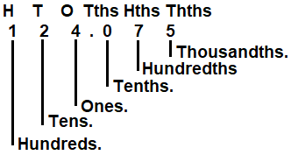 **Soln**

2. Write the place values of 2 in 0.42

**Soln**

0 Tths Hths

0 . 4 2

Hundredths

3. Find the place value of 3 in 37.59

**Soln**

T O Tth Hths

3 7. 5 9

Tens

**Activity**

1. Find the place values of each digits in 25.047

2. Find the place value of the underlined digits.

(a) 0.75

(b) 6.03

(c) 0.123

(d) 75.03

(e) 109.01

3. What is the place value of 7 in 726.04?  
4. Write the place value of 0 in 2.705.

**VALUES OF DECIMALS**

**Note:**

Value is the product of a digit and its place value?

**Examples**

1. Find the value of each digits in the number 251.039.

H T O Tths Hths Thths

2 5 1 . 0 3 9

9 x 1 = 9

1000 1000

= 0.009

3 x 1 = 3

100 100

= 0.03

0 x 0 = 0

10

1 x 1 = 1

5 x 10 = 50

2 x 100 = 200

2. What is the value of 5 in 0.05.

**Soln**

O Tths Hths

1. 0 5

= 5 x 1 =5

100 100

= 0.0 5

3. Find the value of 3 in the number 37.1.

**Soln**

**T O Tths**

3 7. 1

= 3 X 10

= 30

**Activity**

1. Write the value of every digit in 70.12

2. Find the value of each digit in 0.027.

3. Find the value of the underlined digit.

(a) 0.5

(b) 7.65

(c) 23.08

(d) 2.05.

(e) 0.234

(f) 801.95

**EXPANDING DECIMALS**

**(a) Using place values.**

**Examples**

Expand 4.32 using place values.

Soln

**O TH HTHS**

4 . 3 2

(4 X 10) + (3 X ) + (2 X )

**Example II**

Expand 34.204 using place values.

T O Tths Hths Tths

3 4 . 2 0 4

= (3 X 10) + (4 X 10) 2 X ) + (0 X ) + (4 X )

Expand 434.24 using place values.

**Soln:**

**H T O Tths Hths**

4 3 4 . 0 2

= (4 x 1000) + (3 x 10) + (4 x 1) + (0 x ) + (2 x )

**ACTIVITY**

1. Expand 42.3 using place values.

2. Expand 69.24 using place values.

3. Expand the following using places values.

(a) 30.4

(b) 342.52

(c) 97.304

(d) 402.34

**(b) Using values.**

**Examples**

Expand 32.4 using values

**Soln**.

**T O Tths**

3 2 . 4

= (3 x 10) + (2 x 10) + (4 x )

= (3 x 10) + (2 x 10) + ()

= 30 + 2 + 0.4

Expand 69.23 using values.

**Soln**

**T O Tths Hths**

6 9 . 2 3

= (6 x 10) + (9 x 1) + (2 x ) + (3 x )

= 60 + 9 + +

= 60 + 9 + 0.2 + 0.03

Expand 6.306 using values

Soln

O Tths HthsTths

6 . 3 0 6

= (6 x 1) + (3 x ) + (0 x ) + (6 x )

= 6 + 0.3 + 0 + 0.006

**Activity**

1. Expand 0.32 using values.

2. Expand the following using values.

(a) 2.3

(b) 2.03

(c) 42.59

(d) 421.3

(e) 39.462

(c)  **Using powers/exponents /indices.**

**Example I**

Expand 49.5 using powers.

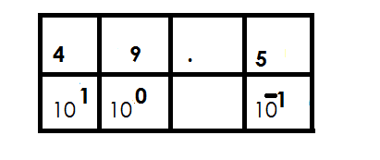 **Soln.**

= (4 x 10**1**) + (9 x 10**0**) + (5 x 10**-1**)

Expand 59.463 using powers.

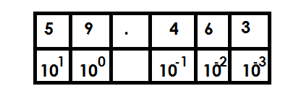**Soln**

= (5 x 10**1**) + (9 x 10**0**) + (4 x 10**-1**) + (6 x 10**-2**) + (3 x 10**-3**)

**Example III**

Expand 402 .42 using indices.

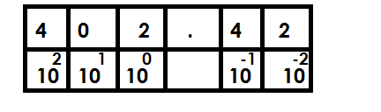**Soln**

= (4 x 10**2**) + (0 x 10**1**) + (2 x 10**0**) + (4 x 10**-1**) + (2 x10**-2**)

**Activity**

1. Expand 49.3 using powers.

2. Expand 56.03 using exponents.

3. Expand 4.93 using indices.

4. Expand the following using powers.

(a) 4.9

(b) 0.49

(c) 54.3

(d) 67.07

(e) 78.067

**WRITING DECIMALS IN WORDS**

**Example I**

1. Write 0.3 in words

0.3 zero point three

**Or**

O T th

0 . 3 Three tenths

**Example II**

2. Write 4.32 in words

**Soln**

4.32 four point three two.

**Or**

Hths

4. 32 4 and 32

Hundredths

Four and thirty-two hundredths

**Example III**

3. Write 402.463 in words

Soln

402. 463 402 and 463

Thousandths

Four hundred two and four hundred sixty-three thousandths

**Example IV**

4. Write 32.04 in words

**Soln**

32.04 32 and 4

Hundredths

Thirty-two and four hundredths

**Activity**

1. Write the following in words

(a) 40.3

(b) 58.69

(c) 403.52

(d) 40.32

(e) 56.03

(f) 403.5

**WRITING DECIMALS IN FIGURES**

**Example I**

1. Write in figures. Four tenths

Four tenth 4

10

= 0.4

**Example II**

2. Write forty – nine and four tenths in figures.

**Soln**

Forty – nine and four tenths 49.4

**Examples III**

3. Write three hundred four point five six in figures.

**Soln**

304.56

**Example IV**

4. Write Thirty – nine and six hundred five thousandths.

**Soln**

Thirty-nine 39 and 605

39.605

**Activity**

1. Write the following decimals in figures.

(a) Two tenths

(b) Five and six tenths

(c) Four and thirty – nine hundredths

(d) Seven hundred two and four hundredths

(e) Sixty-eight point four five six

(f) Four and five hundred fifty – six thousandths

**ROMANS NUMERALS**

**Number**

Is the quantity of something.

**Numeral**

Is a symbol that represents a number.

**TYPES OF NUMERALS**

1. Hindu Arabic numerals.

2. Roman numerals

**HINDU ARABIC NUMERALS**

These are numerals that are used in most parts of the world.

Major Hindu Arabic numerals.

0, 1, 2, 3, 4, 5, 6, 7, 8, 9

**ROMAN NUMERALS**

1. Basic Roman Numeral

|  |  |  |  |  |  |  |  |  |
| --- | --- | --- | --- | --- | --- | --- | --- | --- |
| **Hindu Arabic** | **1** | **5** | **10** | **10** | **50** | **100** | **500** | **1000** |
| **Roman Numeral** | **1** | **V** | **X** | **X** | **L** | **C** | **C** | **M** |

All Roma numerals should be written in capital letters.

**2. Repeated Roman numerals.**

Roman Numerals got by repeating **I**

2 = II

3 = III

Roman Numerals got by repeating X

20 = XX

30 = XXX

Roman Numerals got by repeating C

200 = CC

300 = CCC

Roman Numerals got by repeating M

200 = MM

3000 = MMM

**NB**

The above repeated numerals start with digits 2 or 3.

**3. Roman Numerals got by adding 5, 50 or 500**

**NB.**

These always start with digits 6, 7 or 8.

**Examples**

6 = 5 + 1

= VI

7 = 5 + 2

= VII

8 = 5 + 3

= VIII

60 = 50 + 10

= LX

70 = 50 + 20

= LXX

80 = 50 + 30

= LXXX

600 = 500 + 100

= DC

700 = 500 + 200

= DCC

800 = 500 + 300

= DCCC

**4. Roman Numerals got by subtracting from 5, 10, 50, 100 or 1000.**

**NB**

These always start with digits 4 and 9.

**Examples**

4 = 5 – 1

= IV

9 = 10 – 1

= IX

40 = 50 – 10

= XL

90 = 100 – 10

= XC

400 = 500 – 100

= CD

900 = 1000 – 100

= CM

**Hindu Arabic and Roman numerals**

|  |  |
| --- | --- |
| **Hindu Arabic** | **Roman Numeral** |
| 1 | I |
| 2 | II |
| 3 | III |
| 4 | IV |
| 5 | V |
| 6 | VI |
| 7 | VII |
| 8 | VIII |
| 9 | IX |
| 10 | X |
| 20 | XX |
| 30 | XXX |
| 40 | XL |
| 50 | L |
| 60 | LX |
| 70 | LXX |
| 80 | LXXX |
| 90 | XC |
| 100 | C |
| 200 | CC |
| 300 | CCC |
| 400 | CD |
| 500 | D |
| 600 | DC |
| 700 | DCC |
| 800 | DCCC |
| 900 | CM |
| 1000 | M |
| 2000 | MM |
| 3000 | MMM |

**CHANGING HINDU ARABIC NUMERALS TO ROMAN NUMERALS**

**Examples**

1. Express 19 in Roman Numerals

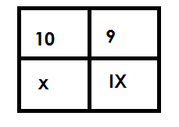 Soln

19 =

= XIX

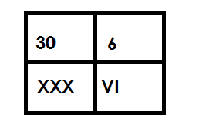2. Change 36 to Roman numerals.

36 =

= XXXVI

3. Change 69 to Roman numerals

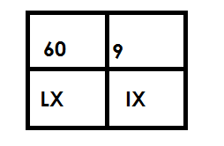 69 =

= LXIX

**Activity**

Change the following Hindu Arabic numerals to Roman numerals.

1. 14
2. 8
3. 23
4. 17
5. 49
6. 89
7. 199
8. 123
9. 449
10. 968
11. 888

**CHANGING ROMAN NUMERALS TO HINDU ARABIC NUMERALS**

**Examples**

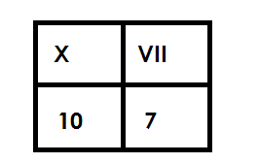1. Change XVII to Hindu Arabic Numerals

XVII =

= 17

2. Express XCVIII to Hindu Arabic numeral.

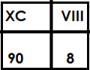 **Soln**

XCVIII =

= 90 + 8

= 98

3. Convert DCCLXXXVIII into Hindu Arabic numeral

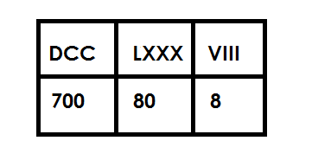 **Soln**

DCCLXXXVIII =

= 700 + 80 + 8

= 788

**Activity**

1. Change the following from Roman Numerals to Hindu Arabic numerals.

(a) XI

(b) LVIII

(c) XCIII

(d) CXXIV

(e) CCCLXIII

(f) DCCXX

(g) DCCCLXXXVIII

(h) CMXXII

(I) CMIX

**WORD PROBLEMS INVOLVING ROMAN NUMERALS AND HINDU ARABIC NUMERALS**

**Examples**

1. Musoke is 9 years. Write his age in Roman numerals.

**Soln**

9 = IX

2. Mukuba scored 54 marks in a test. Write score in Roman numerals.

**Soln**

54 = 50 + 4

LIX

3. There are are XLIV oranges and LVIII apples in a basket. Find the total number of fruits in the basket in Hindu Arabic numerals.

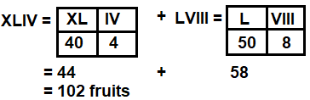

**Activity**

1. A basket contains 23 ripe mangoes. Write the number of mangoes in the baskets in Roman numerals.

2. Mukiibi is 49 years. Express his age in Roman numerals.

3. Katongole has XVIII children. Write his number of children in Hindu Arabic numerals

4. There are XLVIII English books in the library. Express the number of books in Hindu Arabic numerals.

5. Malevu was born in MCMXCII. Write his year of birth in Hindu Arabic numerals.

**ROUNDING OFF**

This is a way of approximating numbers to the required place value.

**Rounding off ofwhole numbers**

* In rounding off, consider the digit on the right of the figure in the required place value to either **round up** or **round down**.
* Round down incase the digit on the right of the figure in the required place value is either 0, 1, 2, 3 or 4 by adding zero (0) to the digit in the required place value.
* Round up incase the digit on the right of the figure in the required place value is either 5, 6, 7, 8 or 9 by adding 1 to the digit in the required place value.
* All digits coming on the right of the digit in the required place value will turn into zero (0) when rounding off whole numbers.

**Examples**

1. Round off 24643 to the nearest hundreds

**Soln**

Tthth H T O

2 4 6 4 3

+ 0

2 4 6 0 0

 24643 24600

2. Round off 4896 to the nearest hundredths

Soln

**Th H T O**

4 8 9 6

+ 1 0 0

4 9 0 0



4896 4900

3. Round off 68 to the nearest hundreds

**H T O**

0 6 8

+ 1 0 0

 1 0 0

 68 100

**Activity**

1. Round off the following to the nearest tens.

(a) 4642

(b) 314

(c) 489

(d) 835

(d) 9

2. Round off the following to the nearest hundredths

(a) 4380

(b) 229

(c) 56

(d) 7

(e) 4

3. Round off the following to the nearest thousands.

(a) 4687 (e) 14324

(b) 96894 (f) 246

(c) 743214 (g) 994

(d) 49684

**ROUND OFF DECIMALS**

**Note:**

* All digits coming on the right of the digit in the required place value are

crossed out.

* The last digit should be in the mentioned place value.
* Round off to 2 decimal places means hundredths, one decimal tenths

whole number means one places value.

**Examples**

1. Round off 34.56 to the nearest tenths

**Soln**

RD

3 4 . 5 6

+ 0 . 1

3 4 . 6 

34. 56 34.6

2. Round off 36.764 to the nearest decimal digit.

RD

3 6 . 7 6 4

+ 0

3 6 . 7 6



 36.76 36.76

**Examples III**

Round off 49.98 to the nearest whole number

**Soln**

RD

4 9 . 9 8

+ 1

 5 0

38. 46 38.5

**Example v**

Round off 7 6 . 4 8 3 to 2 decimal places

Soln

7 6 . 4 8 3

+ 0

7 6 . 48

76.48 76.48

Round off 146.58 to the nearest tens.

**Soln**

RD

1 4 6 58

+ 1 0

1 5 0

146.58 150

**Activity**

3. Round off 46.58 to the nearest tenths.

4. Round off 98.407 to the nearest hundredths.

5. Correct 98.478 to 1 decimal place.

6. Round off 90.861 to the nearest whole number.

7. Round off 67.567 to 2 decimal places.

8. Round off 105.69 to the nearest tens.

9. Round off 148.79 to the nearest tenths.

1. Round of the following to the nearest tenths.

(a) 40.66 (b) 99.90 (c) 507.48

Round off the following to the nearest hundredths.

2a. 59.698 (b) 147.498 (c) 449.467

**WHOLE NUMBERS.**

**OPERATIONS ON WHOLE NUMBERS.**

**ADDITION OF NUMBERS**

**Example I**

Add: 434126 + 12431

**Soln**

4 3 4 1 2 6

+ 1 2 4 3 1

4 4 6 5 5 7

**Example II**

Add: 7 6 4 3 2 + 6 8 9 7

**Soln**

7 6 4 3 2

+ 6 8 9 7

7 3 3 2 9

**Example III**

**Work out** : 84399 + 46784

8 4 3 9 9

+ 4 6 7 8 4

13 3 1 1 8 3

**Activity**

1. Add: 35643 + 12432

2. Add: 432143 + 12344

3. Add: 49986 + 12344

4. Add: 598975 + 146789

5. Add: 4 6 9 5 8 9

+ 3 7 8 9 9 9

6. Add: 1 4 6 5 8 9

+1 3 4 5 9 5

7. Add: 498999 + 110111

**WORD PROBLEMS INVOLVING ADDITION OF WHOLE NUMBER**

**Note**:

Sum is the result of addition.

Observe units used in the question.

**Example I**

In school there are 467 boys and 622 girls. How many pupils are in the school?

Soln

No. of pupils = 4 6 7

+ 6 2 2

10 8 9 pupils



1089 pupils

**Examples II**

There are 24361 books in the library and 12431, more books were donated to the same library. How many books are there altogether?

**Soln**

2 4 3 6 1

+ 1 2 4 3 1

3 6 7 9 2 books.

**Activity**

1. Add: 48.685 + 89.637

2. What is the sum of 52132 and 93452?

3. Containers A and B have 98456 litres and 45,631 litres of petrol respectively. How much fuel is in the containers altogether?

4. In a region, there are 672,165 women and 489,520 girls. What is the total number of females in the region altogether?

5. A school collected sh.4,586,850 in March and sh 3,950, 980 in April. What was the total of collection in the two months?

6. 853,840ml of juice was consumed in February and 5,950,850 in March. How much juice was consumed in the two months?

7. There are 658,165 pencils in one box and 789,968 in another. What is the total number of pencils in the two boxes?

**SUBTRATION OF WHOLE NUMBER**

**Example I**

Subtrac: 4734 – 2412

**Soln**

4 7 3 4

- 2 4 1 2

2 3 2 2

**Example II**

5 13 11 1

**Work out** : 7 6 4 2 4

1 9 8 6

7 4 4 3 8

**Example III**

4 11 12

**Subtract** : 5 2 3 3 1 8 6

- 1 3 4 5 1 0 2

3 8 8 8 0 8 4

**Activity.**

Workout the following.

* 1. 678,028 – 498,762
  2. 340,018 – 67,823
  3. 567,489,037 – 345,467,254
  4. 86421357 – 1358642
  5. 6789054 – 3450287
  6. 598975 – 146789
  7. 432143 – 12344

**WORD PROBLEMS INVOLVING SUBTRACTION OF WHOLE NUMBERS.**

**Note**:

Difference is the result after subtracting.

**Example I**

Subtract 857, 575 from 987628

**Soln**

**5**

9 8 7 6 2 8

* 8 9 7 5 7 5

1 3 0 0 5 3

**Example II**

Find the difference between 1,650, 922 and 769,866

**Soln**

15 14 8 1 1

6 5 0 9 2 2

7 6 9 8 6 6

8 8 1 0 5 6

**Example III**

A farmer had 984636 animals and 462462 died, how many animals remained on the farm.

Remaining 9 8 9 6 3 6

animals 4 6 2 4 6 2

5 2 2 1 7 4

**Example III**

A diary processed 6,500,650 litres of milk and sold 5,650,945 litres. How many litres were left?

5 14 9 9 4

A mount of left 6 5 0 0 6 5 0

5 6 5 0 9 4 5

8 4 9 , 7 0 5 litres

849,705 litres were left

**Activity**

1. Subtract 769,866 from 1,650,922

2. What is the difference between 924568 and 295,877.

3. Subtract: 2,894,052 from 7,014,263

4. Akello’s salary sh 1,240,750. It was reduced by sh 89,850. How much does he get now?

5. Out of 2,045,000kg of maize 987,565kg are sold. How many kg remained?

6. The number of cows in a district were 8,004,566 but 595,878 were slaughtered.

How many cows remained?

7. There were one million chicken on Musa’s farm 950,755 were sold on Idd day. How many remained?

**MULTIPLICATION OF WHOLE NUMBERS**

**Example I**

1. Multiply:1 4 2 x 1 2

**Soln**

1 4 2

X 1 2

2 8 4

+1 4 2 0

1 7 0 4

**Example II**

2. **Workout**  3 5

X 1 2

7 0

+ 3 5 0

4 2 0

3. **Example III**

**Multiply**  2 4 9 x 32

**Soln**

2 4 9

X 3 2

4 9 8

7 4 7 0

7 9 6 8

**Activity**

Multiply the following

1. 28 x 11

2. 34 x 12

3. 56 x 23

4. 45 x 25

5. 247 x 23

6. 897 x 42

7. 409 x 73

8. 312 x 25

9. 565 x 20

**WORD PROBLEMS INVOLVING MULTIPLICATION OF WHOLE NUMBERS.**

**Note**:

Product is the result of multiplication

4 x 3 = 12

Multiplicand Multiplier Product or multiple

**Examples**

1. Multiply: 2 2 5 by 14

2 2 5

X 1 4

9 0 0

+ 2 2 5 0

3 1 5 0

2. There are 125 boxes of soap. Each box contains 25 bars of soap. How many bars of soap are there?

1 2 5

x 2 5

7 2 5

+ 2 5 0 0

3 2 2 5bars of soap

**Activity**

1. Multiply 179 by 19.

2. What is the product of 69 and 76?

3. Find the product of 432 and 63.

4. Multiply 245 by 45.

5. How many pupils are in 33 classrooms if each classroom has 109 pupils?

6. How many nails will 50 boxes hold if each box holds 800 nails?

7. A rectangular garden measure 332 metres by 56 metres. What is the area of the garden in square metre?

8. Fine the area of a rectangular piece of paper whose sides are 42cm by 24cm.

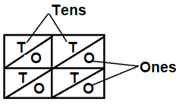**MULTIPICATION OF WNOLE NUMBERS USING LATTICE METHOD.**

**Note**



Or

**Examples**

Multiply 2 4 x 12 using lattice method.

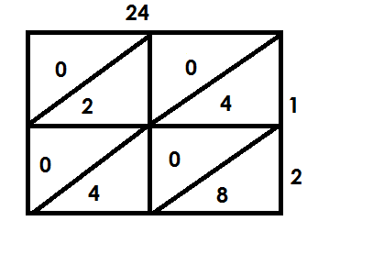 **Soln**



24 x 12 = 288

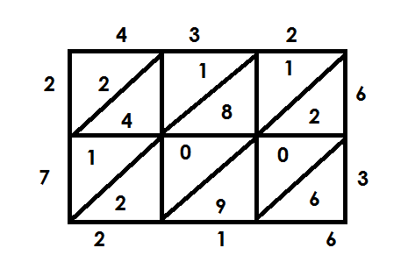2. Multiply 4 3 2 x 6 3 using lattice method.



432 x 63 = 27216

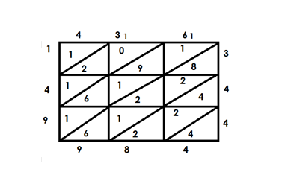3. Multiply: 4 3 6 x 3 4 4

 436 x 344 = 149984

**Activity.**

**Multiply the following using lattice method.**

1. 89 x 45

2. 75 x 25

3. 351 x 15

4. 349 x 23

5. 413 x 514

6. 565 x 204

**DIVISION OF WHOLE NUMBERS**

**a) Working of division using repeated subtraction.**

**Examples**

1. Work out 35 ÷ 5 using repeated subtraction

**Soln**

35 ÷ 5 3 5 - 5 = 30

30 - 5 = 25

25 - 5 = 20

20 - 5 = 15

15 - 5 = 10

10 - 5 = 5

5 - 5 = 0

35 ÷ 5 = 7

2. Work out 49 ÷ 7 using subtraction.

**Soln**

49 ÷ 7 49 - 7 = 42

42 - 7 = 35

35 - 7 = 28

28 - 7 = 21

21 - 7 = 14

14 - 7 = 7

7 - 7 = 0

49 ÷ 7 = 7

3. Simplify 63 ÷ 7 using repeated subtraction.

**Soln**

63 ÷ 7 = 63 - 7 = 56 14 - 7 = 7

56 - 7 = 49 7 – 7 = 0

49 - 7 = 42

42 – 7 = 35 9 times

 35 – 7 = 28

28 – 7 = 21 63 ÷ 7 = 9

21 – 7 = 14

**Activity**

Work out the following using repeated subtraction.

(a) 72 ÷ 9

(b) 16 ÷ 4

(c) 32 ÷ 8

(d) 30 ÷ 5

(e) 54 ÷ 9

(f) 81 ÷ 9

(g) 100 ÷ 20

**b) Division of numbers using long division**

**Examples**

Divide 3 9

Soln

3 9

3

3 9

3 x 3 - 9

 0

9 ÷ 3 = 3

**Example II**

Divide 18 ÷ 2

**Soln**

0 9 1 ÷ 2 = 0

2 1 8 18 ÷ 2 = 9

0 x 2 = 0

1 8

9 x 2 = - 1 8

 0 0

18 ÷ 2 = 9

**Example III**

3. Divide 144 ÷ 3

1 ÷ 3 = 0

0 4 8 14 ÷ 3 = 4

3 1 4 4 24 ÷ 3 = 8

0 x 3 -0

1 4

4 x 3 = 1 2

2 4

 8 x 3 = - 2 4

144 ÷ 3 = 48

4. Divide 864 ÷ 6

144

6 8 6 4 8 ÷ 6 = 1

1 x 6 = 6 26 ÷ 6 = 4

2 6

4 x 6 = 2 4 24 ÷ 6 = 4

* 2 4

4 x 6 = - 2 4

0 0

**Activity 1**

Divide the numbers below using long division

1. 24 ÷ 3

2. 48 ÷ 2

3. 15 ÷ 3

4. 72 ÷ 4

5. 144 ÷ 2

6. 400 ÷ 4

7. 1250 ÷ 5

**Activity 2**

Divide the following

1. 8 3648 6. 6 7268

2. 6 5664

3. 7 6538

4. 6 2718

5. 6 1446

**More on division of numbers**

**Examples**

1. Divide 2466 ÷ 9

Soln

0 2 7 4 2 ÷ 9 = 0

9 2 4 6 6 24 ÷ 9 = 2

0 x 9 = - 0 68 ÷ 9 = 7

2 4

2 x 9 = 1 8 36 ÷ 9 = 4

6 6

7 x 9 = 6 3

3 6

4 x 9 = - 3 6

0 0

2466 ÷ 9 = 27

**Examples**

2. Work out: 2384 ÷ 8

**Soln**

0 2 9 8

8 2 3 8 4 2 ÷ 8 = 0

0 x 8 = 0

2 3 23 ÷ 8 = 2

2 x 8 = - 1 6

7 8 78 ÷ 8 = 9

9 x 8= - 7 2

6 4 64 ÷ 8 = 8

8 x 8 = - 6 4

0 0

2384 ÷ 8 = 298

**Activity**

Divide the following using long division

1. 4578 ÷ 7

2. 5523 ÷ 7

3. 3941 ÷ 7

4. 7268÷ 7

**DIVISION BY MULTIPLES OF 10**

**Examples**

1. Divide 2460 ÷ 10

**Soln**

2460

10

= 246

2. Divide 7630 ÷ 10

**Soln**

7630

10

= 763

3. Divide 6200 ÷ 20

6200 ÷ 20

620 ÷ 2

3 1 0

2 6 2 0

3 x 2 = 6

0 2

1 x 2 = - 2

0 0

0 x 2 = - 0 0



6200 ÷ 20 = 310

**Activity**

**Work out**

1) 840 ÷ 10 2) 600 ÷ 30

3) 1440 ÷ 4 4) 1920 ÷ 80

**MORE ON DIVISON OF NUMBERS**

Division by a two-digit number without a remainder.

**Examples**

1. Divide 1845 by 15

**Soln**

1845 ÷ 15

0 1 2 1

15 1 8 1 5

0 x 15 = - 0

1 8

1 5

3 1

2 x 15 = - 3 0

1 5

1 x 15 1 5

0 0

1815 ÷ 15 = 121

2. A lorry carries 25 pieces of timber. How many times will it use to carry 800 pieces of timber?

800 ÷ 25 80 ÷ 25 = 3

0 3 2 50 ÷ 25 = 2

25 8 0 0

0 x 25 = - 0

8 0

3 x 25 = - 7 5

5 0

2 x 25 = - 5 0

 0 0

The lorry will use 32 times.

**Activity**

a. 6384 ÷ 14

b. 6840 ÷ 45

c. 7370 ÷ 22

d. 4428 ÷ 36

e. 6840 ÷ 45

f. A carpenter uses 18nails to make I chair. How many chairs will be using 594 nails?

g. A story book of 6500 words has different stories of 50 words each. How many stories are in that story book?

h. One book contains 36 papers. How many such books will be made using 2880 papers?

**MIXED OPERATION ON WHOLE NUMBERS.**

**A)** **ADDITION AND SUBTRACTION**

**Note:** Re-arrange to add first

**Examples**

1. Workout 2 – 5 + 9

(2 + 9) – 8

= 11 - 5

= 6

2. Workout: 4 – 6 + 9

(4 + 9) – 6

= 13 - 6

= 7

3. **Work out** 150 – 180 + 400

( 150 + 400) – 180

1 5 0

+ 4 0 0

5 5 0

= 550 – 180

= 370

**Activity**

**Workout the following**

1. 5 – 8 + 9

2. 2 + 9 – 3

3. 9 – 15 + 6

4. 6 – 10 + 7

5. 32 – 40 + 18

6. 24 + 30 – 40

7. 82 – 98 + 35

8. 66 – 80 + 42

9. 80 + 115 – 95

B. **USES OF BODMAS**

**AID TO MEMORY**

When given questions consisting of 2 or more operation, follow **BODMAS**

Brackets (B)

Of (O)

Divide (D)

Multiply (M)

Add (A)

Subtraction (S)

**Examples**

1. Simplify: 5 + 3 x 10

**Soln**

BODMAS

5 + 3 x 10

= 5 + (3 x 10)

= 5 + 30

= 35

2. Simplify: 5 x 12 ÷ 4

**Soln**

BODMAS

5 x 12 ÷ 4

= 5 X (12 ÷4)

= 5 X 3

= 15

3. Work out: 18 – (4 x 3) ÷ 6

Soln

BODMAS

18 – 4 x (9 ÷ 3)

18 – (4 x 3)

18 – 12

6

4. Work out 16 ÷ 4 x 3

(16 ÷ 4) x3)

4 x 3

12

**Activity**

Work out the following

1. 8 + 4 x 5

2. 33 x 2 + 12 ÷ 12

3. of 10 + 15 ÷ 3

4. 14 x 3 – 16

5. (8 – 5) – (3 x 2) + (2 x 2)

6. of 10 + 15 ÷ 5

7. (24 + 16) ÷ 5

8. (8 – 5) – 3 x 2 + (2 x 2)

9. 40 ÷ 8 + 2 – 3

10. 18 – (3 x 8) ÷ 6

**COMPARING AVERAGE AND TOTAL**

**Example I**

The average weight of 2 bags is 8kg. Find their total weight.

**Soln**

**Total**  = Average x number of items

= 2 x 8kg

= 16kg

**Example II**

The average age of 2 women is 40years. Find their total age.

**Soln**

Total = Average x number of items

= 40 x 2

= 80 years

**Activity**

1. The average weight of 2 girls is 40kg find their total weight.

2. The mean age of 6 pupils is 10 years. What is their total age?

3. The average of 12 numbers is 45. Find the total of the 12 numbers.

4. When a box of pencils was shared among 7 pupils each pupil got 3 pencils.

How many pencils were in the box?

5. The average score of Opio marks in 4 subjects is 76. What is his total marks?

6. There is an average of 36 pupils in a class if there are 12 classes, how many pupils are in the chair?

**BASES**

A base is a counting system where a particular counting number is taken to be a limit of its counting system.

**Examples of bases**

1. Binary bases - Base two
2. Ternary bases - Base three
3. Quaternary bases - Base four
4. Quinary bases - Base five
5. Senary bases - Base six
6. Septanary bases - Base seven
7. Octal bases - Base eight
8. Nonary bases - Base nine
9. Denary/decimal /nature base - Base ten

**GROUPING IN BASE FIVE**

**Example 1**

Group the following in five and write down their number in base five.

(i) 3

3 = 3 ones = 3five

(ii)8 = 1 group of five, 3 ones = 13five

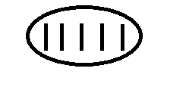

(iii) 16 = 3groups of fives, I ones = 31 fives



(iv) 28

28 = 1 group of five fives,3 ones =103five



(v) 37

37 = 1 group of five fives, 2 groups of fives 2 ones =121 five



**Activity**

1. Group the following numbers in base five

(a) 4 (b) 7 (c) 17 (d) 29 (e) 42

**PLACE VALUE OF BASES**

Examples

Find the place value of each digits in 123five.

**FF F 0**

1 2 3

Ones

Fives

Five fives

**Examples II**

Write the place value of each digit in 1101two

1 1 1 0 1 two

Ones

twos

Two twos

Two two twos

Two two two twos

**Example III**

What is the place value of each digit in 1211three

**Soln**

1 2 1 1three

Ones

Threes

Three threes

Three three threes

**Examples**

Write the place value of the underlined digits in 1 2 4 11

Five fives

Five fivefive fives

**Activity**

1. Find the place value of each digit.

(a) 4five (b) 132five (c) 1234 fives

2. Find the place value of each digits

(a) 10two (b) 101two (c) 101two

3. Find the place value of each digit

(a) 12 three (b) 202three (c) 1202three

4. Write the place value of the underlined digits.

(a) 1 2 4five (b) 1 0 1 two (c) 2 1 1 2 three

5. What is the place value of 4 in 2401five.

**WRITING BASES IN WORDS**

**Examples I**

1. 123five One two three base five.

**Example II**

4132five four one three two base five.

**Example III**

101 two One zero one base two.

2102three Two one zero two base three

**Activity**

Write the following numbers in words.

(a)43five (b) 123five

(c) 2142five (d) 1011two

(e)201three (f) 1010 two

(g)2102three (h)4232five

**EXPANDING BASES USING VALUES**

**Examples**

1. Expand 32five using values.

|  |  |
| --- | --- |
| 3 | 2 |
| 51 | 50 |

 (3 x 5 1) + (2 x 5 0)

(3 x 5) + (2 x 1)   
 15 + 2

2. Expand 124five using values.

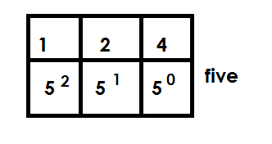1 2 4 five

(1 x 5 **2**) + (2 x 5 **1**) + (4 x 5 **0**)

(1 x 5 x 5) + (2 x 5) + (4 x 1)

25 t 10 + 4

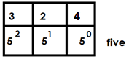3. Expand 324five using values.

324five

(3 x 52) + (2 x 5 1) + (4 x 5 0)

(3 x 5 x 5) + (2 x 5) + (4 x 1)

(3 x 25) + 10 + 4

75 + 10 + 4

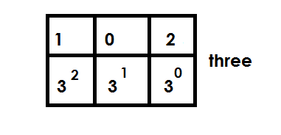4. Expand 102three using values

102three =

(1 x 32) + (0 x 31) + (2 x 30)

(1 x 3 x 3) + (0 x 3) + (2 x 1)

9 + 0 + 2

**Activity**

Expand the following using values.

(a) 43five (b) 123five (c) 432five

(d) 104five  (e) 101 three (f) 102 three

**EXPANDING BASES USING POWERS/ EXPONENTS/ INDICES**

**Examples**

Expand 403five using powers

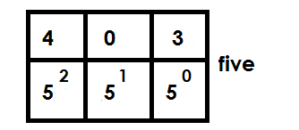**Soln**

403five =

(4 x 52) + (0 x 5 1) + (3 x 50)

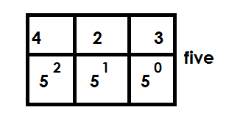Expand the following using powers.

(a) 423five =

(4 x 5 2) + (2 x 51) + (3 x 5 0)

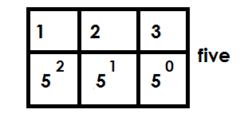(b) 123 five

123five =

(1 x 52) + ( 2 x 5 1) + ( 3 x 50)

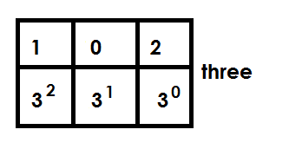(c) 102 three

102three =

( 1 x 3 2) + ( 0 x 3 1) + ( 2 x 30)

**Activity**

1. Expand the following using p

(a) 124five (b) 243 five (c) 423 five

(d) 104 five (e) 103 four

2. Expand 403 using exponents

**EXPANDING BASES USING PLACE VALUES**

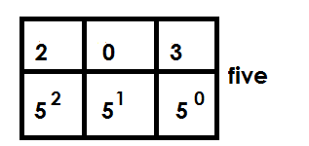**1.** Expand 203five using powers.

(2 x 5 2) + (0 x 51) + (3 x 50)

(2 x 5 x 5) + (0 x 5) + (3 x 1)

2. Expand 403 five using place values.

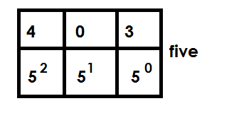

(4 x 5 2) + (0 x 51) + (3 x 50)

(4 x 5 x 5) + (0 x 5) + (3 x 1)

3. Expand 123five using place values

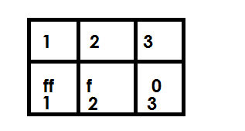

(1 x 5 x 5) + (2 x 5) + (3 x 1)

**Activity**

Expand the following using place values.

(a)23five  (b) 203five

(c) 101two (d) 432five

(d) 104five  (e) 121three

**CHANGING NON-DECIMAL BASES TO BASE TEN (DECIMAL BASE)**

**Examples.**

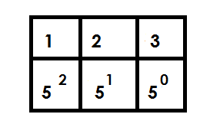1. Convert 123five to base ten.

123five =

(1 x 5 2) + (2 x 51) + (3 x 50)

(2 x 5 x 5) + (2 x 5) + (3 x1)

25 + 10 + 3

38ten

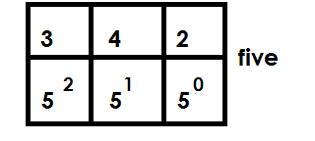2. Convert 342five to base ten

(3 x 52) + (4 x 51) + (2 x 50)

(3 x 5 x 5) + (4 x 5) + (2 x 1)

75 + 20 + 2

97 ten

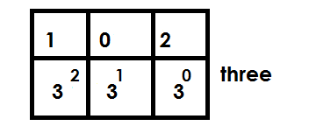3. Convert 102three to base ten

(1 x 32) + (0 x 31) + (2 x 30)

(1 x 3 x 3) + (0 x 3) + (2 x 1)

9 + 0 + 2

11 ten

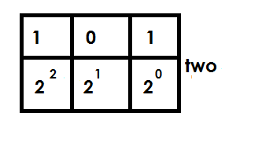4. Convert 101 two to base ten

(1 x 22) + (0 x 21) + (1 x 20)

(1 x 2 x 2) + (0 x 2) + (1 x 1)

4 + 0 + 1

5 ten

**Activity**

1. Convert 23five to base ten.

2. Convert 420five to decimal base.

3. Convert 123five to base ten.

4. Convert 403five to base ten.

5. Convert the following bases to base ten.

(a) 304five (b) 424five  (c) 102three (d) 202 three (e) 111two

**CHANGING FROM BASE TEN TO OTHER BASE**

**Note:**

Factorise using the required base.

**Examples.**

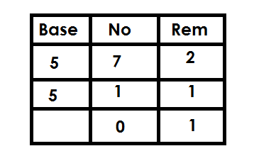1. Change 7ten to base five.

7 ten = 12 five

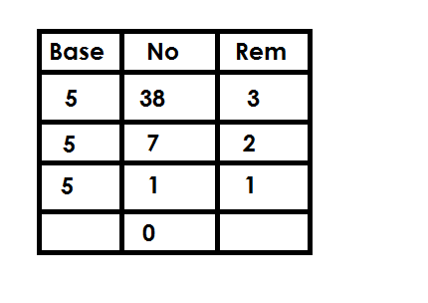2. Convert 38ten to base five

38 ten = 123five

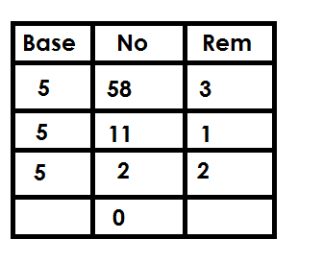3. Convert 58ten to base five

58ten = 213 five

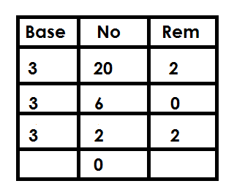4. Convert 20ten to base three

20 ten = 202 three

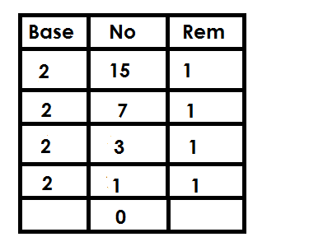5. Convert 15ten to base two.

15ten = 1111two

**Activity**

1. Convert 9ten to base five.

2. Convert the following to base five.

(a) 25ten (b) 30ten (c) 29ten

(d) 42 ten (e) 55ten

3. Convert 30ten to base three

4. Convert 20 ten to base two.

**ADDITION OF BASE NUMBERS**

**Example I**

Add: 1 2 3five

+ 1 1five

1 3 4five

**Example II**

Add: 1 4 2 five 6 ÷ 5 = 1 rem 1

+ 2 1 five

2 1 3 five

**Example III**

Add : 1 4 2 3 five 5 ÷ 5 = 1 rem 0

+ 2 1 2five 6 ÷ 5 = 1 rem 1

1 1 4 0 five

**Example IV**

Add: 1 0 2 three 4 ÷ 3 = 1 rem 1

+ 1 2 three

1 2 1 three

**Example V**

Add : 1 1 0 1 two 2 ÷ 2 = 1 rem 0

+ 1 1 1 two 2 ÷ 2 = 1 rem 0

1 1 0 0 two  3 ÷ 2 = 1 rem 1

**Example VI**

Add: 1 0 2 three 3 ÷ 3 = 1 rem 0

+ 1 1 1 three

2 1 0 three

**Activity**

1. Add: 1 2 3 five 2. Add: 2 4 3 five

+ 3 1 five + 2 4 five

3. Add: 4 0 3 five 4. Add: 4 4 0 five

+ 1 2five + 4 3 five

5. Add: 1 1 1 two 6. Add: 2 0 1 three

+ 1 1 1 two + 1 0 2 three

7. Add: 1 2 2 three

+ 2 1 1 three

**SUBTRACTION OF BASES**

**Note**: The one regrouped is worth the value of the base.

**Example I**

**3 5**

**Subtract**  4 0 2 five

- 1 1 five

3 4 1 five

**Example Il**

**1 4 5+**

Subtract: 2 0 1 five

- 4 2 five

1 0 4 five

**Example IIl**

**5 5+0 (5 +)**

Subtract 3 1 2 five

- 1 2 3 five

1 3 4 five

**Example IV**

**0 5+**

Subtract 1 2 4 five

- 4 3 five

3 1 five

**Example V**

**0 2**

Subtract: 1 1 0 two

- 1 0 1 two

0 0 1 two

**Example VI**

**0 0 2**

Subtract: 1 1 0 1 two

- 1 1 1 two

1 1 0 two

**Example VII**

**1 3**

Subtract: 2 0 2 three

-1 2 1 three

1 1 three

**Activity**

1. Subtract 1 2 3 five 2. Subtract 4 0 2 five

- 1 2 five - 1 2 five

3. Subtract 4 1 3 five 4. Subtract 3 2 4 five

- 3 1 4 five  - 1 4 2 five

4. Subtract: 3 2 4 five 5. Subtract 4 0 1 five

- 1 4 2 five -1 2 3 five

6. Subtract 2 0 1 three 7. Subtract 1 2 0 three

- 1 2 1 three - 1 0 1 three

8. Subtract 1 0 1 two

- 1 1 two

**MULTIPLICATION OF BASES**

**Example I**

1. Multiply: 2 five x 3

3 five 6 ÷ 5 = 1 rem 1

X 2 five

1 1 five

2. Multiply: 4 2 1 five x 2

4 2 1 five 2 x 1 = 2

X 2 8 ÷ 5 = 1 rem 3

1 3 4 2 five

3. Multiply: 40 five x 3

2 4 0 five 12 ÷ 5 = 2 rem 2

X 3

2 2 0 five

4. **Example IV**

1 2 three x 2 4 ÷ 3 = 1 rem 1

1 1 2 three 3 ÷ 3 = 1 rem 0

X 2 three

1 0 1 three

**Activity**

1. Multiply: 4five x 3

2. Work out 12five x 4

3. Work out 21five x 3

4. 121five x 3

5. 321five x 2

6. 113five x 3

7. Multiply: 21 three x 2

**FINITE SYSTEM**

Is a way of expressing numbers as remainders.

**Counting in finite system**

**Examples**

1. Express 11 in finite 5

**Soln**

11 = 2 r 1

5

11 = 1 (finite 5)

2. Write 17 in finite 5

**Soln**

17 ÷ 5 = 3 rem 2

17 = 2 (finite 5)

3. Change 9 to finite 7

**Soln**

9 ÷ 7 = 1 rem 2

9 = 2 (finite 7)

4. Express 23 in finite 8.

**Soln**

23 ÷ 8 = 2 rem 7

23 = 7 (finite 8)

5. Write 32 in finite 8

**Soln**

32 ÷ 4 = 4 rem o

32 = 0 (finite 8)

**Activity**

1. Express the following in finite 5

(a) 9

(b) 5

(c) 13

(d) 19

(e) 20

2. Change the following to finite 7

(a) 22

(b) 33

(c) 8

(d) 53

(e) 49

3. Write the following in finite 8.

(a) 14

(b) 16

(c) 26

(d) 38

(e) 47

**ADDITION IN FINITE USING ADAIL**

1. Add: 3 + 4 = (finite 5) using a dail.

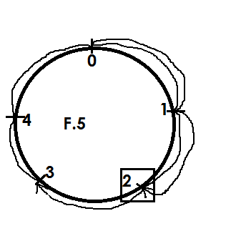



3 + 4 = 2 (finite 5)

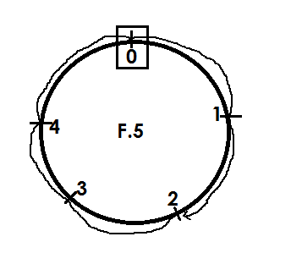2. Using a dail, add: 2 + 3 = (finite 5 )



2 + 3 = 0 (finite 5)

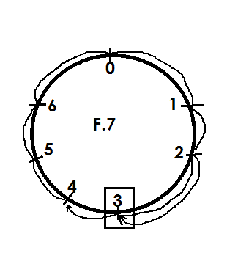3. Work out 4 + 6 = (finite 7)

Soln



4 + 6 = 3 (finite 7 )

4. Using a dail, work out: 3 + 4 = (finite 8)

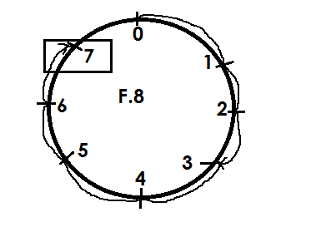



3 + 4 = 7 (finite 8)

**Activity**

Using a dail, add the following.

1. 2 + 1 = (finite 5)
2. 4 + 2 = (finite 5)
3. 5 + 4 = (finite 7)
4. 2 + 3 = (finite 7)
5. 3 + 5 = (finite 7)
6. 6 + 5 = (finite 7 )
7. 4 + 3 = (finite 8)
8. 5 + 3 = (finite 8)
9. 7 + 4 = (finite 8)

**ADDITION IN FINITE WITHOUT USING A DAIL**

**Note**:

When the sum obtained is less than the given finite, maintain the sum as the answer without dividing by the finite.

**Example I**

Add: 4 + 3 = (finite 5)

Soln

4 + 3 = (finite 5)

7 ÷ 5 = 1 rem 2

Therefore 4 + 3 = 2 ( finite 5)

**Example II**

Add : 2 + 4 = (finite 7)

2 + 4 = 6 ( finite 7)

**Example**

Work out: 2 + 1 + 6 = (mod 7)

2 + 1 + 6 = _______ (mod 7)

9 = 1 rem 2

7

2 + 1 + 6 = 2 ( mod 7)

**Activity**

1. **Add the following**

(a) 1 + 1 = (finite 5)

(b) 2 + 3 = (finite 5)

(c) 5 + 4 = ( finite 7)

(d) 3 + 4 = (finite 5)

(e) 6 + 6 = (finite 7)

(f) 4 + 2 = (finite 5)

(g) 2 + 3 + 4 = (finite 6)

(h) 6 + 5 + 1 = (finite 12)

(i) 4 + 3 + 5 = (finite 8)

**SUBTRACT INFINITE USING ADAIL**

**Example I**

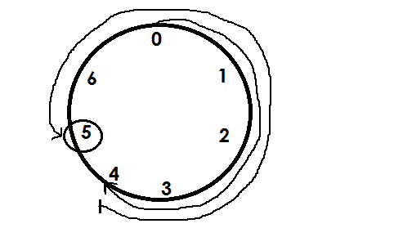Work out: 4 – 6 = (mod 7)



4 - 6 = 5 ( mod 7)

**Example 2**

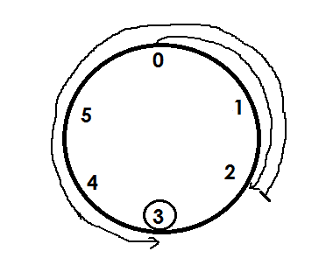Subtract: 2 – 4 = (finite 5)



2 - 4 = 3 finite 5.

**Activity**

1. Workout the following using a dail.

(a) 2 - 4 = (mod 6)

(b) 4 - 7 = (finite 12)

(c) 3 – 5 = (mod 7)

(d) 5 – 8 = (mod 9)

(e) 1 - 4 = (mod 4)

(f) 2 – 3 = (mod 5)

(g) 1 - 4 = (finite 6)

(h) 5 – 7 = (finite 8)

**NUMBER PATTERNS AND SEQUENCE**

**DIVISIBILITY TEST**

**(A)** **Divisibility test for 2**.

Note: A number is divisible by two when

1. It is on even number.
2. Its last digit is even **i.e.,** ending with either 0, 2, 4, 6, 8.

**Examples**

Which of the following numbers is divisible by 2?

(i) 30 even ends with 0.

(ii) 35 Not even ends with 5.

(iii) 49 Not divisible. (odd)

**Activity**

1. Without dividing, which of the following numbers is exactly divisible by 2?

(a) 10 15 22 27 30

(b) 235 78092 3476 2227 100

(c) 86420 24683 135794 97681 425368

**(B) Divisibility test for three**

A number is divisible by 3 if the sum of its digits is divisible by 3 or is a multiple of 3.

**Examples**

1. Without dividing, show that 144 is divisible by 3.

Sum of its digits

144 = 1 + 4 + 4

= 9

9 is a multiple of 3

144 is divisible by 3

2. Show that 1263 is divisible by 3.

Sum of its digits

1 2 6 3 = 1 + 2 + 6 + 3

= 12

12 is a multiple of 3

1 2 6 3 is divisible by 3.

**Activity**

Without dividing show that the following numbers are

(a) 27 (b) 309 (c) 435

**DIVISIBILITY TEST FOR FIVE**

A number is divisible by 5 if the last digit either 0 or 5.

**Example**

320 20 350 3545 are divisible by 5.

**Activity**

Which of the following numbers are divisible by five?

(a) 35 (b) 37 (c) 495 (d) 100,500 (e) 397657

**FINDING LOWEST COMMON MULTIPLE NUMBERS (L.C.M) L.C.D**

A multiple is a product of any two numbers.

A multiple is a number got after multiplying a given number by counting number.

**Review finding multiples of numbers.**

**Example 1**

Find the LCM of 12 and 18.

**Soln**

M12 = {12, 24, 36, 48, 60, …}

M18 = {18, 36, 54, 72, …}

LCM = 36

**Example II**

Find the LCM of 18 and 24.

**Soln**

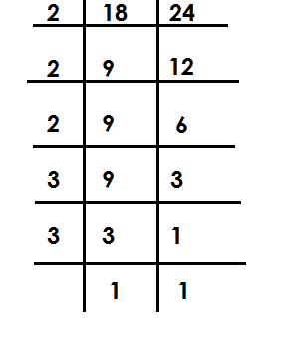

LCM = 2 x 2 x 2 x 3 x 3

= 72

**Example III**

What is the LCM of 20 and 18?

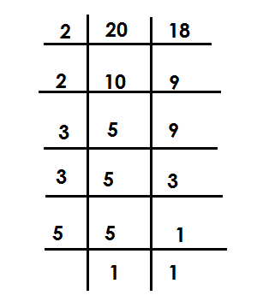 **Soln**

LCM = 2 x 2 x 3 x 5

= 180

Example III

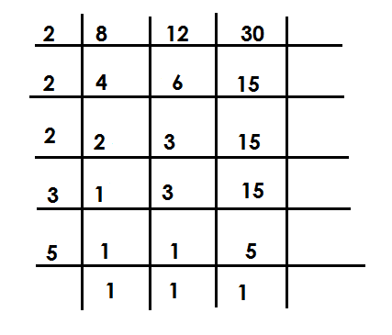Find the LCM of 8 , 12 and 30.

Factorise / divide the three number

using their prime factors.

LCM = 2 x 2 x 2 x 3 x 5

= 120

**Activity**

Find the LCM of the following numbers

1. 8 and 16 7. 60 and 45

2. 12 and 15 8. 9, 12 and 24

3. 9 and 12 9. 12,15 and 20

4. 15 and 24 10. 24, 18 and 30.

5. 30 and 24

6. 32 and 24

**GREATEST COMMON FACTORS**

-A factor is a number that divides a given number exactly.

-GCF is the largest number that can divide the given number exactly.

**FINDING GREATEST COMMON FACTORS (G.C.F / H.C.F / G.C.D)**

**Examples**

Find the GCF of 12 and 18

**Soln**

F12 = { 1 , 2 , 3 , 4 , 6 , 12}

F18 = { 1 , 2 , 3 , 6 , 9 , 18}

GCF = 6

**Example II**

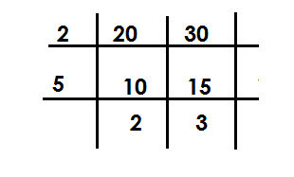Find the GCF of 20 and 30.

Factorise using the numbers that can divide

the given two numbers exactly

GCF = 3 x 5

= 10

**Example III**

Work out the GCF 9 and 12.

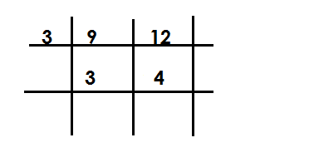**Soln**

GCF = 3

**Example IV**

Find the the LCF of 12 and 8.

**Soln**

**Note:**

**The lowest common factor of any given number is 1.**

F12 = { 1 , 2 , 3 , 4 , 6 , 12 }

F8  = { 1 , 2 , 4 , 8 }

LCF = 1

**Activity**

1. Find the GCF of each pair of numbers.

(a) 12 and 18 (b) 12 and 24 (c)24 and 36 (d) 9 and 21

(e) 34 and 12 (f) 40 and 30 (g) 72 and 96 (h) 33 and 44

(i) 49 and 63

2. Find the L.C.F of (i) 6 and 9

(ii) 12 and 15

(iii) 14 and 21

**TYPES OF NUMBERS**

**WHOLE NUMBERS**

(a) These are positive integers include zero (0).

(b) These are numbers that are not fractions. The first whole number is zero (0)

Examples

{0, 1, 2, 3, 4, 5, 6, 7, 8, ---}

**COUNTING /NATURAL NUMBERS**

These are numbers that show concrete quantity of things

**Note**:

The first counting number is 1

Examples {1, 2, 3, 4, 5, 6, 7 …)

Counting numbers have a pattern of +1 and -1 in ascending and descending orders respectively.

**EVEN NUMBERS**

These are numbers that can be exactly divisible by two. The first even number is zero (0). Example {0, 2, 4, 6, 8, ---}

Even numbers have a pattern of +2 and -2 in ascending and descending orders respectively.

**ODD NUMBERS**

These are numbers when divided by two, give a remainder 1.

The first odd number is one (1)

**Example** {1, 2, 3, 7, 9, …}

Odd numbers have a pattern of +2 and -2 in ascending and descending orders respectively.

**PRIME NUMBERS**

These are numbers with only two factors i.e., one and itself.

The first prime number is 2.

**Note**:

These number have no clear pattern.

Examples {2, 3, 5, 7, 11, 13, 17, …)

**COMPOSITE NUMBERS**

These are numbers with more than two factors.

The first composite number is 4

Examples {4, 6, 8, 9, 10, 12, 14, 15, …)

**TRIANGULAR NUMBERS**

These are numbers got by adding consecutive counting numbers.

The first triangle number is I

Example {1, 3, 6, 10, 15, 21, …}

**FINDING TRIANGULAR NUMBERS**

**Example I**

Find the 3rd triangle number.

**Soln**

3rd No. = 1 + 2 + 3

= 6

**Example II**

What is the 5th triangular number?

**Soln**

5th No. = 1 + 2 + 3 + 4 + 5

= 15

**Example III**

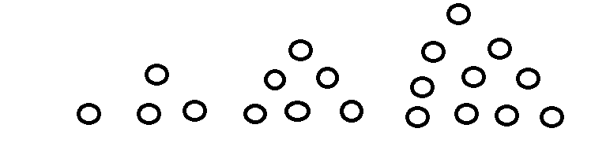Complete the sequence

**Activity**

1. Find the 4th triangular number.

2. What is the sum of the 2nd and 5th triangular number.

3. Find the sum of the next two numbers in the sequence.

1, 3, 6, 10, 15, ________, _______

4. Find the product of the next two numbers in the sequence.

55, 45, 36, 28, _______, ________

**PRIME NUMBERS AND PRIME FACTORISATRION**

**PRIME FACTORISATION**

This is the writing of a number as a product of its prime factors.

Prime factors of a number are represented in two ways;

1. Multiplication form/ Power form
2. Subscript / Set notation form.

**Prime factorising number.**

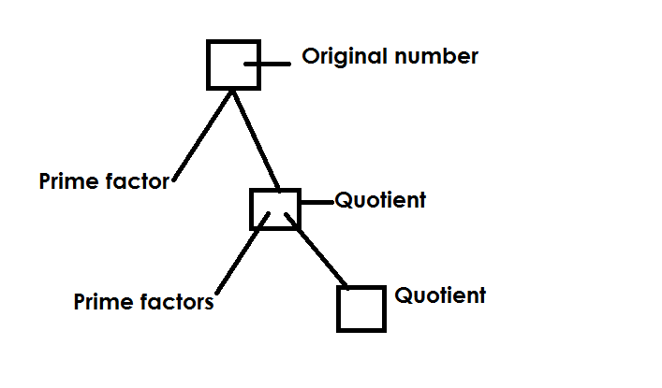**a) Using a factor tree**

**Example I**

Prime factorise 24 and represent the prime factors in

1. Multiplication form
2. Set notation form

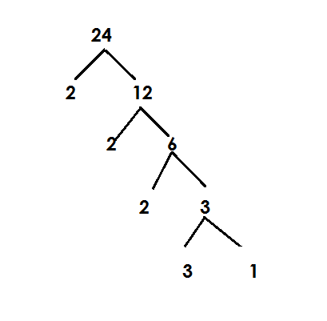 **Soln**

(i) Multiplication form

F12 = 2 x 2 x 2 x 3

Power form / super script form

F24 = (2 x 2 x 2) x 3

= 23 x 31

Set notation / subscript form

F24 = {21, 22, 23, 31}

**Example II**

Prime factorise 72

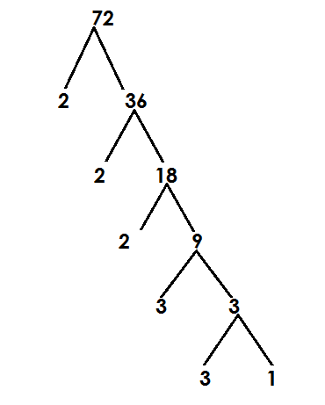(a) Giving your answer in multiplication form.

F72 = 2 x 2 x 2 x 3 x 3

(b) Give your answer in set notation /sub script form.

F12 = (2 x 2 x 2) x (3 x 3)

= 23 x 32

(c) Give your answer in subscript form.

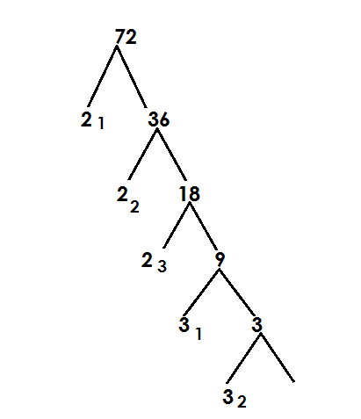

F12 = (21, 22, 23, 31, 32)

**b) Using ladder method**

**Examples**

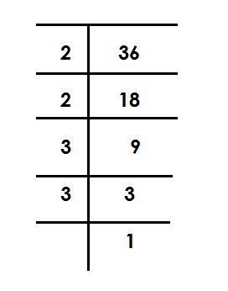1. Prime factorise 36

Multiplication form

= 2 x 2 x 3 x 3

Power form /superscript

= 2 x 2 x 3 x 3

= 22 x 32

Subscript form / set notation

F36 = {21, 22, 31, 32}

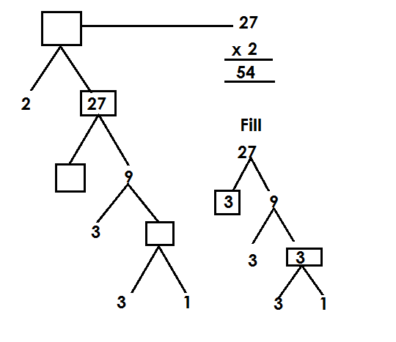2. Fill in the missing numbers

**Activity**

1. Prime factorise each of the following and show your answer in power form.

(a) 18 (b) 40 (c) 30 (d) 45

2. Prime factorise each of the following numbers using set notation/ subscripts.

(a) 10 (b) 20 (c) 60 (d) 49

3. Express the following numbers as a product of their prime factors.

(a) 15 (b) 90 (c) 120 (d) 100

4. Complete the factor tree below.

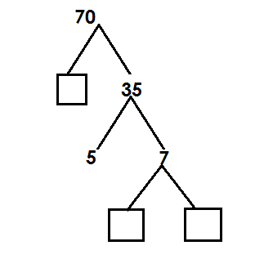

**FINDING THE PRIME FACTORISED NUMBER**

**Examples**

Find the number which is prime factor to give.

= {21, 22, 23, 31}

= (2 x 2) x (2 x 3)

= (4 x 6)

= 24

Find the number whose factorization is 2**2** x 3**2** x 5**1**

= (2 x 2) x (3 x 3) x 5

= 4 x 9 x 5

= 36 x 5

= 180

Which number was prime factorised to give 22 x 52?

= 22 x 52

= 2 x 2 x 5 x 5

= 100

**Activity**

Find the number whose prime factorization are given below.

1. {21, 22, 23)

2. {21, 22, 31, 32}

(c) (22 x 31)

(d) 21 x 32 x 51

(e) 72 x 51

(f) 24 x 31

**REPRESENTING PRIME FACTOR ON A VENN DIAGRAM**

**Examples**

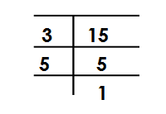Show prime factors of 12 and 15 on venn diagram

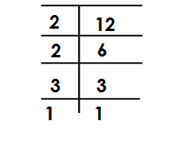 F12 = F15 =

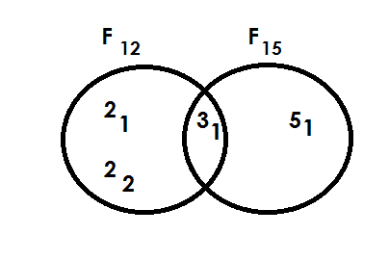 F12 = {21, 22, 31} F15 = {31, 51}

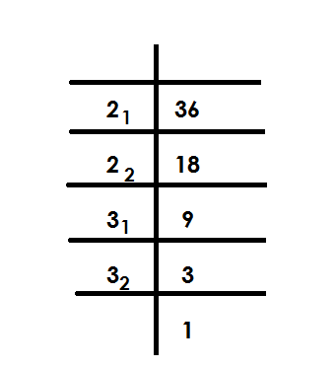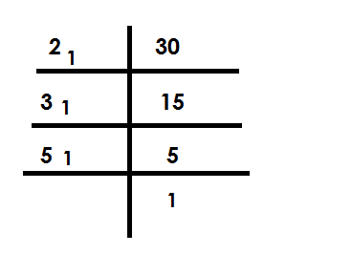Prime factorise 30 and 36 and represent them on a venn diagram.

PF30 = PF36 =

PF30 = {21, 31, 51,}

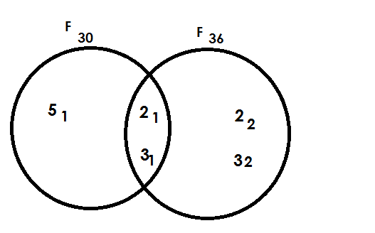

**Activity**

1. Draw venn diagram to represent the prime factors for the following pairs of numbers.

(a)24 and 30. (b)30 and 48 (c)18 and 20. (d) 15 and 20

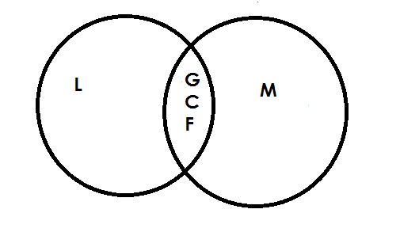 **Find LCM AND G.C.F from a Venn diagram.**

L.C.M = product of intersection

G.C.F = product of union

**Example I**

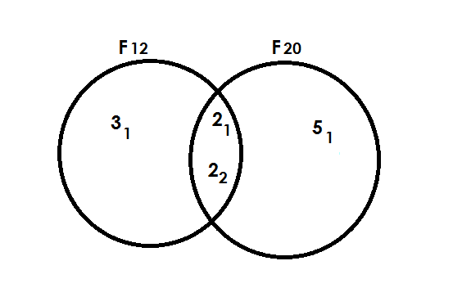Use the venn diagram below to answer question that follow.

Find the G.C.F of F12 and F20

G.C.F = Product of intersection

= 21 x 22

= 2 x 2

= 4

(ii) Find the L.C.M of F12 and F20

L.C.M = Product of union

= 31 x 21 x 22 x 51

= 3 x 2 x 3 x 5

= 6 x 10

= 60

(ii) Find the L.C.M of F12 and F20

L.C.M = Product of Union

= 31 x 21 x 22 x 5

= 3 x 2 x 2 x 5

= 6 x 10

= 60

**Activity**

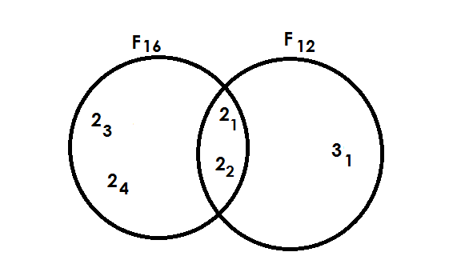1. Study the venn diagram and answer the questions that follow.

(i) Find (i) F16 n F12

(ii) The G.C.F of 16 and 12

(iii) F16 u F12

(iv) L.C.M of F16 and F12

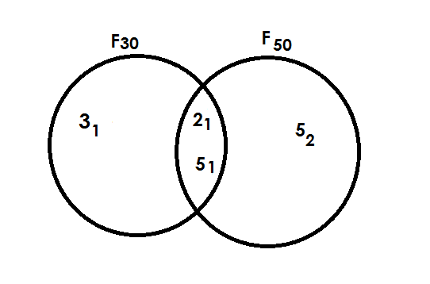2. Study the venn diagram and answer the questions that follow.

(a) Find the G.C.F of 30 and 50.

(b) Find the L.C.M of F30 and 50.

3. Study the venn diagram and answer the questions that follow.

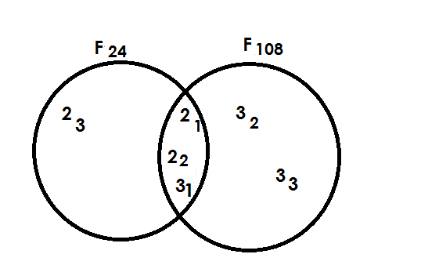

(i) Find F24n F108

(ii) Find the G.C.F of 24 and 108

(iii) Find the L.C.M of 24 and 108

**FINDING UNKNOWNS ON AVENN DIAGRAM**

**Example I**

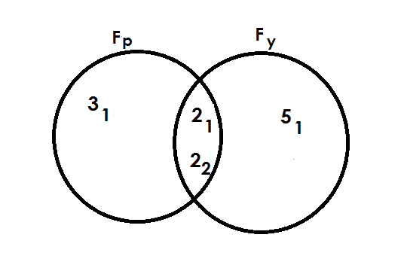1. Use the venn diagram below to answer questions.

Find the value of

(ii) P

P = 31 x 21 x 22

P = 3 x 2 x 2

= 12

(ii) y

Fy = 21 x 22 x 51

= 2 x 2 x 5

= 20

**Example II**

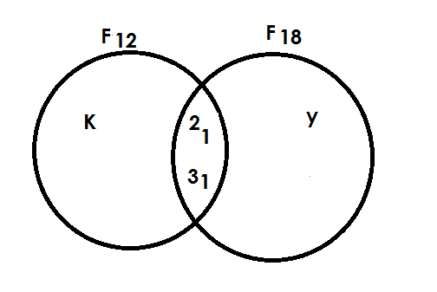2. The venn diagram below shows F12 and F18. Use it to answer question.

Find the value of K.

**Soln**

K + 21 x 31 = 12

K + 21 x 3 = 12

6K = 12

6 = 6

K = 22

Find the value of y.

y x 21 x 31 = 18

y x 21 x 31 = 18

6y = 18

6y = 18 3

6 6

y = 32

**Example III**

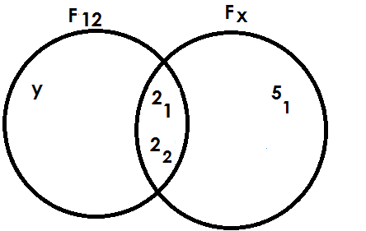3. Below is a venn diagram use I to answer questions.

Find the value of x

x = 21 x 22 x 51

= 2 x 2 x 5

= 20

Find the value of y

y x 21 x 22 = 12

y x 2 x 2 = 12

4y = 12

4y = 12 3

4

y = 31

**Activity**

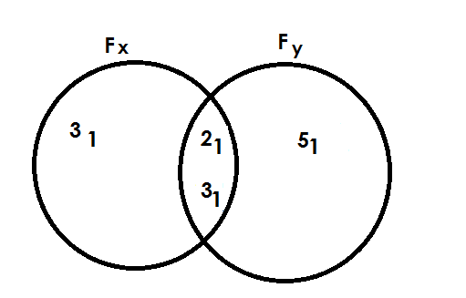1. Study the venn diagrams below and answer the questions.

(a) Find the value of (i) X

(ii) y

(b) Find the G.C.F of x and y.

(c) Find the L.C.M of x and y.

2. Study the venn diagrams below and answer the questions.

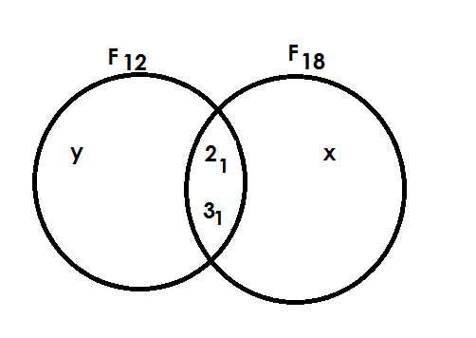

(a) Find the value of (i) X

(b) Find the G.C.F of 12 and 18.

(c) Find the L.C.M of 12 and 18.

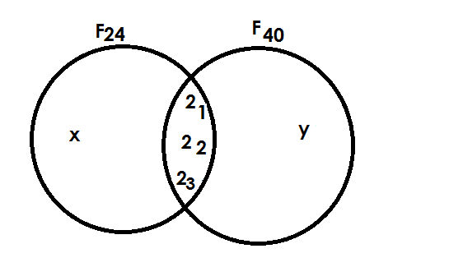3. Study the venn diagrams below and answer the questions.

(a) Find value of (i) m

(ii) n

(c) Find the G.C.F of Fm and 30

(d) Find the L.C.M of Fm and 30

**SQUARE NUMBERS**

Square number is a number got by multiplying a counting number itself twice.

e.g. 2 x 2 = 4

square

**FINDING SQUARE NUMBERS**

Find the square of 2

Soln

22 = 2 x 2

= 4

**Example II**

Find the square of 5

Soln

5**2** = 5 x 5

= 25

Example II

Find the square of n

n2 = n x n

= n2

**Activity**

Find the square of the following numbers.

(a) 6

(b) 7

(c) 8

(d) 10

(e) 12

(f) 13

**FINDING SQUARE ROOTS**

A square root is a number that was multiplied by itself to get a square.

e.g 4 x 4 = 16 square

 square root

A square root symbol is

**Note**:

In findind square root, the following is done;

* First introduce the square root symbol to the given number whose square root is needed.
* Prime factorise the given number.
* Pair the prime factors.
* Pick one factor from each pair.
* Multiply the picked prime factors if more than one. The product got will be the square root.

**Example I**

Find the square root 36.

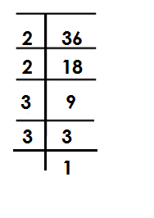

36 = (2 x 2) x (3 x 3)

= 2 x 3

= 6

**Example**

Find the square root of 49

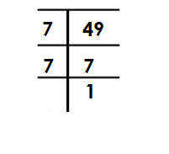 **Soln**

49 =

49 = (7 x 7)

49 = 7

**Example III**

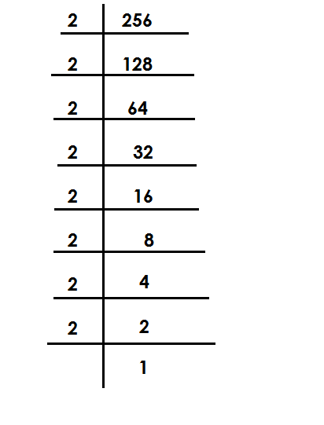Find the square root 256

256 =

256 = (2 x 2) x (2 x 2 ) x ( 2 x 2 ) x ( 2 x 2 )

= (2 x 2) x (2 x 2)

= 4 x 4

= 16

**Activity**

1. Find the square root of the following.

(a) 4

(b) 16

(c) 25

(d) 64

(e) 81

(f) 100

(g) 144

**Application of square root.**

1. What number was multiplied by itself to get 16.

Let the number be m

m x m = 16

m 2  = 16

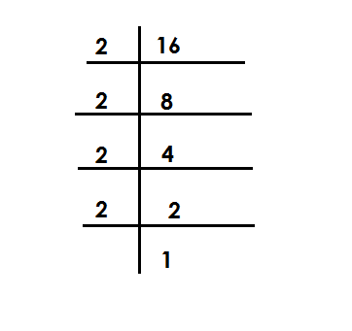 m x m =

m = (2 x 2) x (2 x 2)

m = 2 x 2

m = 4

**Example II**

The area of square is 64cm2. Find length of each side.

**Soln**

Let each side be n

n x n = 64

n2 = 64

n2 = 64

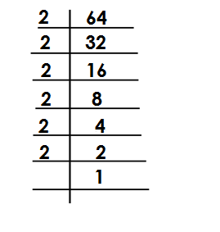

(n x n) =

n = (2 x 2) x (2 x 2 ) x (2 x 2)

n = 2 x 2 x 2

= 8cm

**Activity**

1. The area of a square is 36cm2. Find the length of side.

2. When a number is multiplied by itself the result is 144. Find the number.

3. Area of a square garden below is 400m2.

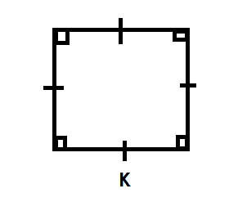

(a) Find the value of K.

(b) Find its perimeter.

4. Find the number that was multiplied by itself to give 81.

5. A square room has an area of 16m2. Find the distance around the room.

**FRACTIONS**

A fraction is part of a whole.

**REVIEW**

* Types of fractions
* Expressing improper fractions as mixed numbers.
* Expressing mixed numbers as improper fractions.
* Equivalent fractions.

**REDUCING FRACTIONS**

Fractions can be reduced using prime factors.

**Example 1**

Reduce 12

24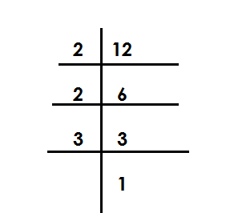

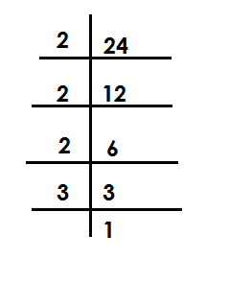 F12  = F24  =

12 = 2 x 2 x 3

24 2 x 2 x 2 x 3

= 1

2

**Example II**

Reduce 75 to its lowest terms.

100

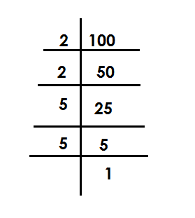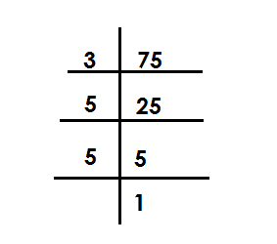 F12 = F100 =

75 = 3 x 5 x 5

100 2 x 2 x 5 x 5

=

**Example III**

Reduce 18 to its lowest terms.

24

**Note**:

Fractions can also be reduced by dividing both numerator and denominator by GCF.

18 = 18 ÷ 6 F18 = {1, 2, 3, 6, 18}

24 = 24 ÷ 6 F24 = {1, 2, 3, 4, 6, 8, 12, 24}

= 3

4

**Activity**

Reduce the following fractions to their lowest forms.

1) 2 2) 8 3) 6 4) 30 5) 32

4 12 18 90 56

6) 24 7) 21 8) 18

72 42 36

**ORDERING FRACTIONS**

**Note**:

- Ascending order means from smallest to biggest.

- Descending order means from biggest to smallest.

- Find the LCM of denominators and the multiply it by all fractions to get their value in whole form.

**Example I**

Arrange the following fractions in ascending order

1, 1, 1

3 2 4

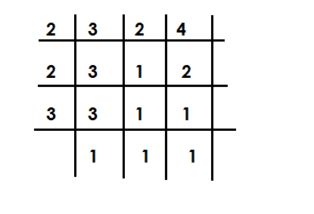 Soln

LCM =

= 2 x 2 x 3

= 12

1 1 1

3 2 4

4 5 3

1 x 12 1 x 10 1 x 12

3 2 4

4 5 3

Ascending order = 1, 1, 1

4 3 2

**Example II**

Arrange the following fraction in a descending order: 5, 7, 3

8 12 8

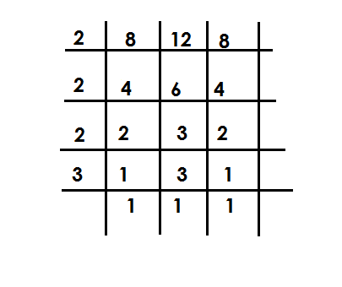 LCM =

LCM = 2 x 2 x 2 x 3

= 24

5 7 3

8 12 8

3 2 3

5 x 24 7 x 24 3 x 24

8 12 8

5 x 3 2 x 7 3 x 3

15 14 9

Descending order = 5 , 7 , 3

8 12 8

**Activity**

1. Arrange the following fractions in ascending order.

(a)  **, ,**

**(b) , ,**

(c) **, , ,**

**(d) , ,**

2) Arrange the following fractions in a desending order

(a)  **, ,**

**(b) , ,**

**(c) , ,**

**(d) , ,**

**ADDITION OF SIMPLE FRACTIONS**

**Note**:

All answers must be in their simplest forms i.e., either a simplifies proper fraction or a mixed number.

Examples Or

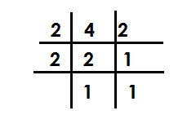Add:  **+**

LCM of the denominators =

= 1 x 2 + 1 x 4

2 x 2 = 4 4 x 2 2 x 4

1 + 1 ( x 12) + ( x 4) = 2 + 4

4 2 12 8 8

= ( 1 x 3 ) + ( 1 x 2) = 6 3

12 8 4

= 1 + 2 = 3 = 3

4 4 4

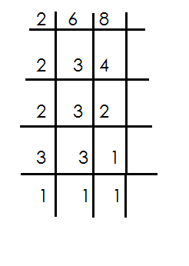**Example II**

Work out: + LCM =

4 3

5 + 3 = 5 x 24 + 3 x 24

6 8 6 8

= (5 x 4) + ( 3 x 3)

24

= 20 + 9

24 2 x 2 x 2 x 3

= 29 1 rem 5 = 24

24

= 1

**Activity**

Add the following fraction.

1.  **+**

2**.**

3. **+**

4. **+**

5. **+**

6. **+**

7. **+**

8. **+**

**ADDITION OF FRACTIONS TO WHOLE NUMBERS**

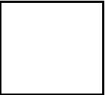Examples Example III

**Soln** Add 4 +

3 + 5 **Soln**

4

**Example** II 4 + ( + )

Workout 4

4 + 10 4 + ( x 8)

4 + 10 = (4 + 10) + 4 + (3 + 4)

= 14 + 8

= 14 4 +

4

**Activity**

Workout the following fractions

1. + 8 8. 6 +

2. 4 + 9 9. 1 +

3. 5 + 4

4. + 9

5. 10 + 2

6. 15 + 5

6. 15 + 5

7. 1 +

**ADDITION OF MIXED NUMBERS**

**Note**:

Change the mixed numbers to improper fraction.

Use the LCM approach to work out

**Example I**

Work out: 1 x 3 =(3 x 2) + (13 x 1) = 4

**Soln** 4

1 + 3 = + = 6 + 13

4

2 194 rem 3

= ( x 4) + ( x 4) 4

4

Work out : 1 + 1 + 1 LCM = 12

1 + 1 + 1 = + + = 49 4 rem 1

= 4

6 3 4

=( x 12) + ( x 12) + ( x 12)

12

= (3 x 6) + (5 x 3) + (4 x 4)

12

= 18 + 15 + 16

12

Work out : + 1 +

= + 1 + = + +

5 3

=( x 15) + ( x 15) + ( x 15)

15

=1 + 20 + 9

15

= 3 0 2

15

= 2

**Activity**

Workout the following

1. 3 + 4 7. 2 + 3 + 3

2. 4 + 2 8. 2 + 1 + 1

3. 1 + + 1 9. 3 + 2 +

4. 1 + + 10. + 1 + 4

5. + 5 +

**WORD PROBLEMS INVOLVING ADDITION OF FRACTIONS**

**Example I**

Tom read of the book on Monday and on Tuesday. Find the fraction of the book he read altogether.

Soln

5 2

+ = ( x 10) + ( x 10)

10

= ( 1 x 5 ) + ( 1 x 2 )

10

= 5 + 2

10

= 7

10

**Example II**

A teacher spent an hour giving examples, 1 for exercise and 1 for making. How long was the lesson?

+ 1 +

4 6 3

=( x 12) + ( x 12) + ( x 12)

=( 1 x 4) + ( 3 x 16) + ( 1 x 3)

= 4 + 18 + 3

12

= 25 2 rem 1

12

= 2 hrs

**Activity**

1. Mark filled of a tank with water in the morning and in the afternoon. Find the fraction of the tank that he filled with water.

2. James covered of the journey by bus and by taxi. What fraction of the journey did he cover?

3. Oluku gave 3 cakes to the son and to the daughter. How many cakes did he give out?

4. Mary had 1 sweets, Jane had 2 sweets and Rose had of a sweet. How many sweets did they have altogether?

5. of the wire is painted red, white and blue. How long is the wire?

6. of the land is for grazing, for planting crops and for construction. Find the size of the whole land.

**SUBTRACTION OF SIMPLE FRACTIONS**

**Examples**

Simplify: -

Son

3 - 1 = 3 - 1

8 8 8

= 2 1

8 4

= 1

4

Workout: 1 - 1 **LCM**= 6

2 3

3 2

1 - 1 =( x 6) – ( x 6)

2 3 6

= ( 1 X 3 ) – ( 1 X 2)

6

= 1

6

Simplify 2 - 1 LCM = 10

**Soln**

2 - 1 = - = 7

2 5 10

= ( x 10) – ( x 10)

10

2 5

= ( 11 x 10 ) – ( x 10)

5

=(11 x 2 ) – ( 3 x 5)

10

= 22 - 15

10

**Example IV**

Work out: 5 - 1

Soln LCM = 3

5 - 1 = -

= (5 x 3) – (4 x 3)

1 3

= (5 x 3) – (4 x 1)

3

= 15 - 4

3

= 11 3 rem 2

3

= 3 2

3

**Activity**

Work out the following

(1)  **-**  (8) **3 - 1**

(2)  **-**  (9) **3 - 1**

(3) **-** (10) **6 - 1**

(4)  **-** (11) **8 - 3**

(5)  **-**  (12) **12 - 5**

(6)  **-**

(7) 2  **-**

**WORD PROBLEMS INVOLVING FRACTIONS**

**Examples**

Matama had , what fraction of the sugar cane remained?

**Soln** LCM

Remaining fraction = 4 - 1

6 5 6 = 19

= 4 x 30 - 1 x 30 5 30

5 6

30

= 24 - 5

30

**Example II**

James had 5 cakes, he gave out 2 to mark. How many cakes did he remain with?

**Soln**

**Note**:

- Change mixed to improper

Remaining cakes = 5 - 2

= -

2 3

=16 x 6 - 5 x 6

3 2

6

= ( 16 x 2 ) - ( 5 x 3)

6

= 32 - 15

6

= 17 2 rem 5

6

= 2

**Example III**

My father had 6 plots of land. If he gave out 2 to the children, find the number of plots of land that he remained with.

**Soln** LCM 4

Remaining plots

= 6 - 2

= 6 - 9

1 4

= 6 x 4 - 9 x 4

1 4

4

= 24 - 9

4

= 15 3 rem 2

4

= 3 plots

**Activity**

1. A girl had a glass full of water and used to take medicine. What fraction of water remained in the glass?

2. Moses was given of a sugar cane and he also gave out to his friend. What fraction for the sugar cane did he remain wit?

3. Mukasa had 3 oranges. If he gave out 1 to Peter, find the fraction of the oranges that remained.

4. There were 16 boxes of books in the store, if 8 boxes were given to primary five East class, how many boxes remained in the store?

5. Okello bough 4kg of rice and 2 were used. How many kg of rice remained?

6. After covering of the journey by a taxi, Wandera walked the remaining distance. Find fraction of the remaining distance.

7. Out of the 8 bars of soap that were bought we have so far used 6 . Find the remaining band of soap.

**ADDITION AND SUBTRACTION OF FRACTIONS.**

**Note**:

**Re-arrange the given fraction starting with addition.**

**Example I**

Work out: 1 - 1 + 1

4 2 3

**Soln** LCM = 12

1 - 1 + 1 = 1 + 1 - 1

4 2 3 4 3 2

1 x 12 + 1 x 12 - 1 x 12

4 3 2

12

= ( 1 x 3) + (1 x 4 ) – 6

12

= (3 + 4) - 6

12

= 7 - 6 = 1

12 12

**Example II**

Simplify: 1 - 2 1 + 4 1

4 2 3

**Soln** LCM = 12

1 - 2 1 + 41 = 1 - 5 + 13

4 2 3 3 2 3

= 1 + 13 - 5

4 3 2

3 4 6

= 1 x 12 + 13 x 12 - 5 x 12

4 3 2

= (3 + 52) – 30

12

= 55 - 30

12

= 22 1 rem 10

12

= 1

**= 1**

**ACTIVITY**

**Workout the following**

1.  **- +**

**2. - +**

**3. + -**

**4. + -**

**5. + -**

**6. - 1 + 7**

**7. 2 + 3 + 2**

**8. - 4 + 6**

**MULTIPLICATION OF WHOLES AND FRACTIONS**

Examples

Simplify: 1 x 12 Examples

2

Soln 2. Shade of the figure below

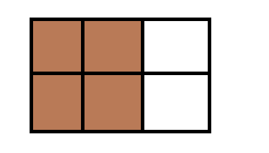1 x 12 = 1 x 12 6

2 2 **Soln**

= 1 x 6 = 2 x 6 parts

= 6 3

= 4 parts

**Example II**

Simplify: 1 x 10

3

**Soln**

1 x 10 = 1 x 10

3 3

= 10 3 rem 1

3

= 3

**Examples III**

Work out: 2 x 24

3

**Soln**

2 x 24 = 2 x 24 8

3 3

= 2 x 8

= 16

**Example IV**

Simplify: 2 x 6

7

2 x 6 = 2 x 6

7 7

= 12 1 rem 5

7

**Activity**

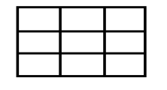Simplify the following

1. 1 x 3 10. Shade 2 of

3 9

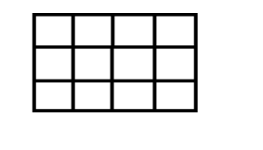2. 2 x 15 11. Shade 3

3 4

3. 6 x 2

3

4. 1 x 12

4

5. 5 x 36

6

6. 4 x 18

9

7. 1 x 8

3

8. 3 x 9

4

9. 2 x 9

5

**MULTIPLICATION OF FRACTIONS BY FRACTIONS**

**Note**:

Multiply numerator by numerator and denominator by denominator.

**Examples.**

Simplify: 1 x 1

3 4

1 x 1

3 4

1 x 1

3 x 4

1

12

**Example II**

Simplify: 2 x 5

3 6

2 x 5 = 2 x 5

6 3 6 3

= 5

9

**Activity**

Simplify the following

1. **x**

**5. x**

**2. x**

**6. x**

**3. x**

**7. x**

**4. x**

**8. x**

**MULITIPLICATION OF MIXED NUMBERS**

**Note**:

-Change mixed number to improve fractions then multiple numerator by numerator and denominator by denominator.

Example 1

Simplify: 1 x

**Soln**

**1 x**

**= x**

**=**

**Example II**

Simplify 5 x 3

**Soln**

5 **x 3 = x**

**2**

**= x**

**= 11 rem 1**

**52**

**3**

**= 17**

**Activity**

Simplify the following

1. 1 x 1 2.1 x 3.1 x 4. 1 x 1

5. 1 x 2 6. 2 x 1

**MULTIPLICATION OF FRACTIONS USING “OF”**

**NOTE:**

The word of can be replaced by X a multiplication symbol (X)

**Example I**

Simplify:1 of 16

2

1 of 16 = 1 x 16 8

2 2

= 1 x 8

= 8

**Example II**

Simplify: 2 of 10

3

**Soln**

2 of 10 = 2 x 10

3 3

= 2 x 10

3

= 20 6rem 2

3

= 6

**Example III**

What is 2 of 5

3 6

Soln

2 of 5= 2 x 5

3 6 3 6

= 2 x 5

3 x 6 3

= 1 x 5

3 x 3

= 5

9

**Example IV**

Simplify: 4 of 30

**Soln**

4 of 30 = 29 x 30

6

= 29 x 30 5

6

= 145

**Activity**

Simplify the following

(1) of 30 (2) of 12 (3)2of 24

(4)of (5) of (6) of

(7)1 of 3 (8) 2 of 3(9) 1 of 3

**APPLICATION OF MULTIPLICATION OF FRACTIONS**

**Example 1**

What is of an hour

Soln

**NB**: Change 1 hr to minutes

1 hour = 60min

= of 60 minutes

of 1 hour = x 60 minutes

= 1 x 60 15

4 1

= 15 minutes

**Example II**

What is of 18

Soln

2 of 18 = 2 x 18 6 = 2 x 6

3 3 1 = 12

**Example III**

A man spent of his salary on food, if his salary was sh.120,000. How much did he spend on food?

**Food** = 3 x sh 120,000

4

= 3 x sh120,000

4

= sh 3 x 30000

= sh 90,000

**Activity**

1. What is of 24 kg?

2. What is of sh 400?

3. Find of 1 kg.

4. Tom read of his book that contains 500 pages, how many pages did he read?

5. Mandela covered of 280km by a taxi, how many km did he cover by a taxi?

6. In a village of 1800 people of them are children, how many children are on the village?

7. of my salary is spent on rent. If my salary is sh200,000, how much do I spend on rent

**FINDING RECIPROCALS / MULTIPLICATIVE INVERSE**

A reciprocal is fraction that when multiplied by a given number the result in one (1)

**Example 1**

Find the reciprocal of

**Soln**

Let the reciprocal be K

2 x K = 1

2K = 1 **OR**

3

2Kx3 = 1x 3 Reciprocal = 1 ÷ 2

3 3

2K =3 = 1 x

2K = 3

2 2 =

K = 3

2

The reciprocal of is

**Example II**

Find the reciprocal of 2

Soln

Let the reciprocal be K

2 x K = 1 7K = 3

K = 1 7K = 3

K = 1 x 3 7 = 7

K = 3

7

**Example III**

What is the reciprocal of 5?

Let the reciprocal be P

5 x P = 1

5P = 1

5P = 1

5P 5

P = 1

5

Example IV

Find the reciprocal of 0.6

Let the reciprocal be y

0.6 x y = 1

6 x y = 1

10

6y = 1

10

6y x 10 = 1 x 10

10

6y = 10

6y = 10

6 1 6

Y = 10

6

**Activity**

Find the reciprocal of the following.

(1) (4) 2 (7) 4 (10) 0.3

(2) (5) 3 (8) 12 (11) 1.4

(3) (6) 4 (9) 7 (12) 0.9

**DIVISION OF FRACTIONS BY WHOLES AND WHOLES BY FRACTIONS.**

**Steps to take:**

Maintain the first fraction, change the division sign to multiplication sign then reciprocate the second fraction.

**Example I**

Work out: 2 ÷ 2

3

**Soln**

= 2 ÷ 2

3 1

= 2 x 1

3 2

= 1 x 1

3 x 1

= 1

3

**Example II**

Simplify: 3 ÷ 35

3 ½ ÷ 35 = ÷

=  **x**

= 1 x 1

2 x 5

= 1

10

**Example III**

Simplify: 6 ÷1

4

**Soln**

6 ÷ 1 = 6 ÷ 1

4

= 6 x 4

1 x 1

= 24

**Example IV**

Divide: 8 ÷ 2

**Soln**

8 ÷ 2

= 8 ÷ 5

2

= 8 x 2

1 5

= 16 3 rem 1

5

= 3 1

5

**Activity**

Work out the following

1. **÷ 2**

1. **4 ÷**
2. **÷ 3**

1. **16 ÷**
2. **÷ 3**

1. **9 ÷**

**DIVISION OF WHOLES AND BY FRACTIONS USING REPEATED ADDITION.**

**Example**

Divide 2 ÷ 1 using repeated addition.

4

**Step1**

Find the equivalent fraction of 2 whose denominator is 4.

2 x 4

1 x 4

= 8

4

**Step2**

Divide using repeated subtraction

2 ÷ 1 8 ÷ 1

4 4 4

**- =**  1st

**- =**  2nd

**- =**  3rd

**- =**  4th

**- =**  5th

**- =** 6th

**- =**  7th

**-**  = 0 8th

2 ÷ = 8

**Activity.**

Work out the following using repeated subtraction

(i) 1 ÷

(ii) 5 ÷

(iii) 2 ÷

**DIVISION OF WHOLES AND BY FRACTIONS USING A NUMBERLINE.**

**Example.**

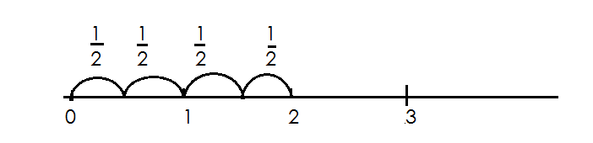Divide2 ÷ using a numberline.

2 ÷ = 4

**Activity.**

(c) Work out the following using a number line

(a) 2 ÷ (b) 8 ÷ (c) 2 ÷

**Division of fraction by fractions**

**Example**

Divide: ÷

**Soln**

÷ = x

= 1 x 4

3 x 1

= 4 1rem 1

3

= 1

**Example II**

Simplify: ÷

=  ***÷***

***=***

= 6

**Example II**

Simplify: ÷ 2

**Soln.**

= ÷ 2

= x

=

**Example IV**

Simplify: 2 ÷ 3

**Soln**

=  **+**

=  **+**

=  **x**

=

**Activity.**

Work out the following

**(1) ÷ (4) ÷ (7) ÷ 4**

**(2) ÷ (5) ÷ 2 (8) 2 ÷ 1**

**(3) ÷ (6) ÷ 2 (9) 2 ÷ 1**

**(10) 2 ÷**

**APPLICATION OF FRACTIONS INVOLVING DIVISION**

**Example I**

How many Chapatis can be got from 2 Chapati?

= 2 ÷

=  **÷**

=  **÷**

=  **x**

= 6

**Example II**

How many litre bottles of milk can be get from 1 litres

No. of bottle = 4 ÷

=  **÷**

=  **x**

=  **x 2**

= 18 bottles

**Example III**

How many small packets of 1 kg can be got from a sack of 9kg?

No. of packets = 9 ÷ 1

= ÷

= x

= 7rem 1

= 7 packets

**Activity**

1) How many cakes be got from 3 cakes?

2) If we use kg of sugar per day, how many days shall we use 12 kg.

3) How many litre bottle can get got forty litre jerry can?

4) A farmer has 7 hectares of land, to be divided into plots of 1 hectares, how many plots will he get?

5) A bag contains 5 kg of maize. Find to be number of kg packets that will be obtained.

6) A woman has 13 kg of sugar. How many packets each kg does she have?

7) 12 litres of milk were given to child if each get litre of milk, how many

children were server altogether?

**DECIMAL FRACTIONS**

* Decimals are fraction whose denomitors are multiples of ten.
* A decimal number is a number with a decimal point separating whole numbers and fractions.
* To the left of a decimal point, there are whole numbers and to the right, there are decimal number. (fractions)
* Decimal places are the number of digits after a decimal point.

**CHANGING COMMON FRACTIONS TO DECIMAL FRACTIONS**

**(A) Without multiples of ten as denominators.**

**Examples**

Change to a decimal fraction

**Soln**

= 0. 5

2 1 0

- 1 0

0 0

= 0.5

Change to decimal fraction

= 2 ÷ 5

0.4

5 20

4 x 5 = 20

= 0.4

Change to a decimal.

0.75

= 4 3 0

2 8

- 2 0

5 x 4 2 0

= 0.75

**Activity**

Express the following fractions as decimals

(a) (b) (c) (d) (e) (f) (g)

**(B) Given multiples of 10 as denominator**

The number of zeros “0” of the denominator in a common fraction is equal to the number of decimal places.

**Examples**

Express the following as decimals

(a) = 0.1 (one zero, one decimal place)

(b) = 2.5 (one zero, one decimal place)

(c) = 0.25 (two zeros, 2 decimal places)

(d) = 0.625 (3 zeros, 3 decimal places)

(e) = 0.003 (3 zeros, 3 decimal places)

**Activity**

Express these as decimal fractions

(a) (b) (c) (d)

(e) (f) (g)

**CHANGING DECIMALS TO COMMON FRACTION**

**Example I**

(a) 0.5 = (1 decimal 1 zero)

(b) 0.0.5 = (2 decimal 2 zero)

(c) 0.003 = (3 decimal 3 zeros)

**Example II**

(a) 6.9 =

= 6

(b) 6.09

= 609

100

= 609

100

(c) 8.625 = 8625

1000

= 8

**Activity**

Express the following decimals as fractions.

(a) 0.1 (e) 14.9 (i) 9.09

(b) 0.001 (f) 49.8

(c) 0.25 (g) 3.78

(d) 9.08 (h) 9.008

**CHANGING MIXED FRACTIONS TO DECIMALS**

**Examples**

(a) 3 = (10 x 3) + 1 (b) 7 = (100 x 7) + 5

10 100

= 30 + 1 = 700 + 5

10 100

= 31 = 705

10 100

= 3.1 = 7.05

(c) 9 = (1000 x 9) + 75 (d) 7 = (1000 x 7) + 5

100 1000

= 9000 +75 = 7005

100 1000

= 9075 = 7.005 100

= 90.75

**Activity**

Express these mixed fractions as decimals fractions.

(a) 9

(b) 7

(c) 3

(d) 3

(e) 7

(f) 4

**Comparing decimals using symbols**

Use >, < or = to complete the following statements.

(a) 0.2 0.5

**Soln**

 0.2 0.5

2 5

10 10

2 x 10 5 x 10

10 10

(b) 0.4 0.25

**Soln**

 4 25

10 100

4 x 100 25 x 100

10 100

40 25

(c) 0.5 0.15

**Soln**

 0.5 0.15

10 100

5 x 100 15

10 100

50 15

**Activity**

**Use >< or = complete**

(a) 0.2 0.9

(b) 3.2 2.5

(c) 0.5 0.05

(d) 4.5 4.05

(e) 20.5 2.05

(f) 40.3 44.3

**ORDERING DECIMALS IN ASENDING AND DESCENDING**

**Note**:

* Change decimals to common fractions.
* Find the LCM of all denominators.
* Multiply each fraction by LCM
* Take the biggest denominator to the LCM

**Examples**

1. Arrange the following fraction in ascending order 0.22, 0.2, 1.2

Change to simple fraction = 22, 2, 12

100 10 10

LCM = 100

|  |  |  |
| --- | --- | --- |
| 0.22 | 0.2 | 1.2 |
| x 100  = 22 (2nd) | = x 100  = 20 (3rd) | = x 100  = 120 (1st) |

Required order = 0.2, 0.22, 1.2

2. Arrange the following fraction in descending order.0.1, 1.1, 0.11

LCM = 100

|  |  |  |
| --- | --- | --- |
| 0.1  1 x 100  100  10 | 1.1  11 x 100  10  110 | 0.11  11 x 100  100  11 |
| 3rd | 1st | 2nd |

The order = 1.1, 0.11, 0.1

3. Arrange from the biggest 0.22, 0.2, 0.202

LCM = 1000

|  |  |  |
| --- | --- | --- |
| 0.22  22  100  22 x 1000  100  = 220 | 0.2  2  10  2 x 1000  10  = 200 | 0.202  202  1000  202 x 1000  1000  = 202 |
| 1st | 3rd | 2nd |

Required order = 220, 202, 200

**Activity**

1. **Arrange the following fractions in ascending order**

(a) 0.1, 03, 0.33

(b) 0.8, 8.08, 0.88

(c) 3.4, 0.34, 3.04

(d) 0.9, 0.09, 9,9

2. **Arrange the following fraction in descending order**

(a) 0.3, 0.07, 0.15

(b) 7.7, 0.77, 0.11

(c) 0.404, 0.044, 0.11

(d) 0.1, 303, 0.33

**ADDITION OF DECIMAL FRACTIONS.**

**Note**

-Arrange vertically according to place values.

-Place the decimal points in line

**Examples**

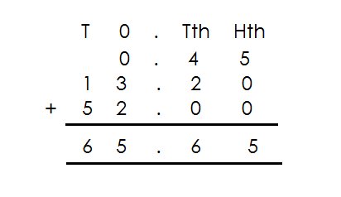1. Add: 0. 4 5 + 1 3. 2 + 5 2. 0 0

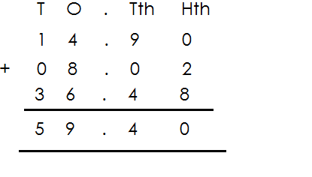2. Add: 1 4. 9 + 8. 0 2 + 3 6. 4 8

**ACTIVITY**

**Add the following**

1. 4.96 + 1.7 + 0.36

2. 0.58 + 5.8 + 58.00

3. 0.22 + 2.22 + 22.22

4. 2.76 + 3.85 + 1.09

5. 65.6 + 4.5 + 20.8

6. 0.35 + 12.2 + 51.0

7. 2.7 + 8.92 + 0.37

8. 0.45 + 1.32 + 52.00

**SUBTRACTION OF DECIMALS**

**Examples**

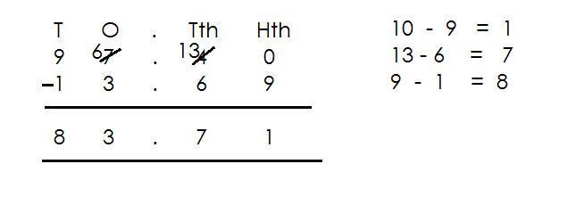1. Subtract: 97.4 - 13.69

2. Subtract: 97. 4 - 13.69

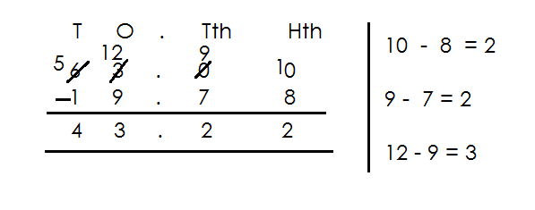

3. Subtract: 97.4 – 13.69

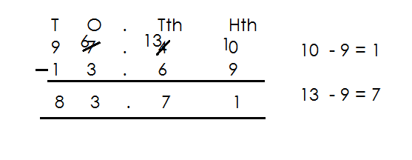

**Activity**

(a) 73 - 19.5 (e) 50. 12 – 17.48

(b) 12 – 9.5 (f) 8.54 – 2.34

(c) 57.9 – 3.51 (g) 14.9 – 3.51

(d) 7.2 - 5.36 (h) 166 – 66.9

**ADDITION AND SUBSTRACTION OF DECIMAL FRACTIONS**

**Note:**

* First re-arrange by adding first then subtract.
* A number takes a sign before it.

**Example**

1. Work out 13.75 – 27 + 91.25

13.75 – 27 + 91.25

T O th Hth T O Tth Hth T O

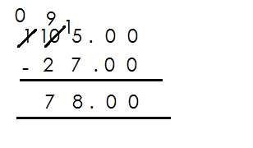 (1 3. 7 5 + 9 1. 2 5) – 2 7

2. Work out 4.000 - 2.625 + 33.000

(4.000 + 33.000) – 2.625

O Tth Hth Thth T O Th HthThth O Tth Hth Thth

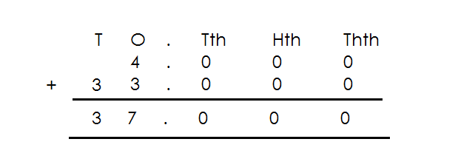 4. 0 0 0 + 3 3. 0 0 0 - 2 . 6 2 5

**Activity**

**Work out the following**

1. 35.1 - 44. 3 + 17.6

2. 8.24 + 22.9 – 78

3. 2.76 + 1.69 – 2.85

4. 7.982 – 9.082 + 4.007

5. 5.625 – 8 + 4.375

6. 23.7 – 65.9 + 82.6

7. 12 – 0.75 + 0.75

8. 65.6 - 45.9 + 0.36

**MULTIPLICATION OF DECIMAL FRACTION BY 10, 100 AND 1000**

**Note:**

-Change the decimals to common fractions then multiply by 10, 100, 1000.

**Examples**

1. Multiply 6.25 x 10 3. Multiply 6.25 x 1000

x 10 = x 1000

= 62. 5 = 625 x 10

10

= 62.5 = 6250

2. Multiply 6.25 x 100 4. Multiply 7.425 x 10

Soln Soln

x 100 x 10

= 625 =

= 74.25

5. Multiply 7.425 x 100 6. Multiply 4.325 x 1000

7.425 x 100 4325 x 1000

74.25 x 100 1000

1000

 = 742.5 = 4325

= 742.5

**ACTIVITY**

Multiply the following

1. 0.12 x 10

2. 15.6 x 10

3. 13.489 x 10

4. 15.6 x 100

5. 9.46 x 100

6. 0.875 x 100

7. 30.729 x 100

8. 0.125 x 1000

**MULTIPLICATION OF DECIMAL BY A DECIMAL.**

**NOTE:** First change decimals to common fractions before multiplying.

1. Multiply 2.3 x 0.2 3. Multiply 0.018 x 0.4

**Soln Soln**

23 x 2 = 18 x 4

10 10 1000 x10

= 23x 2 = 18 x 4

10 x 10 1000 x10

= 46 = 72

100 10000

= 0.46 = 0.0072

2. Work out 3.75 x 2.4

**Soln**

3.75 x 2.4

= 375 x 24

100 x 10

= 375 x 24

100 x 10

= 9000

1000

= 9

**Activity**

Multiply the following

1. 0.6 x 0.06

2. 0.2 x 0.03

3. 2 x 05

4. 3.02 x 0.9

5. 7.2 x 8

6. 0.8 x 24

7. 2.5 x 2.5

8. 0.03 x 0.3

9. 3.6 x 0.11

**INTEGERS**

Integers these are positive or negative numbers including zero.

**Note**:

* An integer is a negative or positive number including zero.
* An integer is a whole number that can be positive or negative.
* Zero is neither a positive nor a negative integer.
* A number line is a line that contains positive and negative numbers including zero.
* Positive integers are represented by (+) and a negative integer is represented by (-)

**Illustration of a numberline.**

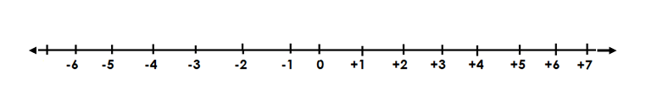

**Finding integers represented by arrows on a number line (arrows on a number line)**

**Examples**

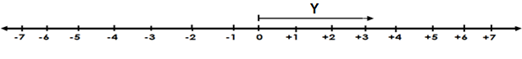Find the integer represented by the arrows on the following numberlines.

a)

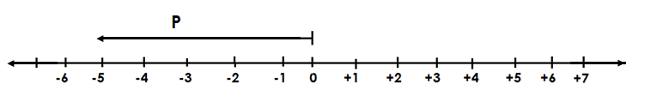Arrow Y represent +3

b)

Arrow P represent – 5

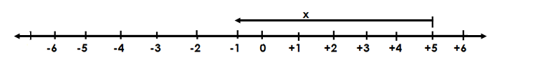c)

Arrow X represents -6

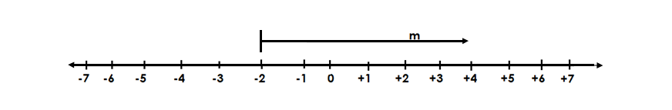

d)

Arrow m represent +6

**NB**: Arrows facing right direction represent the positive integers and arrows

facing the left directions represent the negative integers.

**Activity**

Find the integer represented by the arrow.

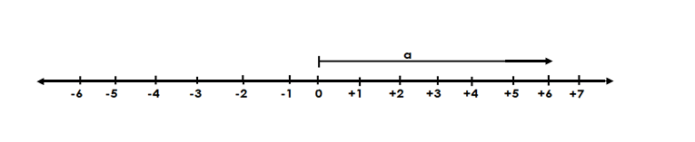1.

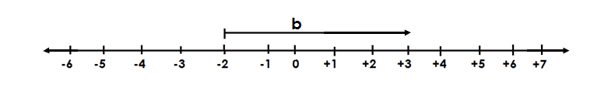

2.

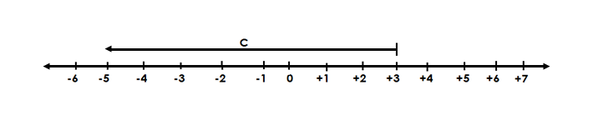

3.

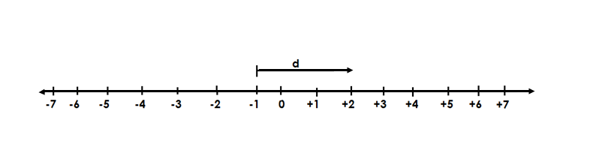

4.

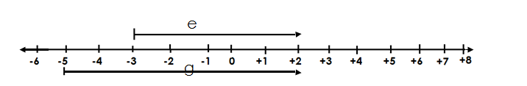

5.

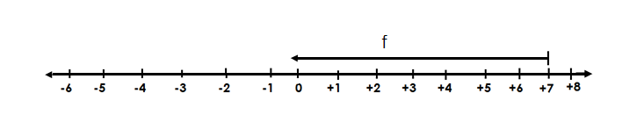

6.

**REPRESENTING INTEGERS ON NUMBERLINE**

**Examples**

1. Show – 4 on a numberline

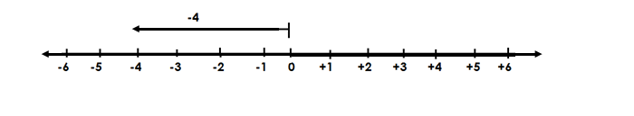

2. Show positive +7 on the numberline.

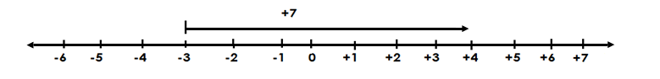

3. Represent -9 on a number line

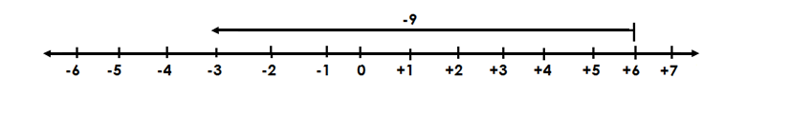

**Activity**

**Show the following integers on the numberline**

1. -2

2. +6

3. +10

4. -8

5. -5

6. +3

7. -4

8. +7

9. -11

10. +1

**INVERSE**

- Inverse is the opposite of the sign of an integer given.

- A number multiplied by its additive inverse gives a zero.

**Finding inverse.**

**Examples.**

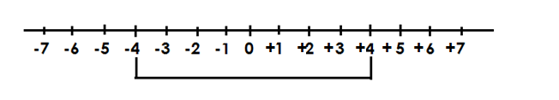1. Find the inverse of -4

-4 is +4

2. Find the additive inverse of -4

Let the additive inverse be y

-4 + y = 0

- 4 + 4 = 0 + 4

y = + 4

3. Find the additive inverse of +6

Let the additive inverse be W

W + 6 = 0

W + 6 = 0 - 6

W = **-**6

**Activity**

1. Find the inverse of the following

(a) +7 (b) -20

(c) +2 (d) -5

(e) +4 (f) -10

2. Work out the additive inverse of the following.

(a) +7 (b) +4

(c) -9 (d) -8

(e) +3 (f) 5

**MORE ON INVERSE OF INTEGERS**

**Examples**

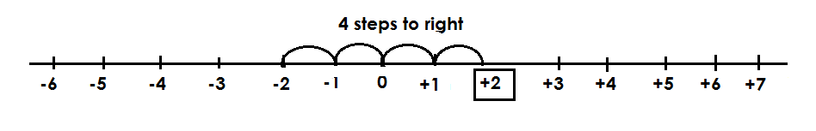1. Which integers is 4 steps on the right of -2?

The integer is +2

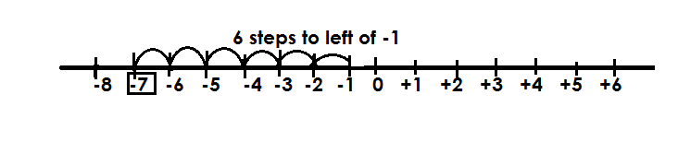2. Which integers is 6 steps to the left of -1

Integer is -7

**Exercise**

1. Which integers is 5 steps to the right of

(a) 0

(b) -7

(c) -3

(d) +4

(e) +2

2. Which integers is 7 steps to the left of;

(a) -2

(b) +6

(c) 0

(d) +9

(e) -1

**Comparing integers**

**Note**:

-All integers on the right of any integer are always greater while integers on the left of the given integers are always smaller.

**Examples**

1. Which is smaller – 5 or +2

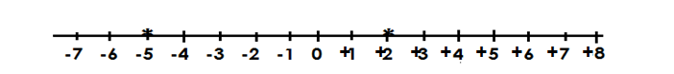 **Soln**

-5 is smaller

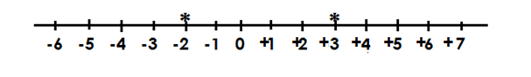2. Which one is bigger, – 2 or +3?

+ 3 is bigger

- 2 <+3

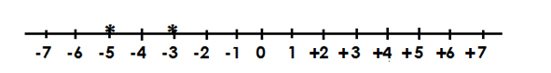3. Which one is smaller -3 or – 5?

-5 is smaller

- 3 ≥ -5

**Activity**

1. Which is bigger?

a. -7 or +7

b. +2 or -3

c. +5 or +2

d. -1 or -4

2. Which is smaller?

a. -4 or +4

b. -2 or -7

c. -8 or +1

d. -5 or +6

**ORDERING INTEGERS**

1. Integers are arranged in either ascending or descending order.
2. Ascending order is the arrangement from the smallest to the biggest.
3. Descending order is the arrangement from the biggest to the smallest.
4. Write the identified integers on the number line from right to left.
5. A number line must be used in ordering of integers.

**Example I**

Arrange +1, - 2, + 4, 0, -3, - 5 in ascending order.

**Soln**



Descending order = - 6, -3, -2, 0, +2, +5

**Activity**

1. Arrange the following integers in ascending order

(a) -4, +2, 0, -3, -2, +5

(b) -6, -3, +2, 0, -4, +3

(c) +2, -4, +6, -1, -3, +1

(d) +3, -3, -2, -4, +1, 0, +2

(e) +1, -4, +3, 0, -2

2) Arrange the following integers in a descending order

(a) +2, -3, -4, +6, -1

(b) -4, +2, 0, -3, +5

(c) +7, -3, -4, +5, -2, +3

(d) -3, +2, 0, -2, +4

(e) -1, 0, +8, -4, +3, +2

**ADDITION OF INTEGERS WITHOUT USING A NUMBERS LINE**

**Note**:

-When there are two signs in the middle, multiply them to remain with one sign eg

+ x + = + + x - = -

- x - = + - x + = -

**Examples**

1. Work out = **+**3 + **+**4

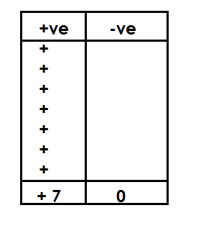 **Soln**

+3 +(+4)

+3 + 4 +3 + +4 = +7

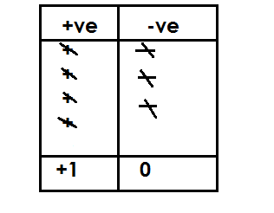2. Work out +4 + - 3

+4 + (-3)

+4 - 3

+4 + -3= +1

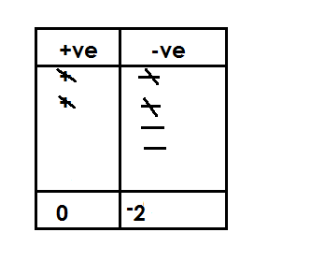3. Work out: -4 + +2

-4 + (+2)

-4 + 2

-4 + +2 = -2

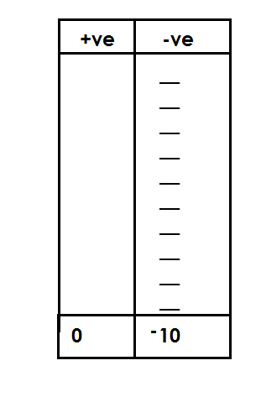

4. Work out: -3 + - 7

**Soln**

-3 + (-7)

-3 – 7

-3 + -7 = -10

**Activity**

1. Work out the following

(a) +3 + +2 (g) +4 + -6

(b) +1 + +5 (h) -9 + -2

(c) +4 + - 5 (i) -6 + -8

(d) +8 + -3 (j) -1 + -7

(e) -2 + +1 (k) -3 + -4

(f) -5 + + 3 (l) -10 + -8

**ADDITION OF INTEGERS ON NUMBERLINE**

**Examples**

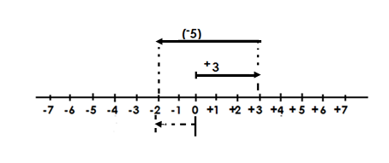1. Add: **+3 +-5**

+3 +-5 = -2

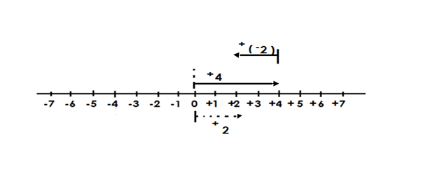**2.** Add: **+4 + -2**

**+**4 + **-**2 = +2

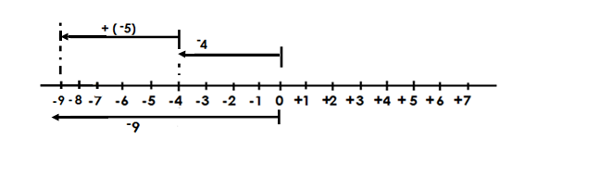3. Work out: **– 4 + - 5**

-4 + - 5 = -9

**– 4 + - 5** = **-**9

**Activity**

Add the following using a number line

1. **-**2 + **-**1 5. **-**7 + 2

2. **-**3 +**-**5 6. **-**9 + **+**3

3. **-**4 + **-**6 7. **-**4 + **+** 3

4. **-**3 + +4 8. +5 + **-**2

**SUBTRACTION OF INTEGERS WITHOUT USING A NUMBER LINE**

Examples +ve -ve

1. Subtract: +6 - **+** 9 + ++ - - -

Soln + + + - - -

+6 – (+9) - - -

= 6 – 9

= -3

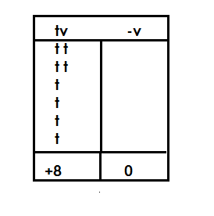2. Subtract to +2 - **-**6

+2 - **-**6

+2 – (**-**6)

+2 + 6

= +8

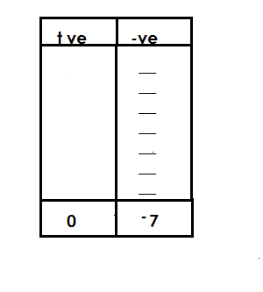3. Subtract: **–** 4 - **+**3

**-**4 - (+3)

- 4 – 3

= **-**7

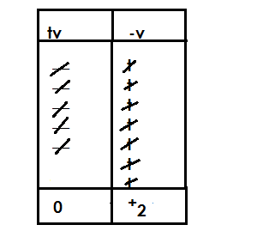4. Subtract: **–** 5 -**-**7

Soln

-5 - (**-**7)

-5 +7

= + 2

**Activity**

Subtract the following without using a number line

a. **+**3 - 2 i. **-**3 - **+** 4

b. **+**3 - **-** 3 j. **+**3 -**-**10

c. **+**7 - **-** 4

d. +15 - **-**7

e. **-**5 - **-** 7

f. **-**2 - **+**7

g. **-**10 - **+**13

h. **-**6 - **+** 4

**SUBTRACTION OF INTEGERS USING A NUMBER LINE**

**Examples**

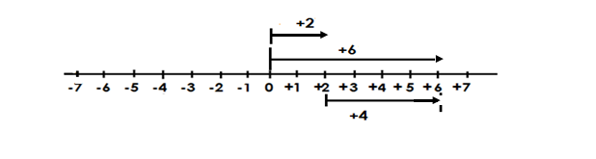1. Subtract: + 6 - **+**2

**+**16- **+**2 = + 4

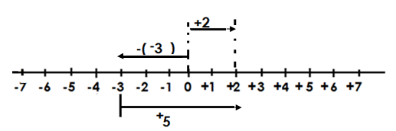2. Subtract: **+**2- **-**3

**+** 2 - **-**3 = **+**5

3. Subtract: **–** 5 - **-** 7

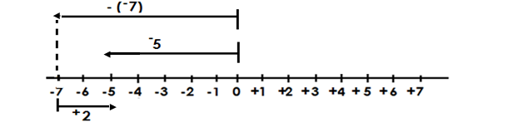

**-**5 - **-** 7 =+2

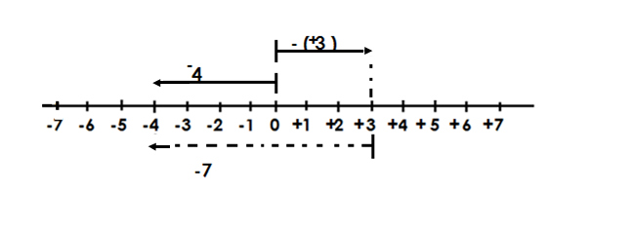4. Subtract: **-**4 - **+**3

**-**4 - **+** 3 = **-**7

**Activity**

Use a number line to subtract the following

(a) **+**7- **+**5 (g) **-**8 - + 6

(b) +3 - **-**2 (h) **-**5 + **+**7

(c) **-**9 - **-** 4 (i) **-**5 - **+**7

(d) **-**4 - **-** 2 (j) **+**10 - **+**8

(e) **-**7 -**-** 8

(f) **-**6 - **-**4

**WRITING MATHEMATICS STATEMENTS AND SENTENCES**

**Examples**

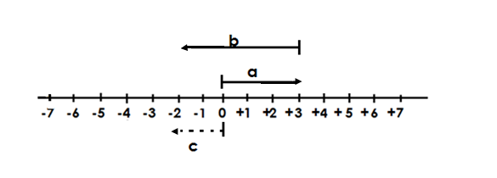1. Write the mathematical statement represented on the number line below.

a + b = c

**+**3 + **-**5 =**-**2

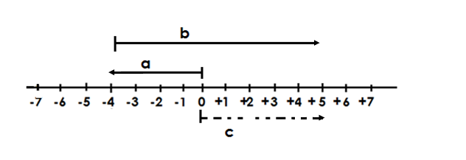2. Write the mathematics represented on the number line below.

a + b = c

**-**4 + **+**9 = **+**5

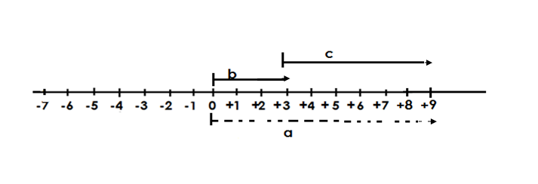3. Below is a number line. Write a Mathematics statement shown and the number line.

b + c = a

+3 + +6 = +9

4. Write the Mathematics sentence represented on the number line below.

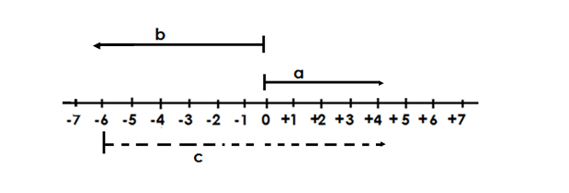

a - b = c

+4 - **-** 6 = **+**10

5. Write the mathematical statement shown on the number line below.

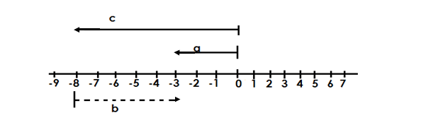

**Soln**

a - c = b

-3 - **-**8 = **+** 5

**Activity**

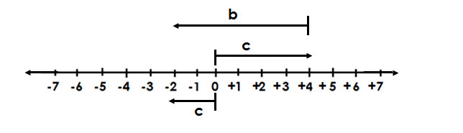Write the Mathematical statement shown on the number line below.

(a)

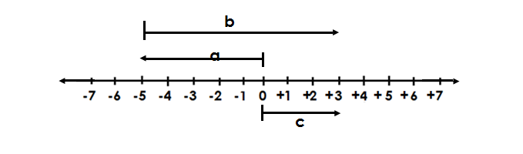

(b)

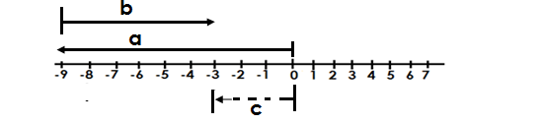

(c)

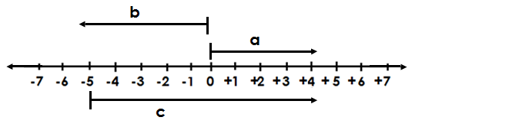

(d)

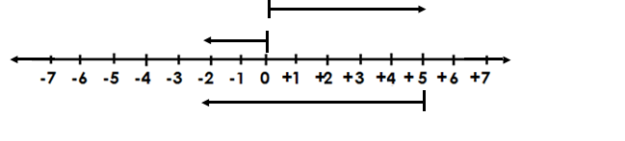

(e)

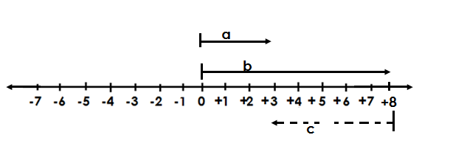

(f)

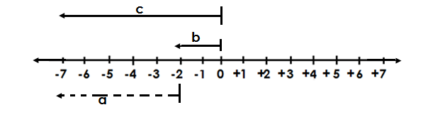

(g)

**GEOMETRY**

**Parallel lines**

These are lines which do not meet because they are of the same distance apart.

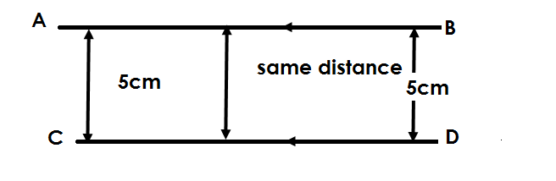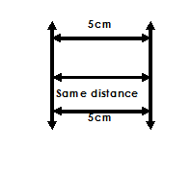 **Example I** **Example II**

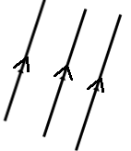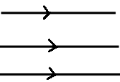To show that the given lines are parallel we use signs as shows below.

**Activities**

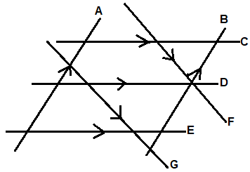Which of the lines above are parallel lines?

**Drawing parallel lines**

**1. Using a ruler**

Place a ruler on the paper, then draw a line on each side of the ruler.

2. **Using a ruler and a set square**

**Procedure**

**Step I**

Draw a line AB and mark point P where the other parallel line shall pass

**Drawing and identifying perpendicular lines**

Perpendicular lines are lines which meet at an angle of 900.

**Note**:

When perpendicular lines meet, they make a square corner called a right angle.

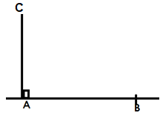The symbol for perpendicular.

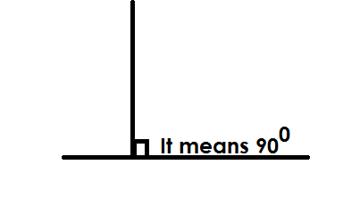

**Drawing perpendicular lines**

Procedure

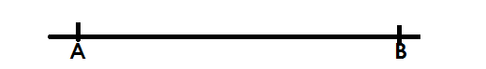-Use a ruler and a set square.

**Step I**

1. Draw a horizontal line.

**Step II**

Place a 600- set square at A as shown in (a) below.

**Step III**

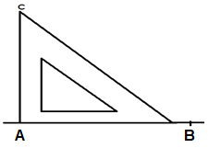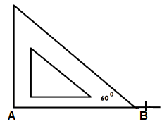Draw a line from A to C using a pencil as in (b) below.

(a)

Step 4

Remove the set square and your lines will look like this.

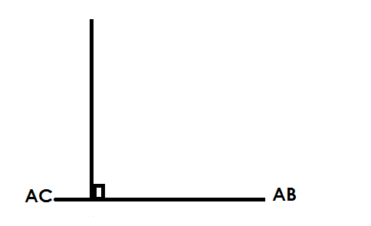

Therefore, Ac is perpendicular to AB

**Activity**

Draw a perpendicular line at the point shown using a pencil and a set square.

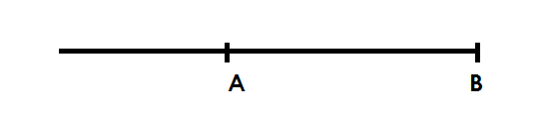1.

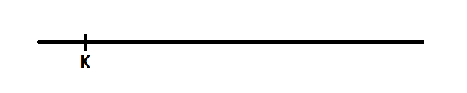

2.

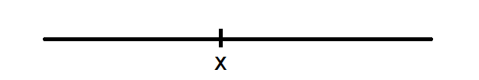

3.

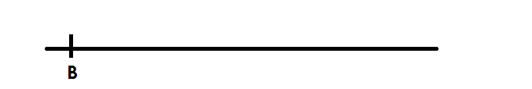

4.

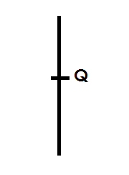

5.

**TYPES OF ANGLES**

An angle is the amount of turning between two straight lines at a fixed point.

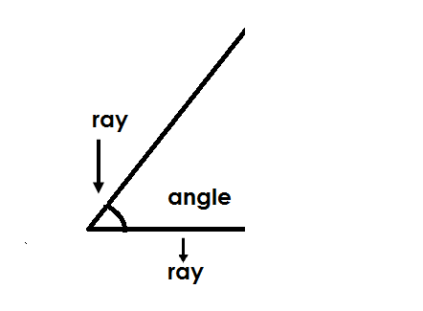Illustration.

**Types of angles.**

**1) Acute angle**

This is an angle which is less than 900

The smallest acute angle is 1**0** and the largest is 89**0**.

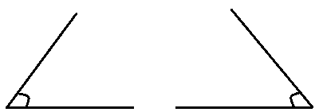**Illustration.**

**2)** **Right angle**

This is an angle which measures exactly 900.

**Illustration.**

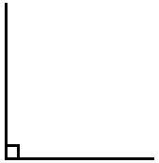

**3) Obtuse angle**

This is an angle great that measures above 900 but less than 1800.

The smallest obtuse angle is 91**0** and the largest is 179**0**.

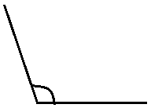**Illustration.**

**4) Straight line angle**

This is an angle which measures exactly 1800.

**Illustration.**







**5) Reflex angle**

This is an angle greater than 1800 but less that 3600.

The smallest reflex angle is 181**0** and the largest is 359**0**.

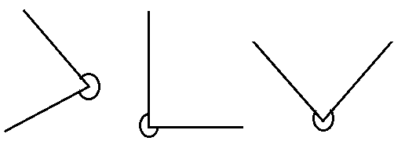**Illustration.**

**6) Centre angles (revolution)**

This is an angle which measures exactly 3600

**Illustration.**

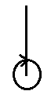

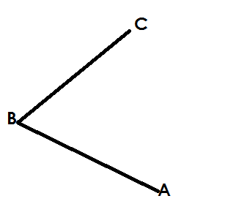**MEASURING DIFFERENT ANGLES USING APROTRACTOR**

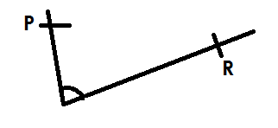(a) (b)

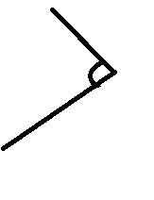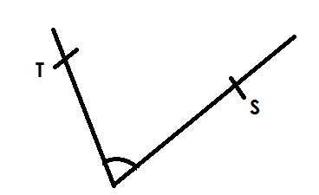

(c) (d)

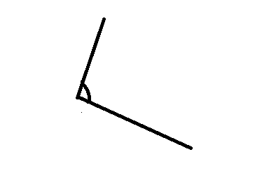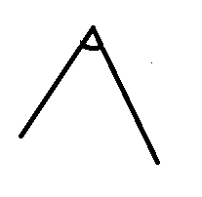

(e) (f)

**DRAWING DIFFERENT ANGLES USING A PROTRACTOR**

**Using a ruler pencil and protractor draw the following angles**.

(a) 600 (b) 500 (c) 750

(d) 1200 (e) 1350

**DRAWING DIFFERENT ANGLES USING A RULER AND PAIR OF COMPASSES ONLY**

Using a ruler and pair of compasses only, construct the following angles.

1. 600 (b) 900 (c) 450  (d) 1200

**CONSTRUCTING AND EQUILATERAL TRIANGLE IN A CIRCLE GIVEN RADIUS.**

**Procedures**

- Mark a point. Using a given radius, draw a circle from the point drawn.

- Make equidistant arcs on the circumference using the given radius.

- Join the arcs by skipping one at a time to draw the equilateral triangle.

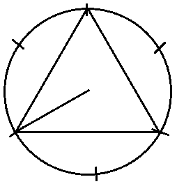

**Activity**

1. Construct an equilateral triangle in a circle given the following radii.

(a) 6cm

(b) 4cm

(c) 5.5cm

(d) 4.8cm

**CONSTRUCTING AN EQUILATERAL TRIANGLE GIVEN SIDES**

**Procedures**

* Draw a sketch
* Draw a base line of the given length.
* The using the same length, draw arcs and join to make an equilateral triangle.

**Example**

Using a ruler and pair of compasses only, construct and equilateral triangle ABC of side. 6cm.

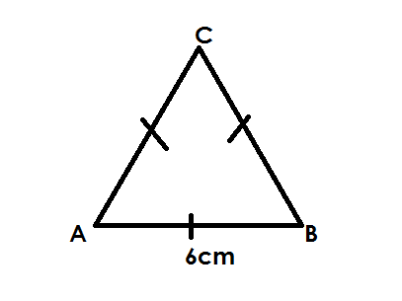**Sketch**

**Accurate drawing**

* Measure and draw a line AB of 6cm.
* Press the compass needle of the compass at either point A or B using the same length of 6cm to draw line / side AC or BC = 6cm.
* Then join the three sides to form an equilateral triangle ABC of sides 6cm.

**Activity**

1. Using a ruler and pair of compasses only construct.

(a) An equatorial triangle PQR of sides 5cm.

(b) An equilateral triangle TNs of sides 4.8cm.

(c) An equilateral triangle ABC of sides 4.50cm.

(d) An equilateral triangle XYZ of sides 5.3cm.

**CONSTRUCTING A REGULAR HEXAGON**

A regular hexagon is a polygon with all its 6 sides equal and its interior angles also equal.

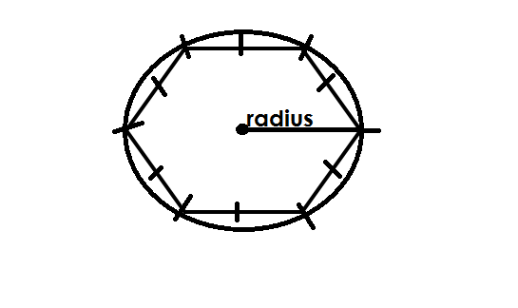**Sketch**

**Procedures**

- Draw a point.

- Using the given radius roll the compass from point to make the circle.

- Cut off equal arcs on the circumference using the given radius.

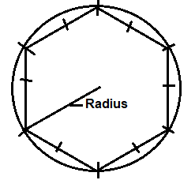- Join all the points on the circumference to make the polygon.

**Activity**

1. Using a ruler and a pair of compasses only, construct aregular hexagon with the following sides.

(a) 4cm

(b) 4.8cm

(c) 5cm

(d) 6cm

**LINES OF FOLDING SYMMETRY**

**Definition**

Is a line that divides a figure into 2 equal parts, which cover each other completely.

A figure is said to be symmetric if it has atleast one line of symmetry.

**LINES OF SYMMETRY IN DFIFFERENT SHAPES.**

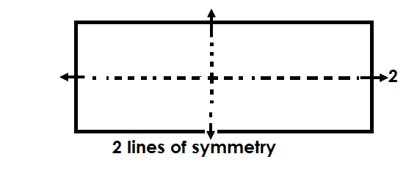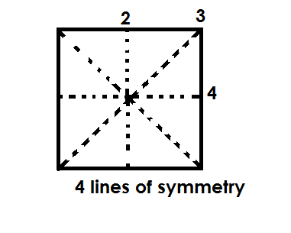(a) Square (b) Rectangle

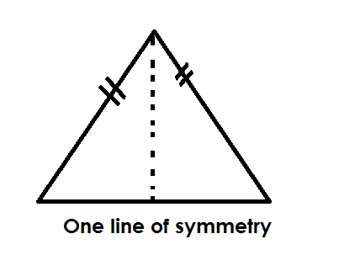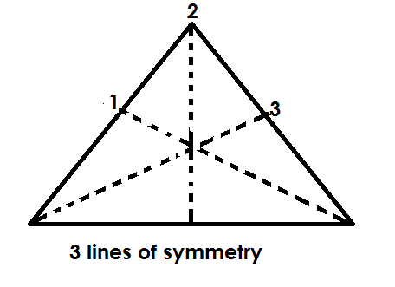(c) Equilateral triangle (d) Isosceles triangle

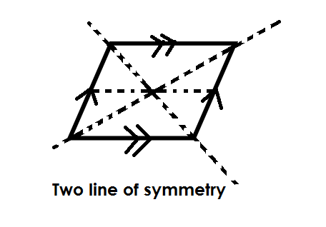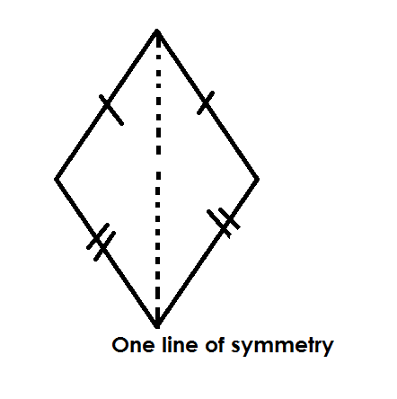(e) Kite (f) Rhiombus

(g) Parallelogram (h) Right Trapezium

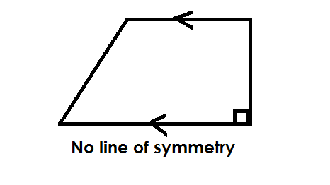

**No line of symmetry**

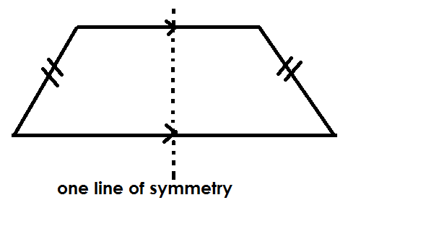(i) Isosceles trapezium

(k) Circle

Many lines of symmetry

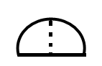(j) Semi circle

One line of symmetry

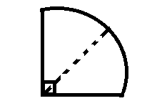(l) Quadrant

One line of symmetry

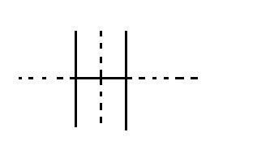**LINES OF FOLDING SYMMETRY IN LETTERS**

(1)

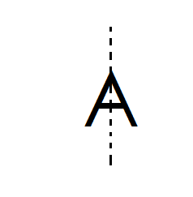 Two lines of symmetry

(2) One line of symmetry

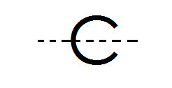

(3) One line of symmetry

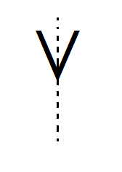

(4) One line of symmetry

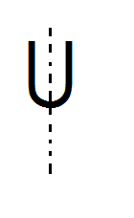(5) One line of symmetry

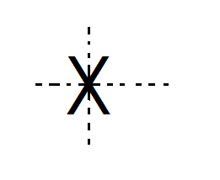(6) Two lines of symmetry

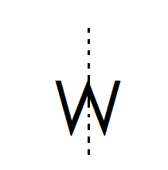

(7) One lines of symmetry

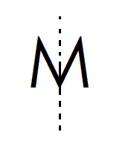

(8) One line of symmetry

**Note**:

All regular polygons have number of lines of symmetry that is equal to these number of sides.

**Name of regular polygon No. of lines of symmetry**

- Equilateral triangle 3

- Square 4

- Pentagon 8

- Hexagon 6

- Septagon 7

- Octagon 8

- Nonagon 9

- Decagon 10

- Nou-Decagon 11

- Duo decagon 12

**REVOLUTIONS / ROTATIONS / TURNS**

A revolution is a complete turn, i.e., a rotation from one point and back to the same point.

A complete revolution is made of 360**0**.

**Illustration**

3600

**FINDING PARTS OF A REVOLUTIONS.**

**Examples**

1. Find of a revolution.

1 revolution = 3600

1800

a revolution = x 3600

= 1800

**2.** What angle is of a revolution?

1 revolution = 360**0**

of a rev = x 360072**0**

= 1440

**Activity**

1. Find the angle that is of a revolution.

2. Which angle is of revolution?

3. Matama turned of a revolution which angle did he make?

4. How many degrees are in of a revolution?

5. Find of a revolution.

6. How many degrees can one make if he turns through of a revolution.

7. Find the angle that is a revolution.

**FINDING NUMBER OF REVOLUTIONS**

**Example I**

How many revolutions are in 7200?

**Soln**

3600 = 1 rev

2

1**0** = x 120

= 2 revolutions

**Example II**

Find number of revolutions in are in 540

**Soln**

3600  = 1 rev

1**0** = rev

63

5400 = x 540 Revolutions

4

2

= 1 rem 1

= 1 revolutions

**Activity**

1. Find number of revolutions in 10800 revolutions.

2. How many complete rotations are in 1800.

3. Find the number of revolutions in 9000.

4. How many revolutions are in 3600 revolution?

5. Calculate number of revolutions in 450.

6. How many revolutions are in 36**0**?

7. Find number of turns in 360**0**.

8. How many revolutions are in 3260**0**?

9. Find the number of turns in 3600**0**.

**ANGLES FORMED ON A COMPASS.**

A compass has two types of points i.e.

- Major cardinal points

- Minor / secondary cardinal points

**Major cardinal points**

- North (N)

- South (S)

- East (E)

- West (W)

**Illustration**

**North**

**West** **East**

**South**

**Minor cardinal points / secondary points**

* North East (NE)
* South East (SE)
* North West (NW)
* South West (SW)

**Illustration**









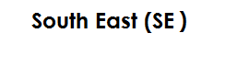



**Note**:

Since a complete revolution is equal to 360**0**,

45

1 sector = 360

8

= 450

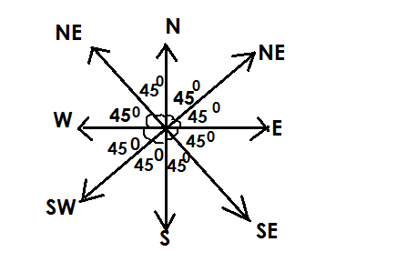**ANGLES BETWEEN COMPASS DIRECTIONS**

**Note**:

A smaller angle is the smallest sector between given points and largest angle is the largest sector between the two given points.

**Examples**

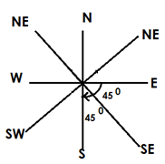What is the smallest angle between East and South?

I sector = 45**0**

2 sectors = 45 x 2

= 900

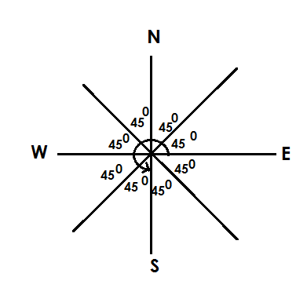Find the larger angle between East and South.

1 sector = 450

6 sectors = 6 x 450

= 2700

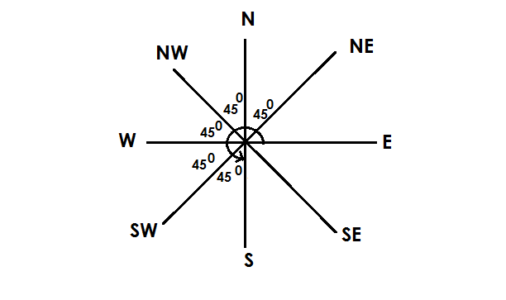What is the larger angle between South and North East?

1 sector = 450

5 sectors = 5 x 450

= 2250

**Activity**

1. Find the smaller angle between the following compass points.

(a) N and S.E

(b) NW and W

(c) NE and SW

(d) NW and NE

(e) E AND S

2. Find the larger angle between the following points.

(a) SE and W

(b) E and S

(c) N and NE

(d) NE and SW

(e) W and NW

**CLOCK WISE AND ANTI CLOCK WISE DIRECTION.**

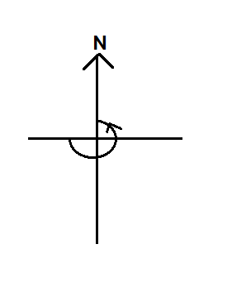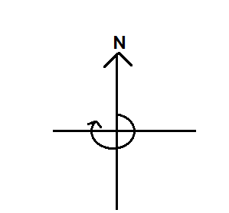Clock wise (right-hand turn) Anti clockwise (left-hand turn)

**FINDING DIRECTION GIVEN ANGLES**

**Examples**

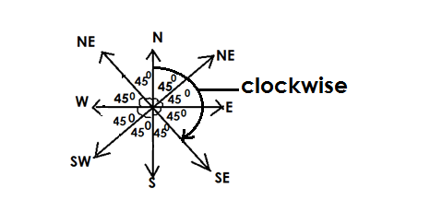Jane was facing North, she turned clockwise through and angle of 1350. In which direction did she face.

No. of sector =

= 3 sectors

She faced in South East

**Example II**

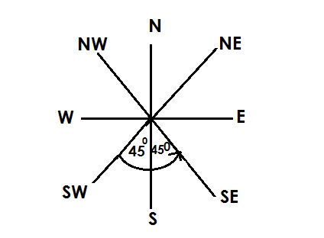Musa was facing in North West. He turned through an angle of 900anti wise. In which directions is he facing now?

No. of sectors = Angle given

450

= 900

450

2 sectors

He is facing in South East.

**Activity**

1. Alex was facing North East. He turned through an angle of 900 anticlockwise. Find his new direction.

2. A pilot was facing North on setting off, he turned through an angle of 1800clockwise in which direction did he take?

3. Wandella was facing in South West. He turned through an angle 1350 clockwise find his new direction.

4. Mukataza was facing in North West. If he turned through an angle of 225 anti clock wise. Find his new direction.

5. Find the direction Wakate will face if he turns through an angle of 3150 from North East clock wise.

**FINDING ANGLE GIVEN DIRECTION**

**Example I**

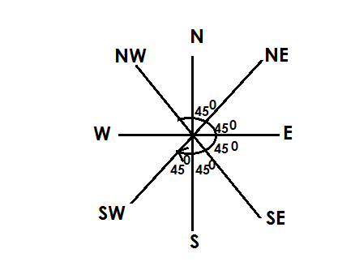A man was facing North. He turned clockwise to face South West. Find the angle turned.

1 sector = 450

5 sector = 5 x 45 0

= 2250

He turned through an angle of 2250

**Example II**

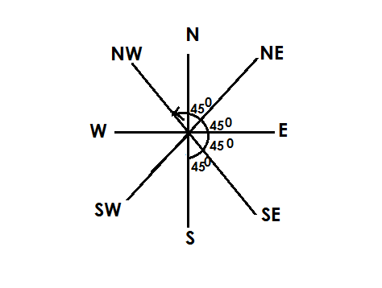Find the angle turned from South to North West anti clock wise.

1 sector = 450

5 sectors = 5 x 450

Therefore, the angle turned through is 2250

**Activity**

1. Through what angle can Okello from North to North East clockwise.

2. Find the angle that can be turned from North to South East anti clock wise.

3. What angle is made by a clockwise turn from South to North East?

4. James facing South East. He decided to turn anti clockwise to North. Through what angle did he turn?

5. Damali sat in class facing in South West If she was told to turn clockwise to face East, find the angle turned.

**CALCULATING MISSING ANGLES.**

(A) **COMPLEMENTARY ANGLES**

These are two or more angles that add upto 900 and originating from on point.

**Examples**

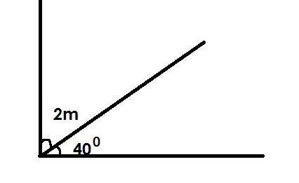Find the value of m.

2m + 400 + = 900

2m + 400 – 400 = 900 – 400

2m =500

2m = 50025

2 2

m = 250

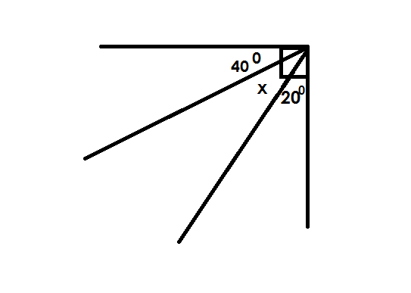Find the value of K in the diagram below.

K + 400 + 200 = 900

K + 600  = 900

K + 600 - 600 = 900 - 600

K = 300

**Activity**

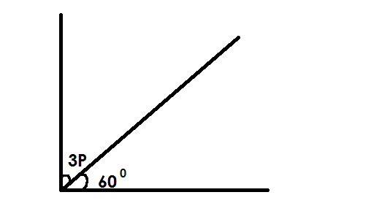Find the value of unknowns in the following

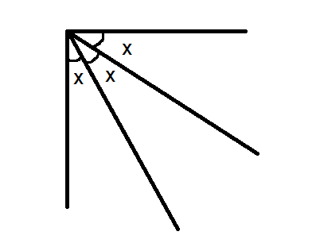(1) (4)

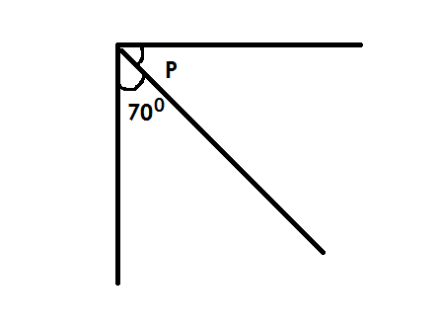

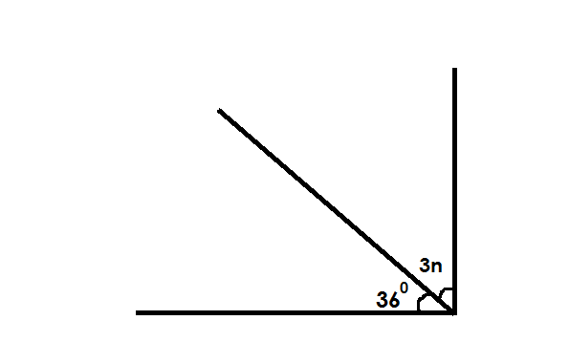(2) (5)

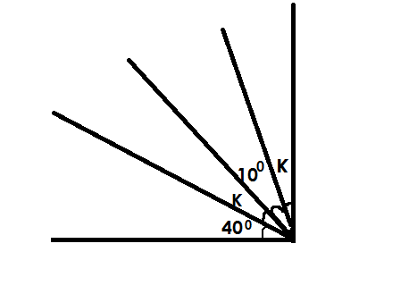

(3) (6)

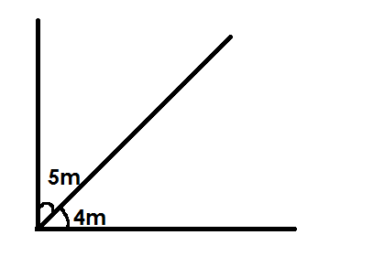

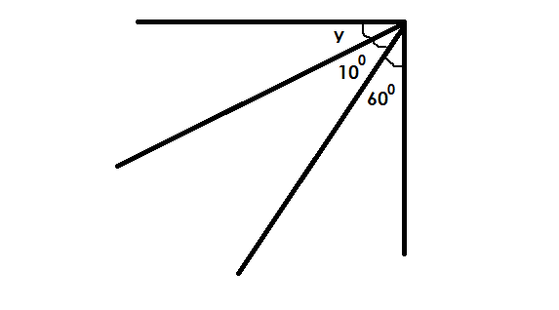(4)

**SUPPLEMENTARY ANGLES**

These are two or more angles that add up to 1800 and originating from one point.

**Examples**

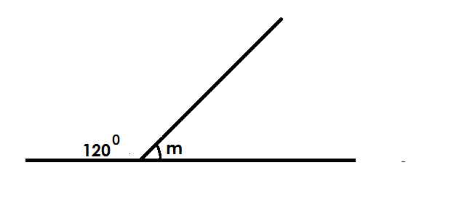Find the value of m

m + 1200  = 1800

m + 1200 - 1200  = 1800 (supp < s)

m = 600

Find the value of x in the figure below.

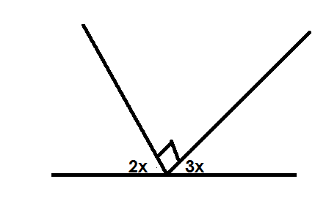

2x + 3x + 900 = 1800 (supp <s)

5x + 900 = 1800

5x + 900 - 900 = 1800 - 900

5x = 90**0**

5 5

x = 180

Find the value of K

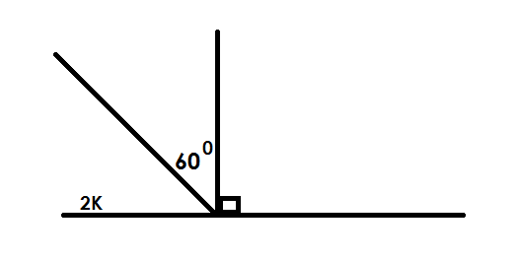

2K + 600 + 900 = 1800 (supp<s)

2K + 1500 = 1800

2K + 1500 - 1500 = 1800 – 1500

2K = 30**0** 15

2 2

K = 15

Find the value of n

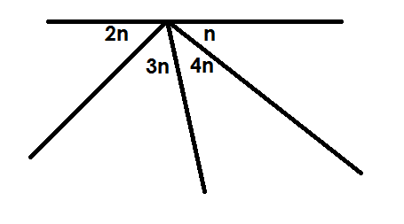

2n + 3n + 4n + n = 180 (supp<s)

10n = 1800

10n = 1800

10 10

n = 180

Three angles n, 700, and 800 are supplementary angles. Find the value of n.

n + 700 + 800 = 1800

n + 1500 = 1800

n + 1500 – 1500 = 1800 – 1500

n = 300

**Activity**

1. Find the value of m

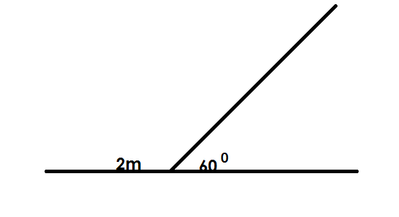

2. Find the value of the unknown angles

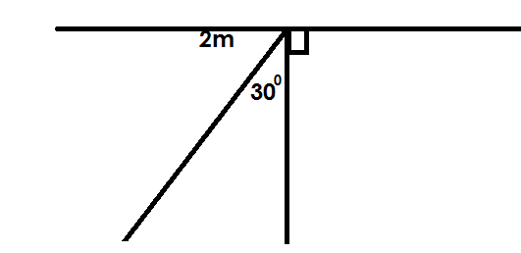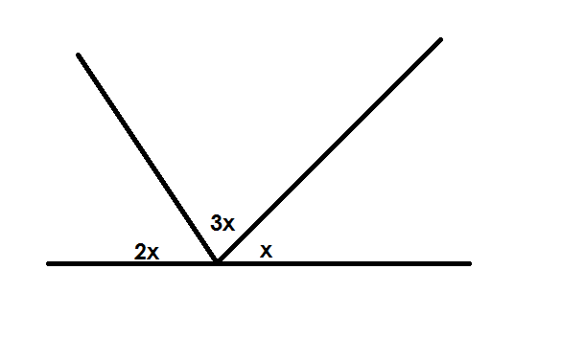(a) (b)

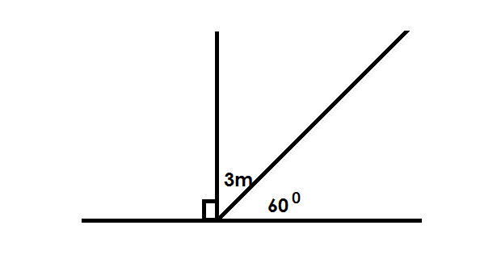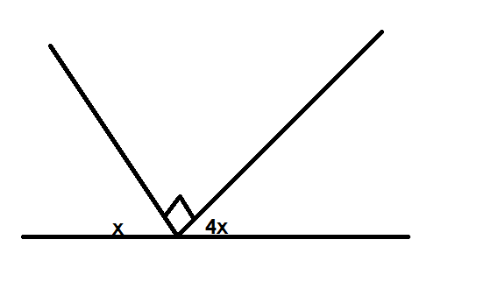(c) (d)

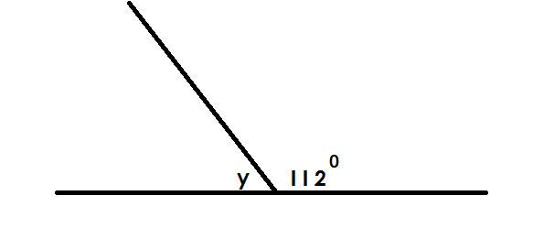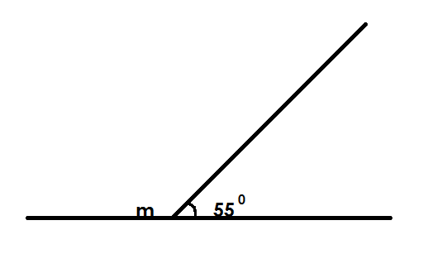

(e) (f)

**INTERIOR ANGLE SUM O F TRIANGLES**

**Note**:

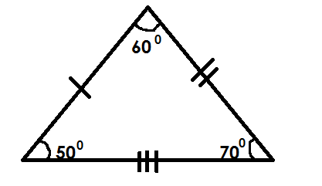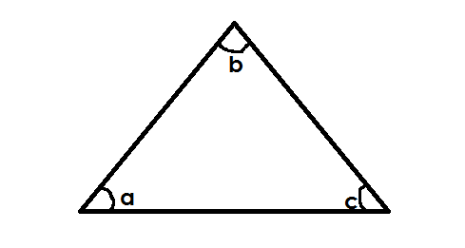A triangle has three interior angles which add upto 180**0**.



**TYPES OF TRIANGLES**

**A. Scalene triangle.**

**Note**: A scalene triangle has non of its sides and angles equal.

**Examples**

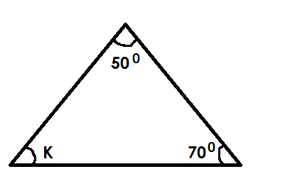1. Find the size of angle marked with letter K.

K + 500 + 700 = 1800

K + 1200 = 1800

K + 1200 - 1200 = 1800 – 1200

K = 600

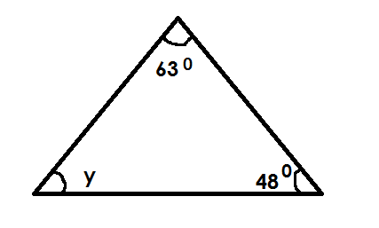2. Find the unknown angle in the triangle below

y + 630 + 480  = 1800

y + 1110 = 1800

y + 1110 - 1110 = 1800

y = 690

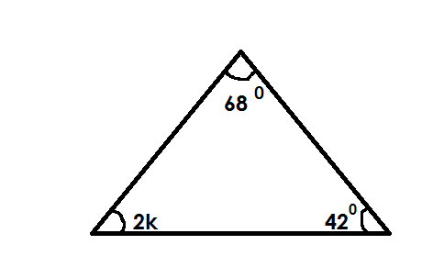3. Find the unknown angle in the figure below.

2K + 680 + 420 = 1800

2K + 1100 = 1800

2K + 1100 - 1110 = 1800 – 1100

2K = 700

2K = 700

2 = 2

K = 350

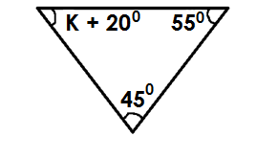4. Find the unknown angle in the triangle below.

K + 200 + 450 + 550= 1800

K + 1200  = 1800

K + 1200 – 1200 = 1800 – 1200

K = 600

**Activity**

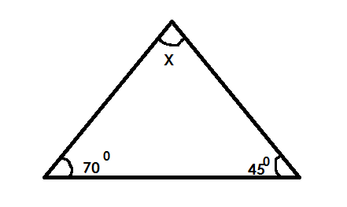1. Find the value of X in degrees.

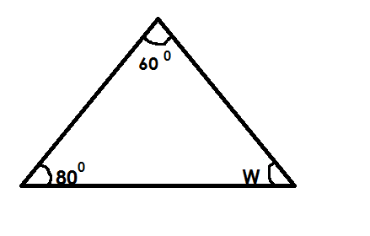2. Find the size of unknown angle.

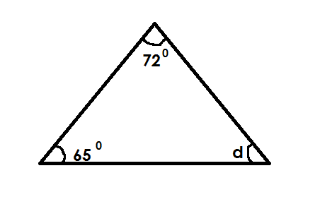3. Calculate the value of Y in degrees

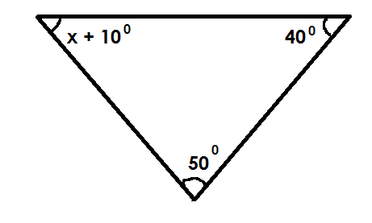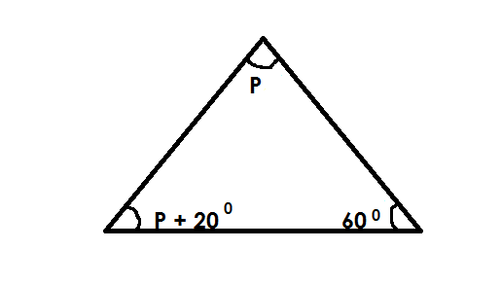4. Find the unknown angle in the triange below.

(a) (b)

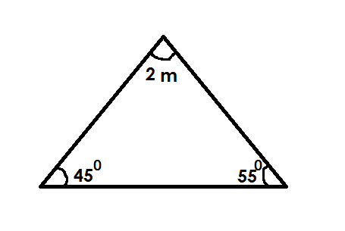(c)

**B. Equilateral triangle**

**Note**:

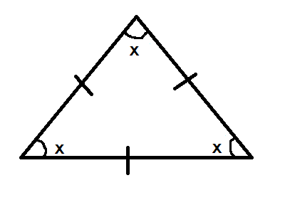All its three interior angles are equal



x + x + x = 1800

3x = 1800

3x = 1800

3 3

x = 600

Each interior angle of an equilateral triangle is equal to 600.

**Examples**

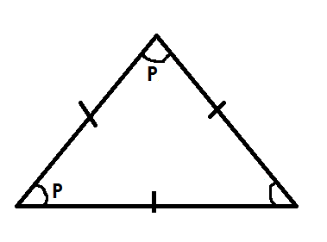1. Find the value of P in the figure below.

P + P = 1800

3p = 1800

3P = 1800

3 3

P = 600

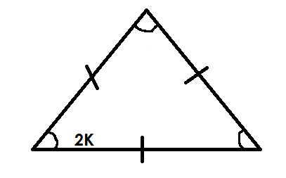2. Find the value of K in the triangle below.

2K + 2K + 2K = 1800

6K = 1800

6K = 1800

6 6

K = 300

**Activity**

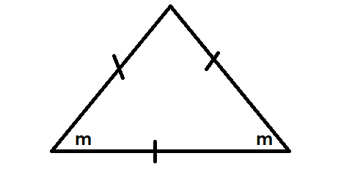1. Find the size of the unknown angle in each of the triangle below.

a.

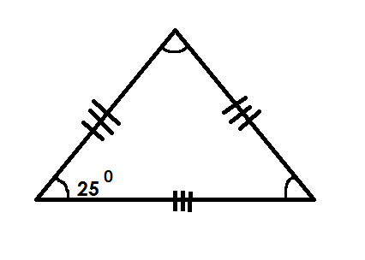

d.

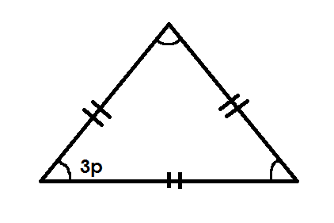

(c)

**C.** **Isosceles triangle.**

**Note**:

In an isosceles triangle, the two adjacent sides are equal making the two adjacent angles equal. (base angles are equal)

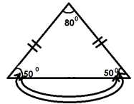Base angles are formed on the line that is different from others**.**

**Examples**

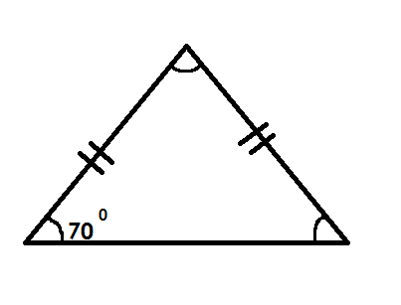1. Find the unknown angle in the figure below.

x + 700 + 700 = 1800

x + 1400 = 1800

x + 1400 - 1400 = 1800 - 1400

x = 400

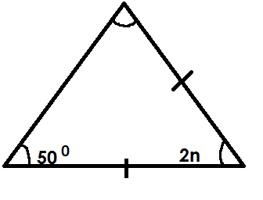2. Find the value of P in the triangle below.

2n + 500 + 500 = 1800

2n + 1100 = 1800

2n + 1100 - 1100 = 1800 – 1100

2n = 700

2n 2

n = 350

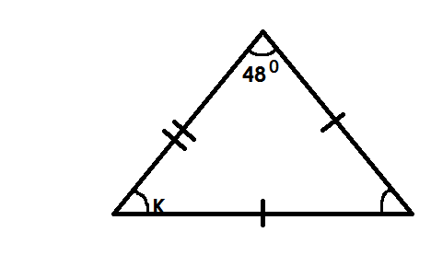3. Find the value of K in the figure below.

K + K + 480 = 1800

2K + 480 = 1800

2K + 480 + 480 = 1800 – 480

2K = 1320

2K = 1320

2 2

K = 600

**Activity**

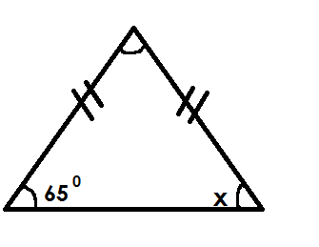1. Find the size of unknown angles in the triangles below.

(a)

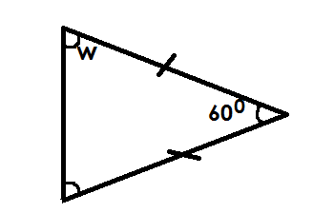(d)

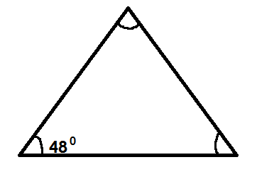

(b)

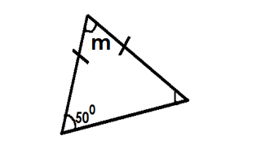

(e)

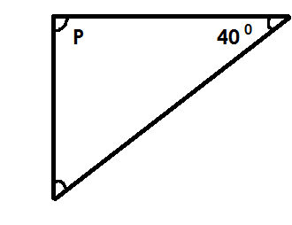(c)

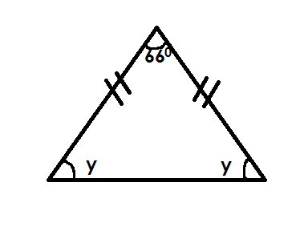(f)

**D.** **Right angled triangle.**

**Note**

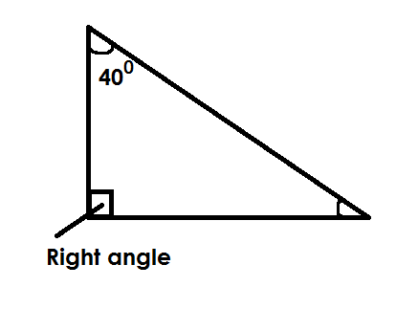In a right-angled triangle, one of its three interior angles measures 90**0** indicated by the symbol;

**Examples**

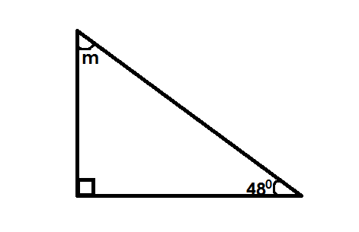1. Find the value of m in the figure below.

m + m 480 + 900 =1800

m + 1380 = 1800

m + 1380 – 1380 =1800 - 1380

m = 420

2. Find the unknown angle in the figure below.

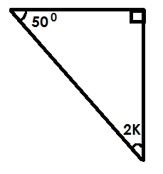 2K + 500 + 900 = 1800

2K + 1400 = 1800

2K + 1400 - 1400 = 1800 – 1400

2K = 400 20

2 2

K = 20

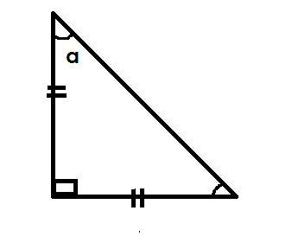3. Find the value of a in the figure below.

Soln

a + a + 900 = 1800

2a + 900 = 1800

2a + 900 - 900 = 1800

2a = 900

2 2

a = 450

**Activity**

1. Find the size of the unknown angle in degrees.

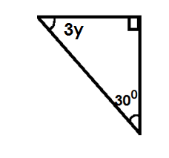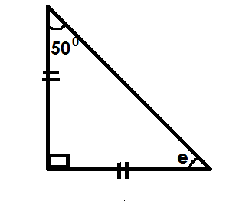(a) (d)

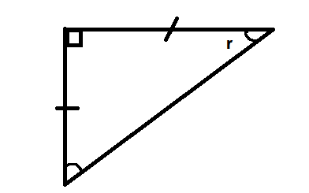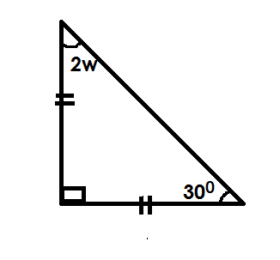

(b) (e)

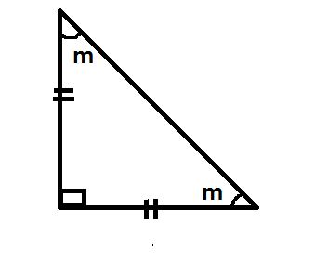(c) (f)

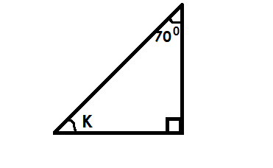

**DATA HANDLING**

**STATISTICS**

Statistics is a collection of information shown in numbers.

**Terms used**

Mode is the number that appears most in given data.

Range is the difference between the highest and the lowest number.

Median Is the middle number got after arranging in ascending order or descending order.

Modal frequency Is the number of times the mode appears.

Mean /average Mean is the uniform distribution of numbers, events, marks or scores.

**NB**  Mean or average is the result got after dividing the sum of items by their number.

**FINDING, MODE, RANGE, MEDIAN AND MEAN/AVERAGE AND MODAL FREQUENCY**

**Examples**

1. Given the list of numbers 1, 4, 6, 7, 8, 4

(a) Find the mode

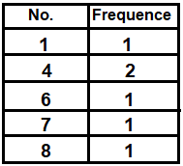 **Soln**

Mode = 4

(b) Find the range

**Soln**

Range = H – L

= 8 – 1

Range = 7

c. Work out the median

**Soln**

Median = 4 4 6 7 8

Median = 4 + 6

2

= 10

 2

Medium = 5

d. Find the mean

**Soln**

Mean = sum of items

No. of items

Mean = 1 + 4 + 4 + 6 + 7 + 8

6

Mean = 30

6

Mean = 5

(e) Find the modal frequency

No Frequency

1 1

4 2

6 1

7 1

8 1

The modal frequency = 2.

2. Richard scored the following marks in his end of term 1 examinations.

35, 50, 60, 45, 60

1. What was his range.

Range = Highest – lowest

= 60 – 35

Range = 25 marks

(b) Find his median mark.

Soln

Ascending

Median = 35 , 45 , 50 , 60 , 60

50

Median = 50 marks

c. Find the modal mark.

**Soln**

No frequency

35 1

45 1

50 1

60 2

The modal mark is 60.

d. Calculate his average mark.

Average = sum of items

No of items

Average = 250

5

Average = 50

e. Find the modal frequency

**Soln**

**No frequency**

35 1

45 1

50 1

60 2

The modal frequency is 2

**Activity**

1. Given the numbers 2, 4, 7, 2, 8 and 1.

(a) Find the mode

(b) Find the range.

(c) Calculate the median

(d) Workout the mean

2. Use the information below to answer question that follow.

3, 6, 7, 4, 5, 1, 4

a. Find the range

b. Workout the mode

c. Workout the mean

d. Find the average

e. Find the modal frequency

3. The boy scored the frequency marks in a test use them to answer questions.

5, 7, 2, 6, 10, 6

a. What is the highest mark?

b. Find the range.

c. What is the median mark?

d. Work out modal mark.

e. Find the mean.

Statistics is a collection of information shown in number.

**FINDING RANGE MODE MEDIAN AND MEAN OF GROUPED DATA**

**Example**

1. The table below shows marks scored by pupils in a test.

|  |  |  |  |  |
| --- | --- | --- | --- | --- |
| Marks scored | 40 | 50 | 30 | 60 |
| No. of pupils | 3 | 2 | 4 | 1 |

(a) How many pupils did the test?

3 + 2 + 4 + 1

= 10 pupils

(b) Find the modal mark

30

(c) Find the range of the mark.

Range = highest – lowest

= 60 - 30

= 30

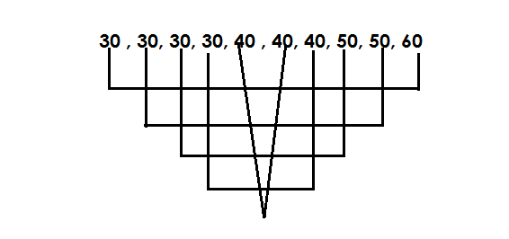(d) Find the median mark.

40 + 40

2

= 80

2

Median = 40

(c) Calculate the average mark

Average = Sum of items

No. of items

AV = (40 x 30) + (50 x 2) + (30 x 4) + (60 x 1)

10

AV = 120 + 100 + 120 + 60

10

AV = 400

10

AV = 40

**Activity**

1. The teacher recorded the weight of pupils as shown in the table below.

|  |  |  |  |  |
| --- | --- | --- | --- | --- |
| Weight in kg | 40 | 20 | 25 | 30 |
| No. of pupils | 1 | 3 | 2 | 4 |

(a) How many pupils were weighed?

(b) Find the modal weight.

(c) Find the range of the weight.

(d) Find the medium weight

(e) Calculate the mean weight.

2. Below is a table showing marks scored by pupils in at test.

|  |  |  |  |  |
| --- | --- | --- | --- | --- |
| Marks scored | 70 | 50 | 80 | 90 |
| Number of pupils | 2 | 3 | 4 | 1 |

(a) How many children did the test?

(b) Work out the modal mark.

(c) Find the range of marks.

(d) Work out the medium mark.

(e) Calculate the average mark.

3. The table below shows goals scored by different teams.

|  |  |  |  |  |  |
| --- | --- | --- | --- | --- | --- |
| Number of goals | 2 | 3 | 6 | 7 | 10 |
| Number of pupils | 4 | 1 | 2 | 1 | 2 |

(a) How many teams participated?

(b) Workout the modal score.

(c) Find the range of score.

(d) Find the median score.

(e) Work out the mean score.

**MORE ON FINDING RANGE, MODE, MEDIAN AND MEAN OF GROUPED DATA.**

**Examples**

Complete the table

|  |  |  |
| --- | --- | --- |
| Marks | No of pupils | Total |
| 40 | …………… | 120 |
| ………… | 4 | 80  …………. |
| 60 | 2 | …………. |
| ………… | 1 | 90 |

No of pupils = 120

40

= 30

Marks = 80

4

= 20

Total = 60 x 2

= 120

Marks 90

1

= 90

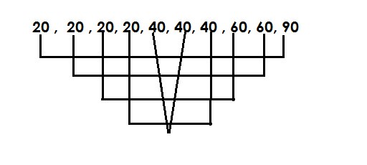b. Find the median mark

median = 80

2

Median = 40

Use the table below to answer questions that foolw.

|  |  |  |
| --- | --- | --- |
| Marks | No of pupils | Total |
| 80 | **IIII** | …………… |
| ………… | **IIIII** | 180 |
| 60 | …….. | 120 |
| ………… | **IIIIIII** | 160 |

a. Complete the above table

Total = 80 x 4

= 240

Marks = 180 30

60

= 30

Tallies = 120

60

= 2

Marks = 160 20

8

Marks = 20

(b) Find the median marks

Median =20, 20, 20, 20, 20, 20, 20, 20, 30, 30, 30, 30, 30, 30, 60, 60,

80, 80, 80, 80

Median = 30 + 30

2

Median = 60

2

Median = 30

c. Find the mean mark

Soln

Mean = Sum of item

No of items

Mean = (20 x 8) + (30 x 60) + (60 x 2) +( 80 x 4)

4 + 6 + 2 + 8

Mean = 780

20

= 39

**ACTIVITY**

1. Use the table below to answer the questions that follow.

|  |  |  |
| --- | --- | --- |
| Marks | No of pupils | Total |
| 80 | 2 | …….. |
| 40 | ……… | 120 |
| …….. | 1 | 50 |
| 70 | …….. | 280 |

(a) Complete the above table

(b) How many pupils are in the class.

(c) Find range of marks.

(d) Calculate the average mark.

(e) What is the median mark.

2. Use the table below to answer questions.

|  |  |  |
| --- | --- | --- |
| **Marks** | **No of pupils** | **Total** |
| 40 | **I I** | …….. |
| ……. | **IIII I** | 180 |
| 80 | ……. | 160 |
| …… | **I** | 90 |

(a) Complete the table

(b) Find the modal mark

(c) Calculate the range mark

**Graphs and interpretation of date**.

A graph is a picture or diagram used to show facts or numbers.

**Tallies**

Tallies are marks used to count and group things is five.

**Examples**

(a)  **1**

(b) **2**

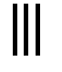

(c) **3**

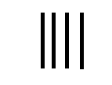

(d)  **4**

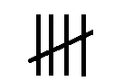

(e) **5**

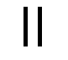(g) **12**



(f) **15**

**Activity**

1. Study and complete the tally marks below.

(a)

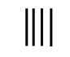(b)

(c)

(d)

(e)

(f)

(g)

(h)

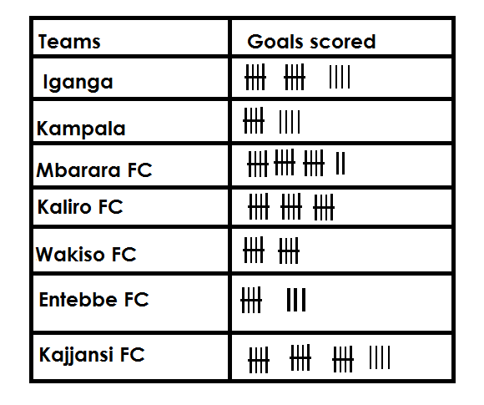2. The table below shows the number of goals scored by different teams. Use it to answer questions that follow.

a. How many goals did Iganga FC score?

b. Which team scored the highest number of goals?

c. How many goals were scored by Mbarara FC and Entebbe FC altogether?

d. Find the number of goals scored by Kampala FC, Kaliro FC.

e. Find the total number of goals scored by all teams.

3. Complete correctly

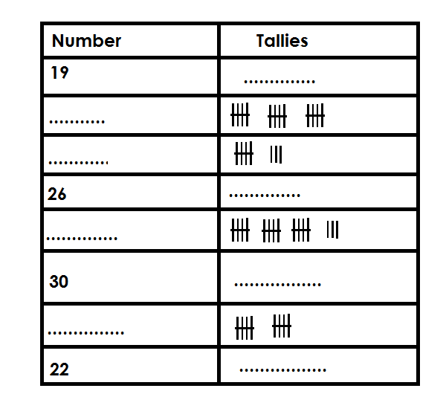

**SCALE INTERPRETION.**

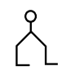 **Examples**

Given that represents 10 pupils find the number of pupils represented by



**Soln**

1 picture = 10

4 pic = (4 x 10) pupils

5

= x 10 pupils

 = 45 pupils

If represents 20 balls. Draw pictures to represents 70 balls.

**Soln**

20 balls = 1 picture.

1 ball = = pic

70 balls = x 70

= 3 rem 1

= 3



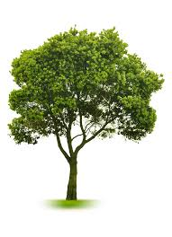 **Activity**

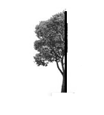1. If represents 50 trees. Find the number of trees represented by



2) Given that represents 20 books. How many books are represented by



3) Given that represents 40 oranges. Draw pictures to represent 200 oranges.

4) If represents 150 balls draw balls to represent 450 balls.

5) Given that represents 8 chairs draw pictures to represent 72 chairs.

**GRAPHS AND DATE HANDLING**

**Review: -**

- Interpretation of pictographs

- Drawing pictographs

**BARS GRAPHS**

This is a type of graphs were information / data is represented by use of columns and blocks.

**INTERPRETATION OF BAR GRAPHS**

**Example 1**

The graph below shows the attendance of pupils of primary five in a week.

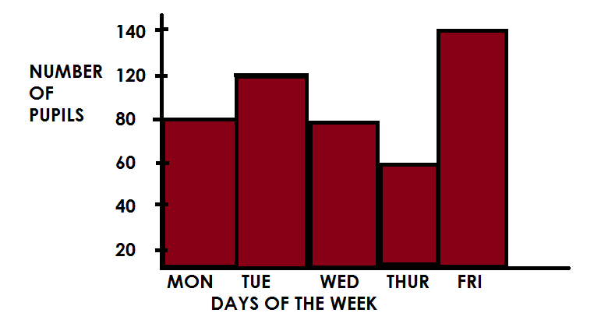

Vertical (A – axis)

Horizontal axis (x – axis)

**Note**:

While dealing with graphs, identify the vertical scale (axis) and the horizontal scale

(x – axis)

**A scale**

This is the quantity / number that is represented by one square.

-1 square one the vertical / axis represents 20 pupils.

-1 square on the horizontal axis represents one (1) day.

**Questions**

(a) On which day was the attendance height.

It was Friday.

(b) How many pupils were present on Tuesday?

120 pupils

(c) Which two days had the same attendance?

Monday and Wednesday

(d) How many pupils attended on Tuesday and Thursday?

Tue 1 2 0 pupils

Thur + 6 0 pupils

1 8 0 pupils

(e) Find the range in the attendance of pupils

Range = H - L

= 1 4 0 pupils

- 6 0 pupils

8 0 pupils

(f) Calculate the average attendance of pupils in the class.

Average = Sum of all items

No. of items

= 80 + 120 + 80 + 140

5

= 480 96

5

= 96 pupils

**Activity**

1. Study the graph and answer the questions below.

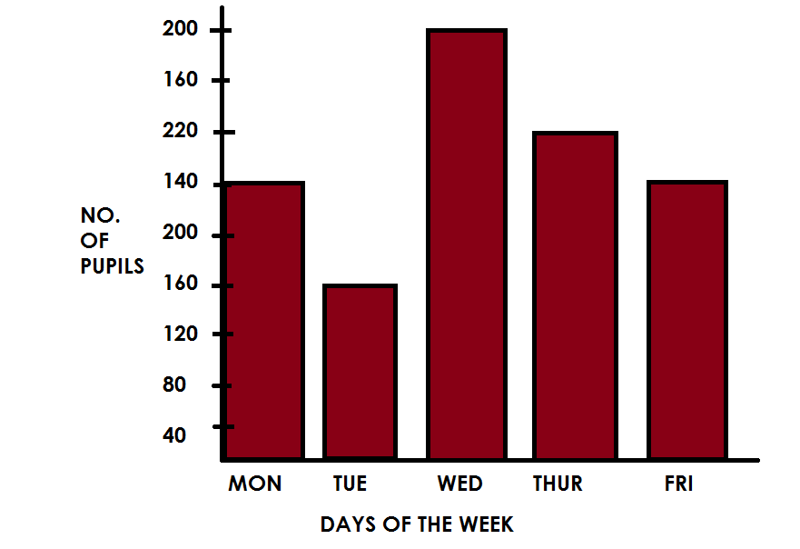

**Questions**

(a) State the vertical scale.

(b) What is the horizontal scale.

(c) How many pupils attended on Thursday?

(d) Find the total attendance of pupils on Monday and Friday.

(e) Which day had the lowest attendance?

(f) Identify the day that had the height attendance.

(g) Find the median attendance.

(h) Calculate the range in the attendance of pupils for the whole week.

(i) Work out the average attendance of pupils of the whole week.

2) The graph below shows number of eggs sold in a week.

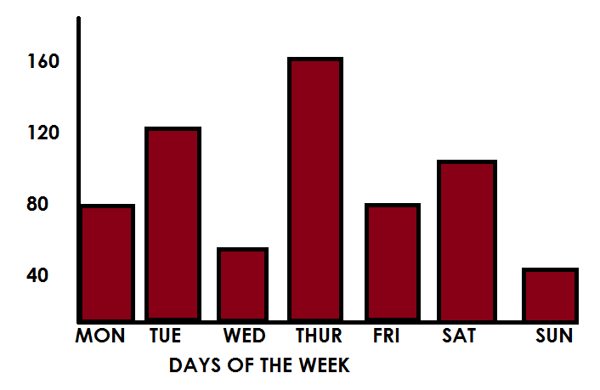

**Questions**

(a) How many eggs were sold on Wednesday?

(b) Which day had the height attendance?

(c) Identify the two days that had the same attendance.

(d) If eggs were packed on trays each 30 eggs, how many trays were produced on Monday and Sunday?

(e) Calculate the average number of eggs produced from Monday to Friday.

(f) Find the range in the production of eggs for whole week.

**DRAWING BARS GRAPHS**

- The graph should be well labeled.

- All graphs are drawn on a scale.

- If the scale is not given, come up with the vertical and horizontal scale before representing information on a bar graph.

- A good graph should have a title.

**Example I**

The table below shows types of food liked by pupils in P.5.

|  |  |  |  |  |  |
| --- | --- | --- | --- | --- | --- |
| No. of pupils | 10 | 15 | 5 | 20 | 25 |
| Types of food | Potatoes | Millet | Posho | Cassava | Rice |

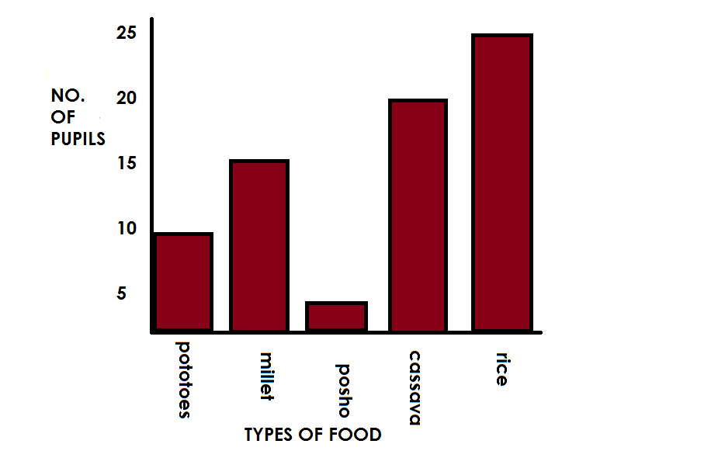

**Questions**

(a) How many pupils like rice?

(b) Find the range of pupils.

(c) How many pupils are in primary five?

(d) Calculate the average number of pupils.

**Activity**

The table below shows pupils of St. Anthony Primary School.

|  |  |  |  |  |  |
| --- | --- | --- | --- | --- | --- |
| No. of pupils | 40 | 100 | 40 | 80 | 60 |
| Class | P.1 | P.2 | P.3 | P.4 | P.5 |

Show the above information on the graph below.

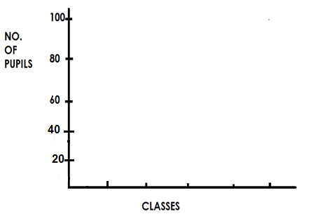

1. Which class has the highest number of pupils?
2. How many pupils are in P.1 and P.4?
3. Calculate the average number of pupils in the school.

2. The table below shows the average between rainfall at the Mt. Elgon between March and August. Study the table carefully.

|  |  |  |  |  |  |  |
| --- | --- | --- | --- | --- | --- | --- |
| Month | March | April | May | June | July | August |
| Rainfall | 30cm | 65cm | 50cm | 70cm | 80cm | 70cm |

1. Draw a bar line graph to represent the information in the table.
2. Choose a title for your graph.
3. What is the scale on your vertical axis?
4. What is shown on your horizontal axis?
5. What is shown on your vertical axis?

**LINE GRAPH**

Line graphs are often used to show how something changes over a period of time.

**Example I**

The following were numbers of correct answers scored in different subjects.

|  |  |
| --- | --- |
| **SUBJECTS** | **NUMBERS OF CORRECT ANSWERS** |
| English | 5 |
| Maths | 6 |
| SST | 9 |
| SCI | 6 |
| R.E. | 8 |
| Music | 10 |

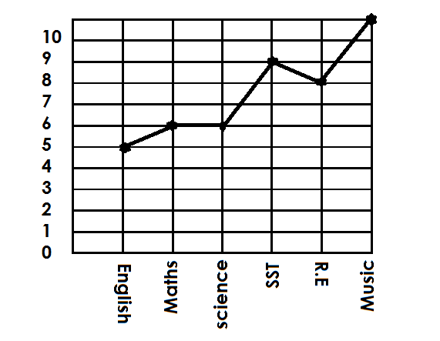Draw a line graph and represent the above data.

(a) What was Mukobe’s score in SST?

Mukobe scored 9 in SST.

(b) How many questions did Mukobe fail in Maths?

10 – 6 = 4 Mukobe failed 4 questions.

(c) In which subjects did Muobe have all answers correct?

Mukobe got all members correct in music.

(d) Workout Mukobe’s total score in all five subjects

= 5 + 6 + 6 + 9 + 8 + 1 0

= 4 4

**Activity.**

1. The table below shows marks scored by Alex in a test which was marked out of 10.

|  |  |
| --- | --- |
| **Subject** | **Marks scored.** |
| ENGLISH (ENG) | 8 |
| MATHEMATICS (MTC) | 10 |
| SCIENCE (SCI) | 4 |
| SOCIALSTUDIES (SST) | 6 |
| RELIGIOUS EDUCATION (R.E) | 5 |

Draw a line graph and represent the above information.

2. Below are different ages of pupils in P.3.

|  |  |
| --- | --- |
| **Pupils Name** | **Age** |
| Alex | 8 |
| Musa | 7 |
| Ali | 9 |
| Alice | 10 |
| Ruth | 8 |
| Faith | 8 |

Draw a line graph and represent the above data

3. Use the information below showing number of people in different families to draw a line graph.

|  |  |
| --- | --- |
| Family. | Number of people. |
| Kato’s family | 11 |
| Mubiru’s family | 8 |
| Ariho’s family. | 9 |
| Kiiza’s family. | 10 |

4. The table below shows Kasita’s daily sales for a week.

|  |  |  |  |  |  |  |
| --- | --- | --- | --- | --- | --- | --- |
| Day | Mon | Tue | Wed | Thur | Fri | Sat |
| Sales in (sh) | 20,000 | 15,000 | 25,000 | 30,000 | 40,000 | 35,000 |

(a) Draw a graph to show the information in the table.

(b) What is the difference between the highest and lowest sales?

(c) What is total value of sales for the six days?

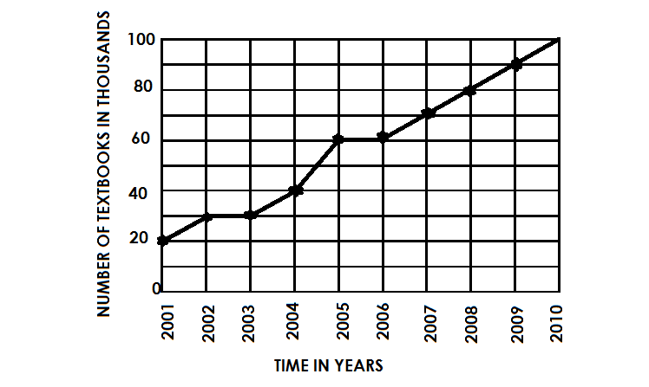5. The graph below shows text books received by primary schools in a district for ten years use it to answer questions that follow.

(a) In which year was the biggest number of text books received?

(b) How many text books were received in 2002?

(c) Calculate the total number of textbooks that were received in 2009 and 2000.

(d) Name the year in which 50,000 books were received.

(e) In which year was the least number of textbooks received?

**TIME**

**Telling time in a.m and p.m.**

* a.m mean Ante Meridiem.
* a.m is the first part of the day hence morning time.
* a.m starts from 12:00 mid – night to 12:00mid- day
* p.m means post meridiem.
* p.m is the second part of the day hence afternoon and evening time.

**Example**

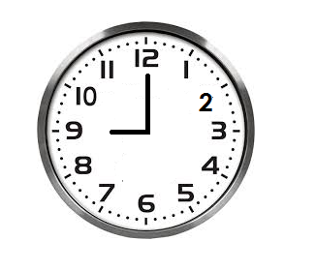(1) Write the time in a.m and p.m

9:00 a.m**or** 9:00p.m

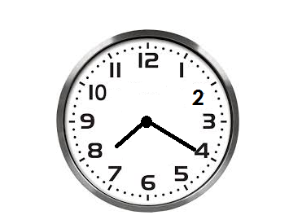(2) Write the meaning time on the clock face below.

8:20 a.m

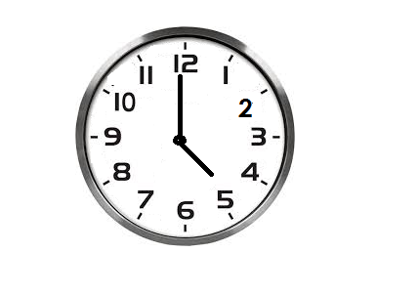(3) Write the morning time shown on the clock face below.

5: 50am

(4) Express 6 o’clock in the morning

Soln

6:00a.m

(5) 8 o’clock in the afternoon

Soln

8:00p.m

**Activity**

(1) Write the morning time shown on the face.

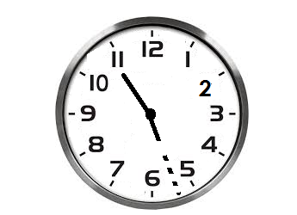

(2) Write the evening time shown on the clock face.

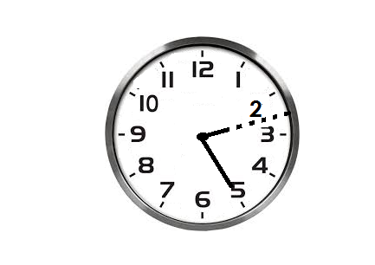(3) Write the morning time on the clock face.

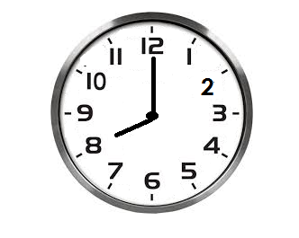

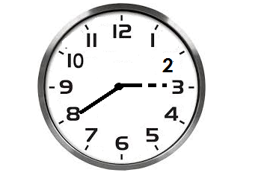(4) Write the afternoon time shown on the clock face.

(5) Write the time using a.m or p.m

(a) The time when the first lesson begins at 8 o’clock.

(b) The time when you go to sleep at 9 o’clock.

(c) The time when we go home at a half past 5 o’clock.

(d) What time is a quarter to 9 o’clock in the morning.

(e) The time when we go to school at a half past 6 o’clock in the evening.

**CHANGING HOURS TO MINUTES**

**Note**: **1 hour = 60 minutes**

**Examples.**

Change 4 hours to minutes

1 hour = 60minutes

4 hours = (4 x 60) minutes

= 240minutes

Covert 2to minutes

1 hour = 60minutes

2 hour =2 x 60 minutes

30

= x 60 minutes

= 150 minutes

Express 9 x 60mimutes

1 hour = 60minutes

9hours =9x60minutes

15

= 37 x 60 minutes

4

= 555 minutes

Convert 3hours to minutes.

**Soln**

1 hours = 60minutes

3hours =3x 60 minutes

15

= x 60 minutes

= 195 minutes

**Activity**

1. Convert 4 hours to minutes.

2. Convert the following hours to minutes

(a) 1 hours (b) 4 hours (c) 6 hours (d) 7 hours

(e) 9 hours (f) 10 hours (g) 13 hours

**CHANGING MINUTES TO HOURS**

**Note: 60minutes = 1 hour**

**Example**

1. Change 240 minutes to hours.

**Soln**

60 minutes = 1hr

1 min = hours

4

240 mins = x 240 hrs

= 4hrs

2. Change 150 minutes to hours

**Soln**

60mins = 1hrs = 555 hours

1 min = x 555 hrs 60

9 hrs

**Activity**

1. Change the following minutes into hours

(a) 120 minutes

(b) 360 minutes

(c) 210 minutes

(d) 135 minutes

2. The meeting lasted for 90 minutes. Express the time the meeting lasted in hours.

**ADDITION OF TIME**

**Note**:

We cannot have more than 59 minutes in the column of minutes.

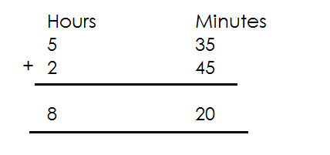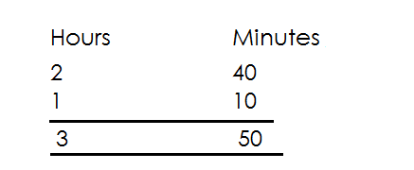 **Example**

1. Add: 2. Add:

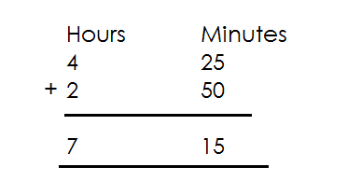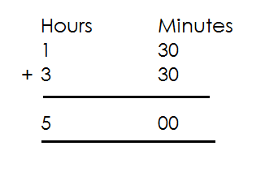

3. Work out: 4. Add:

**Activity**

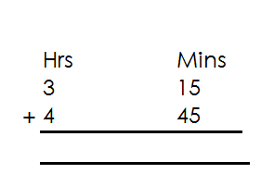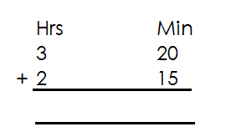1. Add the following

(a) (d)

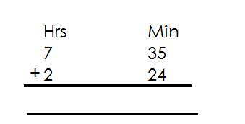

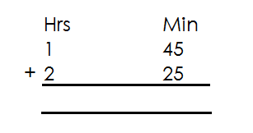(b) (e)

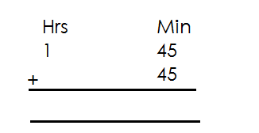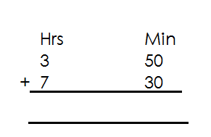

(c) (f)

2. Add 3hrs 35 minutes to 4 hrs 42 minutes.

3. Baguma walked for 2hrs 40minuted from his home to the river and for 1hr 50 minutes from the river to the market. How long did it take him to walk from home to the market?

**SUBTRACTION OF TIME**

**Note**:

When re-grouping in subtraction of hours and minutes, regroup 1 hour = 60 minutes.

Examples.

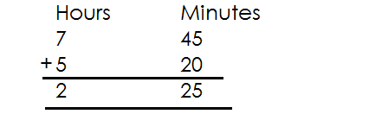1. Subtract:

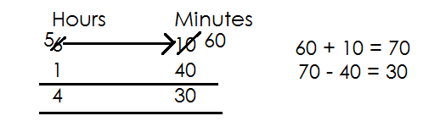2. Work out:

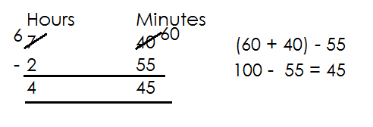

3. Subtract:

**Activity**

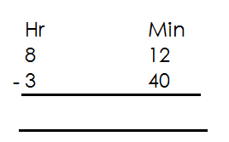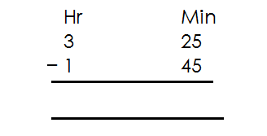1. Subtract the following

(a) (d)

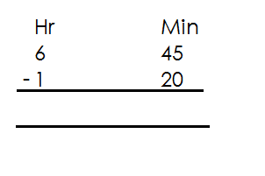

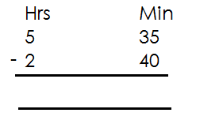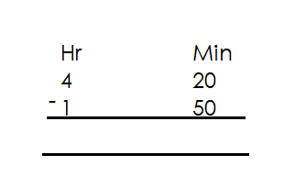(c) (e) (d)

2. Ben took 3 hrs 25 min to move from home to town. If he walked 1hour 35min and took a taxi for the rest of the journey. How much time did he spend in the taxi?

3. Anukunda spent a total of 5hrs 20 minutes at school. She played for 1 hr 30 minutes for how long did she stay in class?

**CHANGING TIME FROM 12 HOURS CLOCK TO 24 HOURS CLOCK.**

**Note**:

* Time in 24 hour clock system is determined in hours (don’t put a.m or p.m) .
* Dots separating hours and minutes are not written on time in 24-hour clock
* Time in 24-hour clock system is written using 4 digits.
* 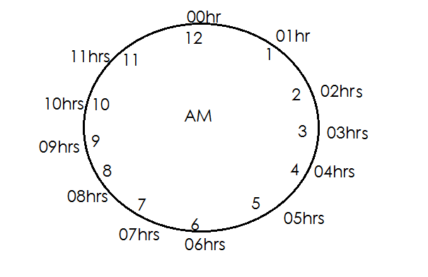Given AM, use AM clock face whose first hour in 24 is 00hrs.

1. 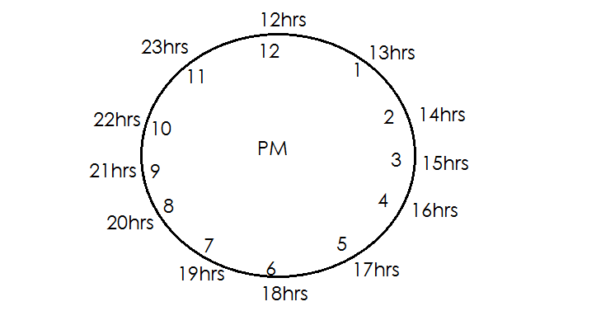Give pm, we use pm clock face whose first hr in 24hour is 12 hours.

- Minutes, in 12-hour clock system remain the same in 24-hour clock system.

**Examples**

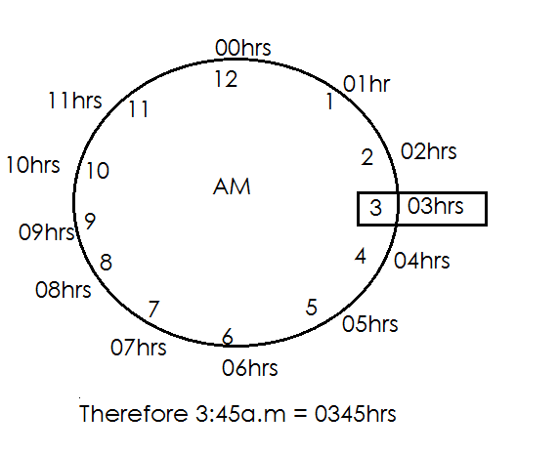1. Express 3:45a.m to a 24 hours clock system.

2. Write 12:00midnight in 24-hour clock system.

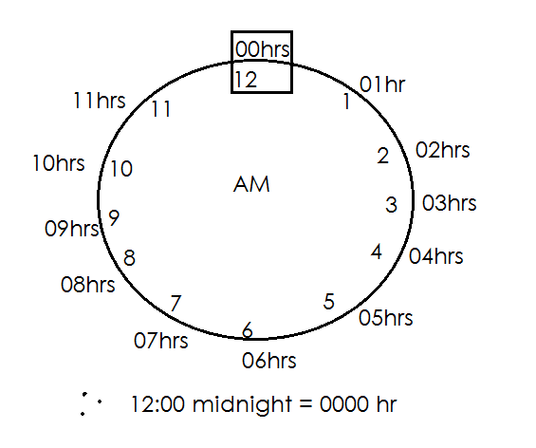

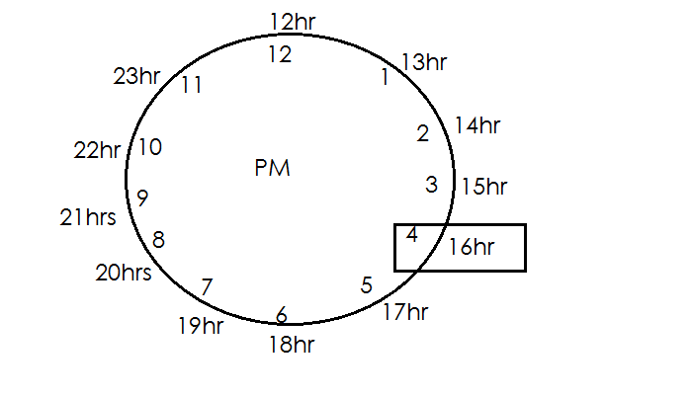3. Express 4:35pm to 24hr clock system.

There 4:35 pm = 1635 hr.

**Activities**

1. Express 2:30pm to 24-hour clock system.

2. Change 3:20am to a 24-hour clock system.

3. Convert 4:25pm to a 24-hour clock system.

4. Convert the following to the 24-hour clock

(a) 11:28pm

(b) 11:00am

(c) 9:30am

(d) 8:25pm

(e) 2:35am

(f) 7:42am

**CHANGING 24 HOURS CLOCK SYSTEM TO 12 HOUR CLOCK SYSTEM**

**Note**:

* When the 24-hour time is below 12 hours, that time is in am part of the day.
* When the 24-hour time is 12 hours and above, that time is pm.

**Examples**

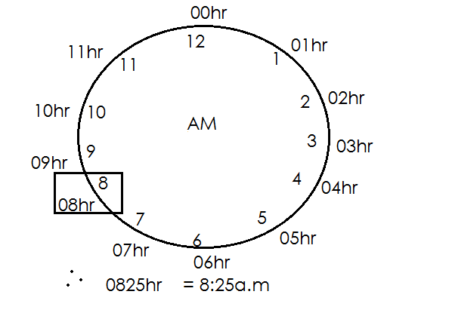1. Change 085hr into 12-hour clock system

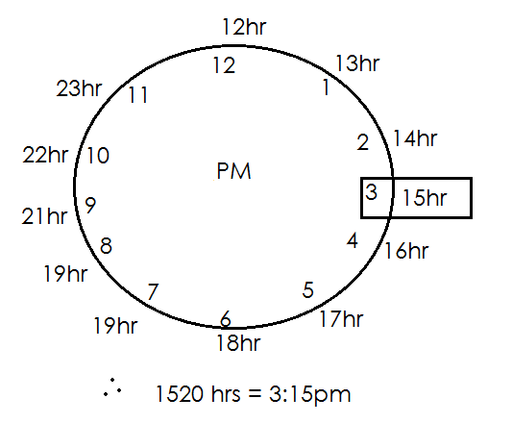2. Express 1520hr in 12-hour clock system.

**Activity**

Convert the following from 24 hours clock system to 12-hour clock system.

1. 1210 hrs 5. 1612hrs

2. 2100hrs 6. 1400hrs

3. 1745hrs 7. 2315hrs

4. 1330hrs

**FINDING DURATION**

Duration is the length of time something lasts.

**Or**

Duration is the time taken or used.

**Note**:

Duration = Ending time - starting time

Duration = ET - ST

**Examples**

A staff meeting started at 9:15a.m and ended at 11:45a.m. How long did it last?

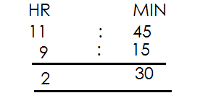 Duration = ET - ST

Ending time

Starting time

Duration =

The meeting lasted for 2 hours 30 minutes

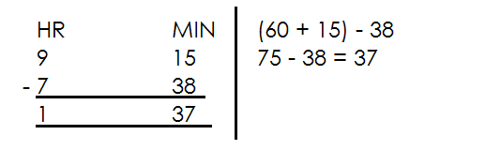2. Tony started walking from his home at 7:30am and reaches town at 9:15a.m. How long was his journey?

The jouney lasted for 1hour 37 minutes.

3. Tom started an examination at 2:30pm and ended at4:30pm. How long did he take?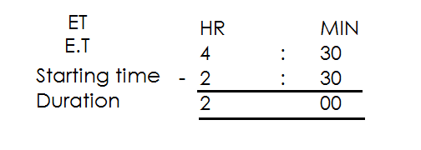

He took 2 hours

4. Jovan left Kampal for Nairobi at 6:00a.m and arrived in Nairobi at 8:20pm. How long did the journey take?

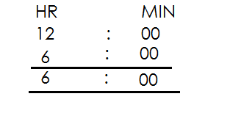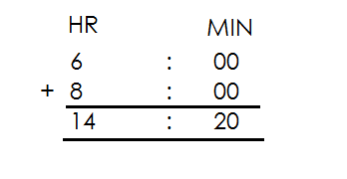 From 6:00am - Mid day (12:00) Then add



**Activity**

1. A foot ball match started at 5:00pm and ended at6:50pm. How long did it last?

2. A party started at 10:30am and ended at 3:00pm. How long did the part take?

3. Kasule left Kampala for Kasese at 4:12a.m and arrived at 12:00noon. Find the time the journey lasted.

4. A lesson started at 8:00a.m and ended at 9:30a.m. How long did it take?

5. My father went to the garden at 7:40am and came back at 11:00a.m. He long did he take?

6. A speech day started at 8:15am and ended at 5:00p.m. How long was the speech day?

**FINDING STARTING TIME A VENN ENDING TIME AND DURATION**

Starting time = Ending time - Duration

S.T = E.T – D

**Examples**

A 2 hours meeting ended at 10:00a.m. At what time did it start?

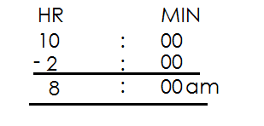 ST = E.T - D

The lesson started at 8:00a.m

A forty minutes lesson ended at 11:20a.m. At what time did start?

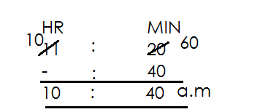Soln = E.T - D

The lesson started at 10:40a.m

**Example III**

Our baby wake up at 11:00a.m.He took 1sleeping. At what time did it start sleeping? 30

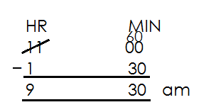**Soln** 1 hr x 60

E.T =

D = 1 hr 30min

The baby started sleeping at 9:30a.m

**Activity**

1. A maths lesson which ended at 9:30am lasted for 2 hours. At what time did it started?

2. A fifty minutes lesson ended at 11:50am. At what time did it start?

3. A football match ended at 11:0pm if it lasted for 1 hr 30minutes. At what time did it start?

4. Bobi’s speed speech lasted for 2hours 30min. If it ended at 11:50a.m. At what time did it start?

5. Richard sung for 40minutes. If he stopped at 9:20a.m. At what time did he start singing?

**FINDING ENDING TIME WHEN GIVEN STARTING TIME AND DURATIONS**

Ending time = Starting time + Duration

E.T = S.T + D

**Example**s

A lesson started at 8:00am and took 1 hours. At what time did it end?

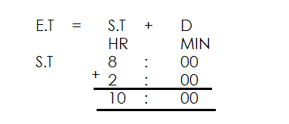

It ended at 10:00am

**Example II**

A farmer who started digging at 7:20a.m used 3 hours. At what time did he end?

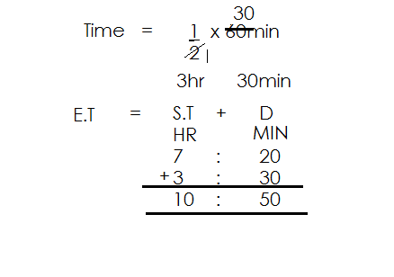**Soln**

He ended at 10:50am

**Activity**

1. A morning lesson started at 8:00a.m it took 2 hours. At what time did the lesson end?

2. A footbale match started at 3:30pm. If it took 1 . At what time did it end?

3. A church service took 3 hours. It started at 4:30p.m. At what time did it end?

4. At what time did the shoe end it it started at 4:00pm and took 3 hours?

5. Our baby woke up at 11:00a.m. He took 1 hours sleeping. At what time did he start sleeping?

**FINDING DISTANCE USING TIME AND SPEED**

**Note**:

- Distance is a numerical measurement for how far apart objects or points are.

- Speed is the rate at which distance is covered.

Distance = Speed x Time

Therefore Distance = S X T

**Examples**

Find the distance a driver covers in 2 hrs at a speed of 90km/hr

Distance = S x T

= 90km x 2hr

1hr

= 90km x 2

= 180km

A taxi takes 1 hrs to cover a distance from Kampala to Mufuta at a speed of 60km/hr. Find the distance between Kampala and Mufuta.

Distance = S X T

= 60km x 1hr

= 3 60km x hr

1hr

= 30km x 3

= 90km

Find distance covered by a bus that travels at a speed of 12okm / hr in 40min.

Distance = S X T change minutes to hours by

2 dividing given minutes by 40 min

= 120 x 40hr

1 hr 60

= 80km

**Activity**

1. A car moved at a speed of 50km/h for 3hrs. Find distance covered.

2. Find the distance covered by a cyclist moving at 15km/hr in 4hrs.

3. A motorist travelled from town A to B at a speed of 80km/hr in 2 hrs find the distance covered.

4. A school truck travelled for 2 hrs at an average speed 60km per hours. What distance did it cover?

5. A cyclist travelled for 3 hours at a speed of 80km/hr. Find distance covered.

6. A car travelled for 4 hr at an average speed of 84km/hr. How long was the journey?

7. A car moving at 120km/hr take 20min to cover a journey. How long is the journey?

8. Musa takes 40min to covers a distance at a speed of 60km/hr. Find the speed used.

9. At a speed of 48km/hrMatama takes 45min to cover the journry, how long is the journey?

**MORE ABOUT DISTANCE**

**Example I**

A taxi left Jinja at 8:00am travelling to Kampala at a speed of 60km/hr. If it reached at 10:00am. Find the distance covered.

**Soln**

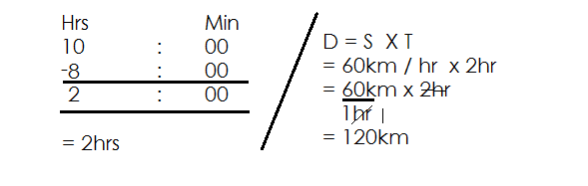 Time taken = ET - ST

**Activity**

1. A car moves at a speed of 80km/hr from 2:00pm to 4:00pm. Find the distance covered.

2. Find the distance coverd by taxi travelling at an average speed of 90km/hr from 1:00pm to 4:00pm.

3. A bus moves at a speed of 70km/hr from 8:15am to 11:15am. Find the distance covered.

4. At a speed of 54km/hracylist left Katongo at 9:00am and arrived at Kampala at 10:30am. How far is Kampala from Katonga?

5. A cylist left Kampala at 11:00am and arrive Masaka at 1:00pm moving at a speed of 70km/hr. Calculate the distance covered.

**FINDING TIME GIVEN DISTANCE AND SPEED.**

**Note:** Time = Distance ÷ Speed

= D ÷ S

Time is measured in hours, minutes or seconds.

**Examples**

How long will a car take to cover a distance of 120km at a speed of 40km/hr.

T = D ÷S 3

= 120km ÷ 40km/hr = 120km x 1hr

= 120km ÷ 40km 40km

1hr = 3hrs

A motorist covered a distance of 90km a speed of 60km/hr. Find time used.

 Time = D ÷ S

= 90km ÷ 60km/hr = hr

= 90km ÷ 60km

 1hr = 1 hr

= 90km x 1hr

60 km

2

**Activity**

1. Peter has to cover a journey of 240km at a speed of 80km per hour. Find time taken.

2. Find time needed to cover a journey of 180km at a speed of 60km.

3. Calcualte time required for a car to cover a distance of 120km at a speed of

60km /hr.

4. Acyclistcoverd a distance of 100km ate a speed of 40km/hr. how many did he take?

5. How long will it take acyclist did he a distance of 80km at a speed of 20km/hr.

6. If a bus moves at 30km/hr and covers a distance of 240km, how long does it take to cover the journey?

7. A taxi travelled at a speed of 70km/hr to cover a distance of 245km. How long did it take?

**FINDING SPEED GIVEN DISTANCE AND TIME**

Speed = D ÷ T Speed = D if given whole numbers

Speed is measure in T

km/hr or m/sec

**Examples**

Find speed used to cover a distance of 150km is 5hrs.

**Soln**

Speed = D

T

3

= 150

5hrs

= 30km/hr

A car covered a distance of 90km in 1 hrs. Calcualte the speed used.

Speed = D ÷ T

= 90km ÷ 1 hr

= 90km ÷ hr

= 90kkm x hr

= 30km x

= 60km/hr

At what speed did the bus travel to cover a distance of 80km in 40 minutes.

S = D ÷ T

 = 80km ÷ hr

= 80km x hr

= 120km/hr

**Activity**

1. Find the speed needed for a motorist to cover a distance of 360km in 3hrs.

2. A driver covered a distance of 200km in 2hrs. At what speed was he travelling?

3. A cyclist covered a journey of 84km in 4 hrs. At what sped was he travelling?

4. Find speed used to cover a distance of 60km in 2 hr.

5. An athlethic covered a distance of 12km in 1 hr find his speed.

6. A car covered 60km inhours. How many km did it cover in eachhour?

7. Martha spends 6hours on the way from Mbale to Kampala a distance of 420km. At what speed was she travelling?

8. Find speed needed to cover a distance of 30km in 20 minutes.

9. Calculate speed used to cover a distance of 120km in 50 minutes.

10. Othieno covered a distance of 180km in 40 minutes. Calculate his speed in km/hr.

**MEASURES**

**MONEY**

Money is a medium of exchange.

**Simple rates and proportion**

**Examples**

A book costs sh 5000. What is the cost of 6 similar books? 

 1 book Sh 5000

6 books Sh 5000

x 6

Sh 30,000

6 pens cost sh 1200. What is the cost of 7 simila pens?

 6 pens Sh 1200

1 pen Sh 1200 200

 6

 1 pen Sh 200

7 pens Sh 200

x 7

Shs 1400

 A den of pencils cost shs 1440. Find the cost of sh 5 pencils.

 1 dozen 12 pencils.

12 pencils sh 1440

 120

Sh 1440

 12

 1 pencil Sh 120

5 pencils Sh 1 2 0

X 5

Sh 600

**Activity**

1. The cost of one table is sh 20,000/=. Find the cost of three similar tables.

2. 2 books cost sh 2400. What can one pay if one needs only one book?

3. A pair of shoes costs shs 5000. How much shall I pay for 3 pairs of shoes?

4. 3 pencils cost sh 450. What is cost of 10 pencils?

5. Eight dresses cost sh 64,000. Find the cost of 10 similar dresses.

6. Two kilograms of sugar cost sh 10,000. Find the cost of 5 kg of sugar.

7. A boy bought 12 pencils at sh 24000. How much was he to pay if he neede only 3 similar pencils?

8. two shirts cost shs 20,000. How many shirts can l get with sh 80,000?

9. A green grocer sells 8 mangoes for sh 1600. How many mangoes can one get with sh4000?

**BUYING AND SELLING (SHOPPING LIST)**

**Examples**

1. Amoti went for shopping and bough the following items

One loaf of bread at sh.1800.

3 bars of soap at sh 3000 each.

2 kg of sugar at sh 2000 per lk

(a) How much did he spend on soap a lone?

Soap = 3 x sh 3000

= Sh 9000

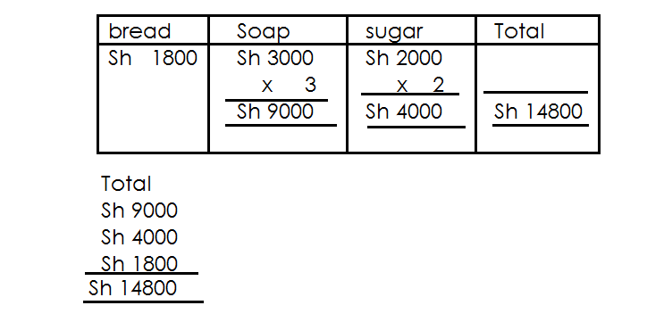(b) Find his total expenditure.

1. Chris went to the shop and bough the following items.

2kg of salt at sh 1200/=

2 kg of beans at sh 3000 per kg.

500g of cooking oil at sh 2000 per litre

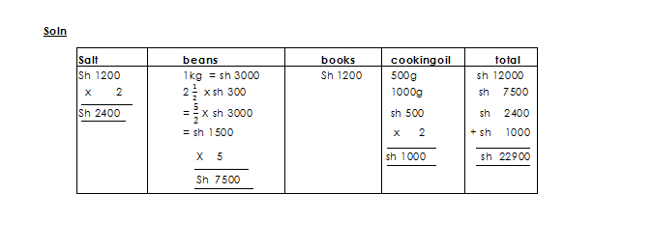 Find his total expenditure

**Example 3**

3. Amanya went to the market and bough the following items.

2kg of beans at sh 2000 akg

1 kg of rice each kg at sh 3000

250g of salt sh 1000 akg

12 tomatoes at sh 500 for every heap of s tomatoes.

(a) Find his total expenditure.

|  |  |  |  |  |
| --- | --- | --- | --- | --- |
| **Beans** | **Rice** | **Salt** | **Tomatoes** | **Total** |
| 1kg = sh. 2000  2kg = sh. 2000  x 2  sh 4000 | 1 kg = sh 3000  1 kg =1 x 3000  = x 3000  = 3 x sh 1500  = sh 4500 | 250 x sh 1000  1000  Sh 250 | 4  12 x sh 500  3  Sh 2000 | Sh. 4000  Sh. 4500  Sh. 2000  Sh. 2500  Sh. 250  Sh 10750 |

(b) If he was given change of sh 4250, how much did he have?

Sh 4250 + Sh 10750

Sh 10750

+ Sh 4250

Sh 15000

**Activity**

1. Martha went shopping ans bough the following items.

3kg of rice each at sh 2000.

2 bars of soap at sh 4000.

1 kg of meat at sh 12000 akg.

(a) Calculate her total expenditure.

(b) If she had sh 30,000, find he change.

2. Wadada went to the market and bough the following items.

2 kg of sugar at sh 4000 per kg.

4 packets of tea leaves at sh 1000.

500g of rice at sh 600 akg.

(a) Calculate his total expenditure.

(b) If he went with 4 five-thousand-shilling notes, find his change.

3. Opio went to the shop and bought the following items.

1litres of oil at sh 4000 each litre.

3 bars of soap at sh 12000

400g of meat at sh 400 per heap of 3 oranges.

(a) Find his total expenditure.

(b) If he was given a change of sh 25200, how much did he go with?

**SHOPPING BILLS**

**Note**

Quantlty = Amount

Unit cost

Unt cost = Amount ÷ Quantity if given

Amount = Unit cost X Quantity

**COMPLETING BILL TABLES**

**Examples.**

Complete the table below.

|  |  |  |  |
| --- | --- | --- | --- |
| **Item** | **Quantity** | **Unit cost** | **Amount** |
| Sugar | 2kg | Sh 4000 | Sh 8000 |
| Soap | 1 bars | Sh 3000 | Sh 4500 |
| Salt | 2 kg | Sh 2000 | Sh 5000 |
| Rice | 2kg | Sh 2000 | Sh 4000 |
|  | **Total expenditure** | | **Sh 215000** |

|  |  |  |  |  |
| --- | --- | --- | --- | --- |
| **Soln** | **Quantity** | **Unit cost** | **Amount** | **Total** |
| Amount  2 x sh.4000  Sh 4000  x 2  Sh 8000 | 3  Sh4500  Sh 3000  2  3 I rem 1  2  1 | Sh (5000 ÷ 2 )  Sh(5000 ÷ )  Sh 5000 x  Sh 2000 | 2 x sh. 2000  Sh 2000  x 2  sh 4000 | Sh 8000  Sh 4500  Sh 5000  +Sh 4000  Sh. 21500 |

**Example**

(a) Complete the table below

|  |  |  |  |
| --- | --- | --- | --- |
| **Item** | **Quantity** | **Unit cost** | **Amount** |
| Rice  Sugar  Meat  Cooking oil | 1kg  2kg  500g  L | Sh 3000  Sh**2000**  Sh 1000kg per kg  Sh 8000 | Sh**4500**  Sh 4000  Sh**500**  Sh 4000 |
|  | Total expenditure | | Sh 13000 |

**Soln**

|  |  |  |  |
| --- | --- | --- | --- |
| **Item** | **Unit cost** | **Quantity** | **Total** |
| Sh (1 x 3000)  1500  Sh x 3000  Sh 4500  Amount  Sh 5000g x 1000  1000g  Sh 500 | Sh4000  2  Sh 2000 | Sh4000  Sh 5000  2  litres | Sh 4500  Sh 4000  Sh 4000  + Sh 500  Sh 13000 |

(b) If he had 4 five-thousand-shilling notes calculate his change.

Amount he had

1 note = sh 5000

4 notes = sh (4 x sh 5000)

= sh 20000

Change = sh 20000

- sh 13000

Sh 7000

**Activity**

1. Complete the following shopping list a mother gave to her children

|  |  |  |  |
| --- | --- | --- | --- |
| **Item** | **Quantity** | **Unit cost** | **Amount** |
| Meat  Salt  Irish potatoes  Rice | 3kg  500g  ……… kg  2 kg | Sh 10,000 per kg  Sh 1200 per kg  Sh 2000 per kg  Sh 2400 | Sh ………..  Sh …………  Sh 4000  Sh …….. |
| Total expenditure. | | |  |

2. Amoti went for shopping and bough the following items.

|  |  |  |  |
| --- | --- | --- | --- |
| **Item** | **Quantity** | **Unit cost** | **Amount** |
| Rice  Meat  Cooking oil  Posho  Tea leaves  Omo | 4kg  …… kg  …………litre  2 kg  700g  2.5kg | Sh 3000  Sh 10,000  Sh 3000 per litre  Sh……….  Sh 2000 per packet  Sh 3600 per kg | Sh……….  Sh 35000  Sh 1500  Sh 7500  Sh ………  Sh ……… |
| Total |  | |  |

If he went with 2 fifty thousand notes, calculate his change.

3. Richard went for shopping and bought the following items.

|  |  |  |  |
| --- | --- | --- | --- |
| **Item** | **Quantity** | **Unit cost** | **Amount** |
| Mugs | dozen | Sh ………… | Sh 20,000 |
| Blue band | ………… | Sh 3000 | Sh 10, 5000 |
| Salt | 500g | Sh 1500 | Sh ………….. |
| Bean | ………. Kg | Sh 4000 | Sh 2000 |
| Rice | 0.5kg | Sh 3500 | Sh ……….. |
| **Total** |  |  | Sh ………. |

If he went with 3 twenty thousand shillings note. What was his change?

**PROFIT**

A profit is the amount gained after selling.

**Note:**

Profit is realized when when the selling price is higher that the buying price

Profit = selling price - Buying price

= S.P - B.P

**FINDING PROFIT**

**Examples**

1. Isaac bought a shirt at sh 3000. He sold it at sh 3800. What was his profit?

**Soln**

Selling price = Sh 3800

Buying price = Sh 3000

Profit = S.P - B.P

= Sh. 3800

+ Sh. 3000

Sh 800

2. A trader bough a dress at sh 24,000 if he sold it at sh 30,000. Calculate his profit.

**Soln**

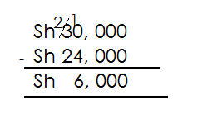 Profit = S.P - B.P

3. A trader bough a dozen of books at sh 10, 000. If he sold each book at sh 900. Find his profit.

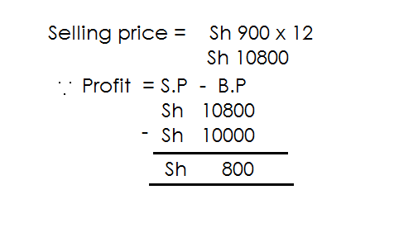 **Soln**

**Activity**

1. Agaba bought a pen at Sh 1850 and sold it at sh 3400. What was her profit?

2. A man bought a coat at sh 81.000 and sold it at sh 90,000. What was his profit?

3. A goat is dold at sh 150,000. What is the profit if it was bough at sh 125000?

4. A woman sold a cow at sh 585,000 which she had bought at sh 467,000. What profit did she get?

5. A shirt was bough at sh 13,200. Find the profit Lule got after selling it at sh 18650.

6. Martha bought 10 tomatoes at sh 1500. If she sold each tomato at sh 250. Calcualte her profit.

7. A trader bought a five litre jerrycan if milk at sh 8000. If each litre was sold at sh 1800. Find his profit.

**LOSS**

Loss is the amount lost after selling.

**Note**:

**Loss** is realized when the selling price is lower than the buying price.

Loss = Buyingprice – selling price

= B.P – S.P

**FINDING LOSS**

**Examples**

1. A man bought a goat at sh 120,000. He sold it at sh 105,000. What was his loss.

**Soln**

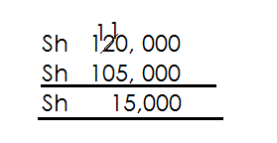 Loss = B.P - S.P

2. A trade bought a half a dozen of dresses at sh 50,000. If he sold each dress at sh. 6000. Find his loss.

Soln

No of dresses = x 12 6

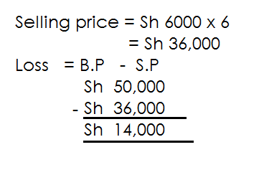 6 dresses.

**Activity**

1. Tony bought an umbrella at Sh 12,000 and sold it at sh 9000. What was his loss?

2. A pair of shoes costs sh 25,000 it was sold for sh 16500. What was the loss?

3. Calculate the loss on crates of soda which were bought at sh 720,000 and sold for sh 615,250.

4. A man bought 2dozens of books at sh.20,000. If he sold each book at sh 600. What was his loss?

5. Otim bought 2 dozen of shirts at sh 60,000/=. If she sold each shirt for sh 2000. Calcualte the loss she gets?

**FINDING BUYING PRICE GIVEN PROFIT AND SELLING PRICE.**

**Note:**

Buying price = selling price – profits

Mark sold a radio at Sh 60,000. He made a profit of Sh 15,000. What was the cost price of the radio?

**Soln**

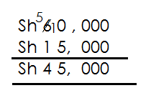 Buying price = S.P - Loss

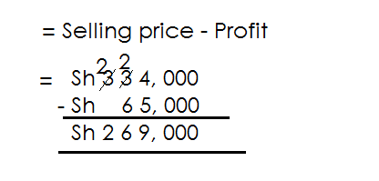A trader sold a bicycle at Sh 334,000 and made a profit of Sh 65,000. What was his buying price?

**Activity**

1. Kassim sold a plate for sh 1400. He made a profit of sh 300. At how much did

buy it?

2. A radio was sold at sh 32,000 and a profit sh 4,000 was made. What was the cost price of the radio?

3. Adyebo sold a suit at sh 127,000 and made a profit of sh 14,500.

What was the cost price of the suits?

4. Matovu sold 3 bicycles at sh 720,000 and much a profit of sh 56,500. How much did the bicycle cost?

5. A television set was sold at sh 358,000 and a profit of sh 69,000 was made. Find the cost price of a television set.

**FINDING BUYING PRICE GIVEN LOSS AND SELLING PRICE**

**Note**:

When given loss;

**Buying price = selling price + loss**

**Examples**

1. Ouma sold a calf at sh 73,000. He made a loss of sh 9000. How much did he buy it?

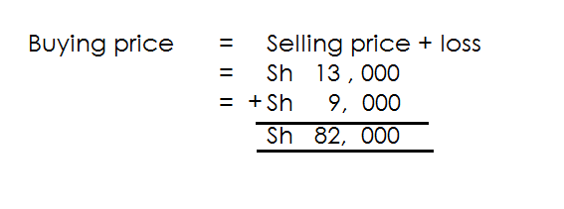 **Soln**

2. Esther sold a radio at sh 120,000. She made a loss of 25,000. What was his buying price?

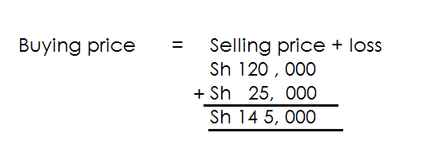 **Soln**

3. A carpenter sold 4 beds at sh 320,000 and made a loss of sh 43,500. What was buying price of the beds.

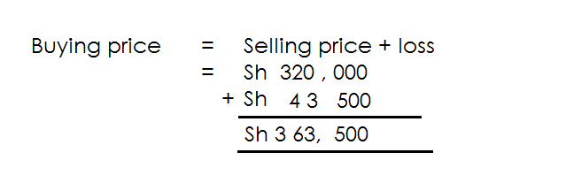

**Activity**

1. Mary sold a pair of shoes at sh 26,000 and msde a loss of sh 5000. What was the buying price?

2. A price of land is sold at sh 850,000 making a loss of sh 115,500. What was the buying price of the piece of land?

3. Bazibu sold 3 sacks of onions at sh 155, 000 and made a loss of sh 17,55. Find the cost price of the onions.

4. Bateefu sold a fridge at sh 425,000. She made a loss of sh 78,000. At how much did she buy it?

5. Racheal sold 4 goats at shsh 600,000 and made a loss of sh 65,000. Find the buying price of the 4 goats.

**FINDING SELLING PRICE WHEN GIVEN BUYING PRICE AND PROFIT.**

**Note:**

When profit and buying price is given selling price = Buying price + profit

**Examples**

1. The cost price of a shirt is sh 17500. A trader made a profit of sh 3500.

What was the buying price?

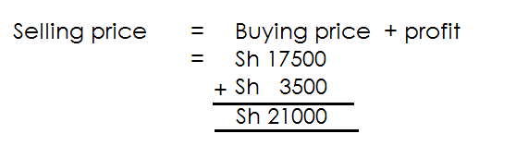 Soln

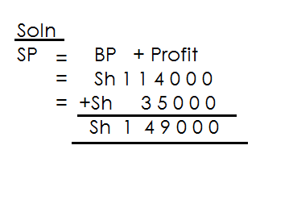2. Bujjingo bought a tin of orange at sh 114,000. He sold the orange and made a profit of sh 35,000. At what price did he sell the oranges?

**Activity**

1. A goat was bought at sh 27,000. It was sold at a profit of 6400. What was the selling price of a goat?

2. A hawker bought a dress at sh 80,000 she made a profit of sh 25000. What was her selling price?

3. Moses bought a television at sh 758,000. It was sold at a profit of sh 35,800What was the selling price of the television?

4. A lady bought a cock at sh 27,900. She later sold it making a profit of 27500. Calculate the selling price of the cock.

5. A cow was bought at sh 255,000. It was sold at a profit of sh 89,500. Find its selling price?

**FINDING SELLING PRICE GIVEN AND BUYING PRICE**

**Note**:

- When given loss and cost price selling price = Buying price – loss

**Examples**

1. A boy bought a toycar at sh 16500 and sold it at a loss sh 3700. What was the selling price of the toy car?

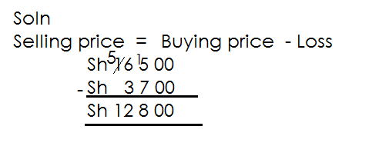 Soln

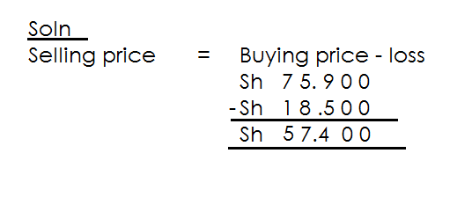2. A ball was bought bought at sh 75,900. It was sold making a loss of sh 18,500. At how much was it sold?

**Exercise**

1. A bunch of matooke was bought at sh 4000. It was sold at a loss of sh 1000. What was the selling price?

2. A sheep was bough at sh 25,000. It was sold at a loss of sh 9000. What was the selling price of the sheep?

3. Mande bought a car at sh 600,000 and sold it at a loss of 1 million. What was his selling price?

4. Suman bought a plot of land at Sh 3,450, 000 and sold it a loss of sh 350,000. What was his selling price?

5. Annet bought a phone at 890.000. During Covid she sold at a loss of sh 45,000. What was her selling price?

**TRANSPORT**

**Examples**

A taxi driver charges sh 2000 for a trip from Kampala to Jinja per person.

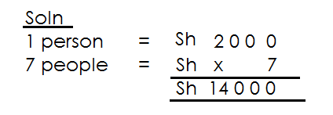(a) How much will 7 people pay for the trip?

(b) Kagada had to travel from Kampala to Jinja and then back to Kampala. How much did it cost him if the return fare is also shs 2000?

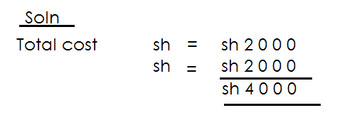

2. A taxi conductor charges sh 8000 for an adult and sh 5000 for a child from Kampala to Masaka.

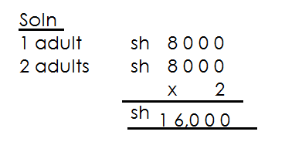(a) Tony and his wife travelled from Kampala to Masaka. How much did they pay?

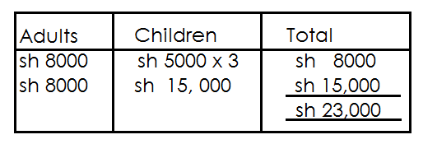(b) Father and his 3 children travelled from Masaka to Kampala. How much did they pay altogether?

**Activity**

1. A taxi charges shs 5000 for a journey from Entebbe to Kampala taxi park.

(a) How much will 2 people pay from Entebbe to Kampala?

(b) A man boards a taxi from Entebbe with his wife and ither 3 family members. How much will the whole family pay for the journey?

2. It costs sh 200 to move from Kampala to Jinja and sh 3000 from Jinja to Mbale.

(a) How much will one pay for the journey from Kampala to Mbale?

(b) If 5 people are travelling from Kampala to Mbale, how much will they pay altogether?

3. A transport company charges sh 4000 for an adult and sh 3500 for a child from Mukono to Kampala.

(a) A man and his wife travelled from Mukono to Kampala how much did they pay?

(b) Mother and her 4 children travelled from Mukono to Kampala. How much did the company charge them?

**MEASUREMENTS**

**Conversion units**

**Length**

Kilometer - km

Hectometres - Hm

Decametres - Dm

Metres - m

Decimetres - dm

Centimetres - cm

Millimetres - mm

**CHANGING KILOMETRES TO METRES.**

**Examples**

1. Changes 19km to m

1km = 1000m

19km = 19 x 1000m

= 19000m

2. Change 2 km to m. 3. Change 0.25k to m

**Soln** 1km = 1000m

1km = 1000m 0.25km = 1000m

2 km =2 x 1000m = x 1000m

250 = 250m

= x 1000m

1

= 9 x 250m

= 2250m

**Activity**

1. Change the following km to m.

(a) 12km

(b) 34km

(c) km

(d) 3 km

(e) 11 km

(f) 8.5km

(g) 0.12km

(h) 22.5km

**CHANGING METRES TO KILOMETRES**

**Examples**

1. Change 3300m to km

1000m = 1km

1m = 1 km

100

33000m = 1 x 3300 km

100

= 33km

2. Change 450km to km

100m = 1km

1m = 1 km

100

450m= 1 x 450 km

100

= 45km

100

= 0.45km

3. Express 108m as km.

1000m = 1km

1m = 1 km

1000

108km = 1 x 108 km

100

= 108 km

1000

= 0.108km

**Activity**

1. Change the following from metres to kilometers.

(a) 24000m

(b) 99000m

(c) 15400m

(d) 806m

(e) 550m

(f) 45m

(g) 205m

**CHANGING METERS TO CENTIMETRES**

Note:

1m = 100cm

**Example 1**

Change 4m to cm

**Soln**

1m = 100cm

4m = (4 x 100) cm

= 400cm

**Example II**

Change 8 m to cm.

1m = 100cm

8 m = 8 x 100 cm

5

= x 100 cm

= 850cm

**Example III**

Change 2.4m to cm

1m = 100cm

2.4m = (2.4 x 100)cm

= x 1000

= 2400cm

**Activity**

Change the following to centimeters.

(1) 41m (7) 8m

(2) 2 m (8) 4 m

(3) 4.6m (9) 12m

(4) 8 (10) 80 m

(5) 0.08m (11) 12.5m

(6) 7.4m (12) 20.5m

**CHANGING CENTIMETERS TO METRES**.

**Note**:

100cm = 1 m

1 cm = 1 m

100

**Examples**

Change 4000cm to m.

**Soln**

100cm = 1m

1cm = 1m

100

4000cm = 1 x 4000 m

100

= 40m

Change 80cm to metres

**Soln**

100cm = 1m

1 cm = 1m

100

80cm = 1 x 80cm

100

= 0.8m

Change 50cm to metres

**Soln**

100cm = 1m

1cm = 1

100

50cm = 1 x 50 m

100

= 5

10

= 0.5m / m

**Activity**

Change the following to m.

1. 4600cm 5. 60cm

2. 7000cm 6. 8cm

3. 8100cm 7. 40cm

4. 7600cm 8. 120cm

**CHANGING LITRE TO MILLIMETRES**

**Note:**

1Litre = 1000ml

**Examples**

Change 4litre to ml

1litre = 1000ml

4litre = (4 x 1000) ml

= 4000ml

Change 6 litres to ml.

**Soln**

1 litre = 1000ml

6 litre = ( 6 x 1000) ml

= 13 x 1000 ml

2

= 6500ml

Change 0.12 litre to ml

**Soln**

I litre = 1000ml

0.12litre = ( 0.12 x 1000) ml

= 12 x 1000 ml

100

= 120ml

**Activity**

Change the following to mililitres.

1. 2litre 4. 8 litre 7. 0.25litre

2. 40litre 5. 42 litre 8. 0.5litre

3. 74litre 6. 2 litre 9. 12.6 litres

**CHANGING MILLILITRES TO LITRES**

**Note**:

1000ml = 1 litre

1 ml = 1litre

1000

**Examples**

Change 4200ml to litres

**Soln**

1000ml = 1 litre

1ml = 1litre

1000

4200ml = 1 x 4200 litres

100

= 4.2 litres

Change 36000 ml to litre

1000ml = 1 litre

1ml = 1 litre

100

3600ml = 1 x 36000 litre

100

= 36litres

**Activity**

1. 3000ml 4. 8700ml 7. 4250ml

2. 4600ml 5. 240ml 8. 12ml

3. 800,000ml 6. 6780ml

**CHANGING KILOGRAMS TO GRAMS.**

**NOTE**:

1 kg = 1000g

**Examples**

Change 5kg to g.

1 kg = 1000g

5kg = (5 x 1000) g

= 500g

Change 6 kg to g.

**Soln**

= 6 kg 6 kg x 100 g



= 13 x 1000 g

2

= 6500g

Change 8.4kg to grams

1kg = 1000g

8.4kg = 8.4 x 1000g

= 84 x 1000 g

10

= 8400g

**Activity**

Change the following to grams.

1. 4kg 3. 46kg 5. 18 kg 7. 6.5kg 9. 14. 12kg

2. 6kg 4. 1 kg 6. 46kg 8. 12.25kg 10. 8.2kg

**CHANGING GRAMS TO KILOGRAMS**

**Note**:

1000g = 1kg

1g = 1 g

1000

**Example I**

Change 300g to kg

**Soln**

100g = 1kg

1 g = 1 kg

100

300g = 1 x 300 kg

100

= 3 kg

10

= 0.3kg

**Example II**

Change 120000 g to kg

1000g = 1 kg

1g = 1 kg

100

120000g = 1 x 120000 kg

1000

= 120kg

**Activity**

Change the following to kg.

1. 50g 5. 70000g

2. 60g 6. 12000g

3. 24g 7. 1240000g

4. 250g 8. 46000g

**FINDING AREA OF SHADED AND UNSHADES PARTS**

**Note:**

**Area of the shaded part = Area of outer figure – Area of inner figure.**

**Examples**

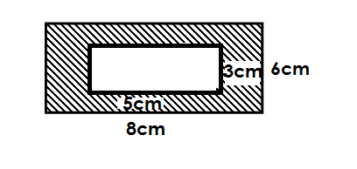Use the figure below to answer questions.

(a) Find area of the outer figure

**Soln**

A = L x W

= 8cm x 6cm

= 48cm2

(b) Find area of the inner figure

**Soln**

Area = L x W

= 5cm x 3cm

= 15cm2

(c) Work out the area of the shaded part

**Soln**

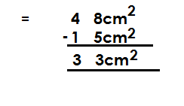 Area of shaded = Area of outer = Area of inner

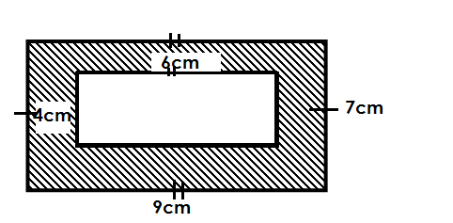Find area of the shaded part in the figure below.

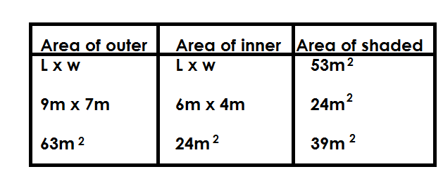 **Soln.**

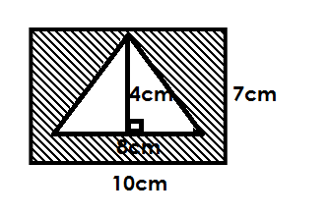Study the figure below and answer question.

(a) Find area of the outer figure

**Soln**

Area = L x w

= 10cm x 7cm

= 70cm2

(b) Find area of the inner figure

**Soln**

 Area = x b x h

= x 8cm x 4cm

= 16cm2

(c) Calcualte area of the shaded part.

Area of shaded = Area of out – A of inner

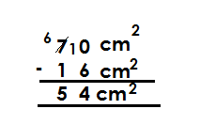

=

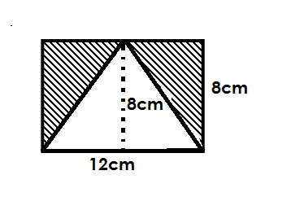Use the diagram below to answer questions.

**Note**:

Height = width

Find area of the shades part.

|  |  |  |
| --- | --- | --- |
| **Area of outer** | **Area of inner** | **Area of shaded** |
| L x W  12cm x 8cm  96cm2 | x b x h  6  x 12cm x 8cm  48cm2 |  |

**Activity**

1. Given the figure below.

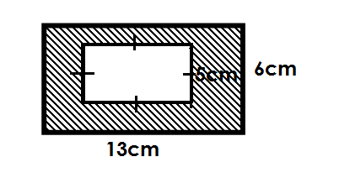

(a) Find area of the outer figure.

(b) Find area of the inner figure.

(c) Calculate area of the shaded part.

2. Find area of the shaded parts in the following figures.

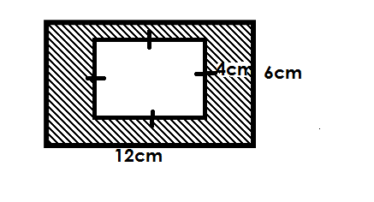

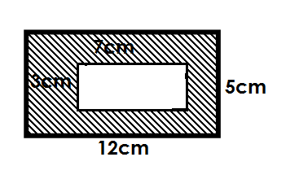(a) (b)

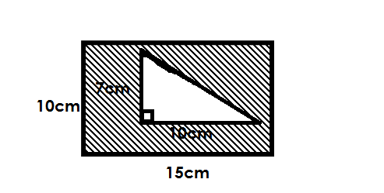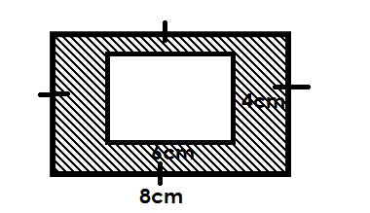

(c)(d)

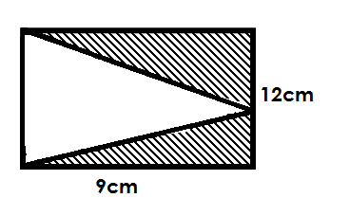(e)

**FINDING AREA AND PERIMETER OF COMBINED FIGURES.**

**Note**:

-The sum of the length of all short vertical lines is equal to one long vertical line.

-The sum of the length of all short horizontal lines is equal to one long horizontal line.

**Examples**

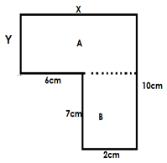Study the figure below and answer questions.

Find the value of X and Y

(i) X = 6cm + cm

= 8cm

(ii) Y = 10cm - 7cm

= 3cm

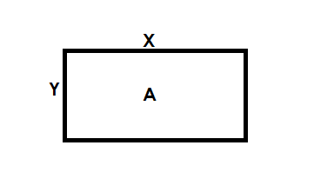Work out area of the figure.

A = L x W

= X x Y

= 8cm x 3cm

= 24cm2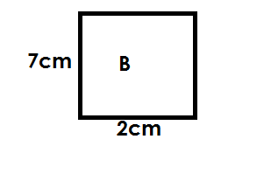

Area of B = L x W

= 7cm x 2cm

= 14cm2

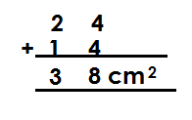 Total area =

(c) Calculate its perimeter

**Soln**

Perimeter = Sum of all sides

= 10cm + 8cm + 3cm + 6cm + 7cm + 2cm

= 3cm.

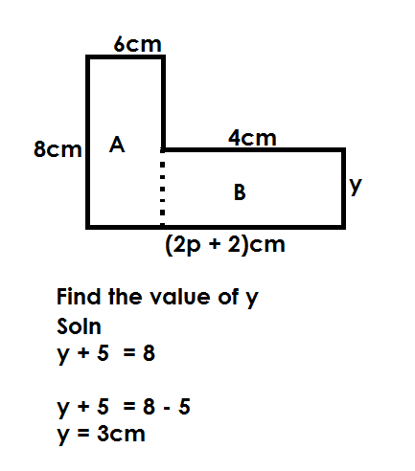Use the figure below to answer questions.

(ii) Find the value of P.

2p = 2 = 6 + 4

2p + 2 = 10

2p + 2 – 2 = 10 – 2

2p = 8 4

2p 2

P = 4

(b) Calculate its area.

|  |  |  |
| --- | --- | --- |
| **Area of A** | **Area of B** | **Area of FIGURE** |
|  |  |  |

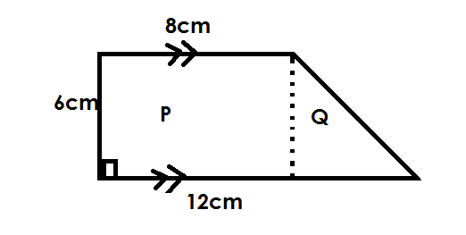Find area of the figure below.

|  |  |  |
| --- | --- | --- |
| **Area of P** | **Area of Q** | **Area of figure** |
|  |  |  |

**OR**

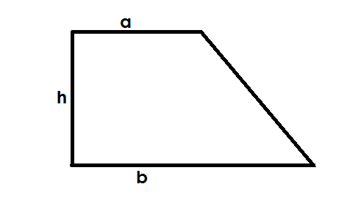Area of a trapezium = x h (a + b)

Area = x h (a + b)

 = x 6cm (8cm + 12 cm)

= x 6cm x 20cm

= 60cm2

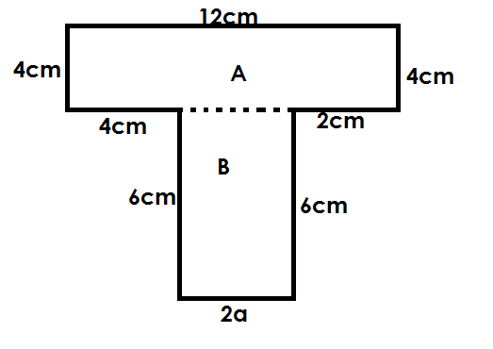Given the figure below.

(a) Find the value of a

2a + 4cm + 2cm = 12cm

2a + 7cm = 12cm

2a + 6cm – 6cm = 12cm – 6cm

2a = 6cm

2a = 2

a = 3cm

(b) Calculate its area.

|  |  |  |
| --- | --- | --- |
| **Area of A** | **Area of B** | **Area of figure** |
|  |  |  |

(c) Calculate its perimeter

**Soln**

Perimeter = Sum of all sides

= 6cm + 6cm + 6cm + 4cm + 4cm + 12cm + 4cm + 2cm

= 44m2

**Activity**

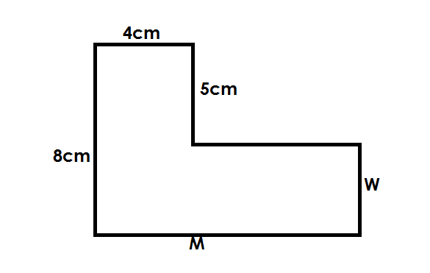1. Study the figure below.

(a) Find the value of

(i) M

(ii) W

(b) Calculate the area of the figure.

(c) Calculate its perimeter.

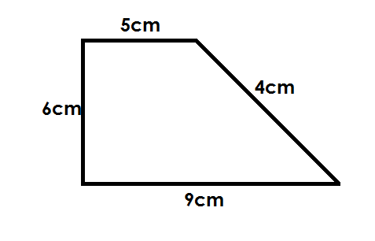2. Given the figure below.

(a) Find the area of the figure.

(b) Calculate its perimeter.

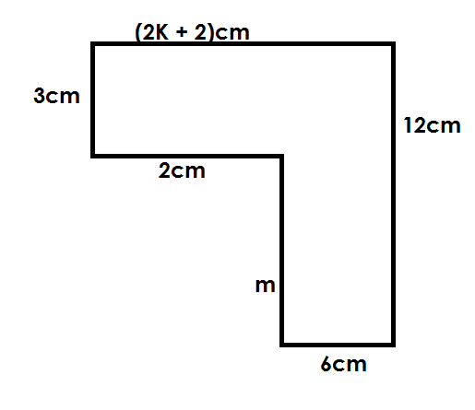3. Use the figure below to answer questions that follow.

(a) Find

(i) K

(ii) M

(b) Workout the area of the figure

(c) Find its perimeter.

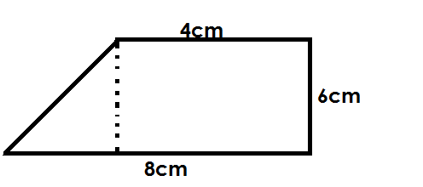4.

(a)

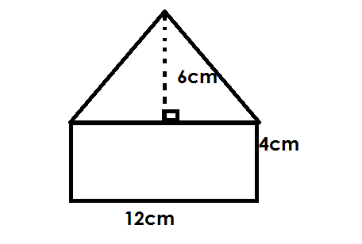(b)

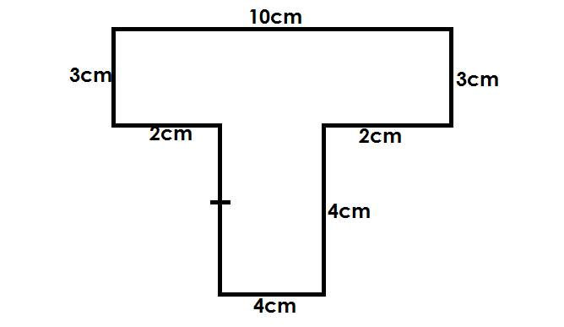

(c)

**VOLUME AND CAPACITY**

Volume is the amount of space occupied by an object.

Volume is measured in cubic units.

that a container can accommodate of liquid.

**Acuboid**

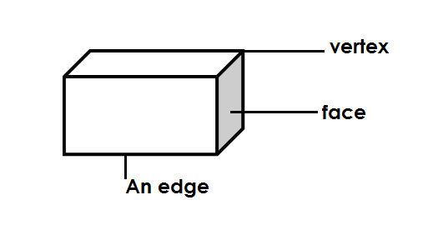1. A cuboid is a rectangular base prism.

**Properties of a cuboid.**

- It has 6 faces.

- It has 8 vertices.

- It has 12 edges

Finding area of shaded face of a cuboid.

**Note**:

-All parallel lines / edges of a cuboid are equal.

**Examples**

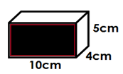Below is a cuboid.

Find area of the shaded face.

Area = L x W

= 10cm x 5cm

= 50cm2

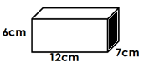Find the area of the shaded faces in the figure below.

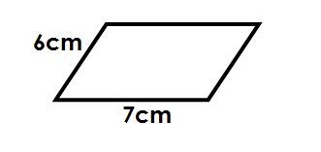**Soln.**

Area = L x W

= 7cm x 6cm

= 4cm2

**Activity**

Find the area of the shaded part.

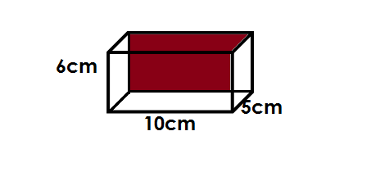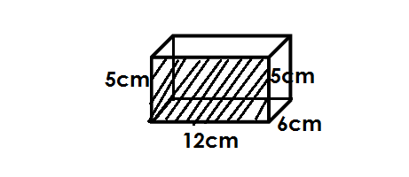(a) (b)

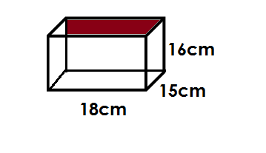

(c)

**TOTAL SURFACE AREA OF A CUBOID**

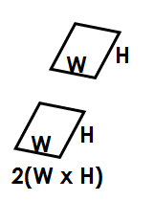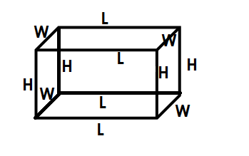T.S.A is the sum of areas of all faces making up a cuboid.

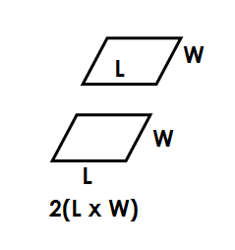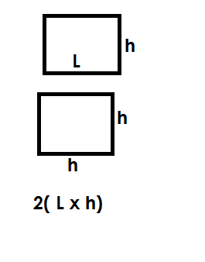

T.S.A = 2 (L x W) + 2 (L x H) + 2 (W X H)

**Examples**

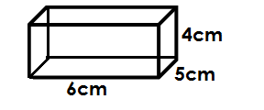Find the total surface area of the figure below.

T.S. A = 2(L x W) + 2(L x h) + 2(W x h)

= 2(6cm x 4cm) + 2(6cm x 3cm) + 2(4cm x 3cm)

= 2(24cm2) + 2(18cm2) + 2(12cm2)

= 2 x 24cm2 + 2 x 18cm2 + 2 x 12cm2

= 48cm2 + 36cm2 + 24cm2

= 108cm2

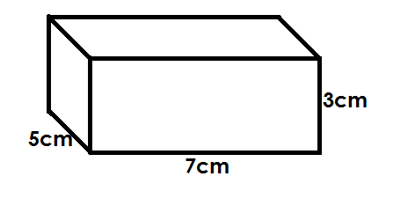Calculate the total surface of the figure below.

T.S.A = 2 (L x w) + 2 (L X h) + 2 (W x h)

= 2(7cm x 5cm) + 2 (7cm x 3cm) + 2 (5cm x 3cm)

= 2 x 35cm2 + 2 x 21cm2 + 2 x 15cm2

= 142cm2

**Activity**

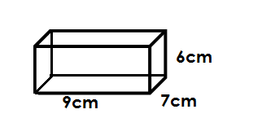Find the total surface area of the following figure

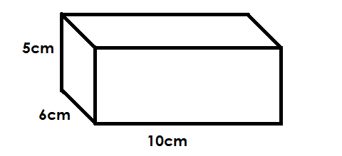(a) (b)

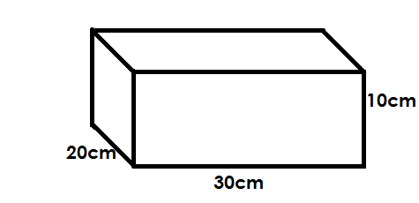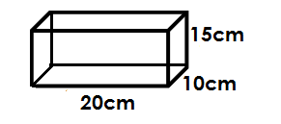(c) (d)

**FINDING VOLUME AND CAPACITY OF A CUBOID**

Volume = Length x width x height

Capacity = Volume

1000cm3

**Examples**

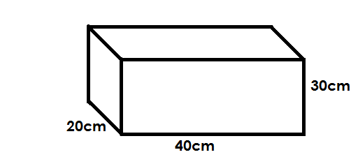Below is a cuboid

(a) Calculate its volume

Volume = L x W x H

= 40cm x 20cm x 30cm

= 240,000cm3

(b) How many litres of water can it hold when completely full.

Capacity = Volume

1000cm3

= 240, 000cm3 L

1000cm3

= 240 litres

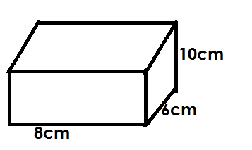Below is a water tank.

Calculate its capacity

**Soln**

Volume = L x W X H

= 10cm x 8cm x 6cm

= 480cm3

Capacity = Volume L

1000cm3

= 0.480cm3

1000cm3

= 0.48L

Find the volume of a cuboid that measures 12cm by 8cm by 6cm.

**Soln**

Volume = L x W x H

= 12cm x 8cm x 6cm

= 576cm3

**Activity**

Find the volume of the following figures.

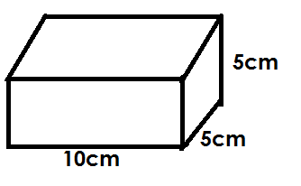(1)

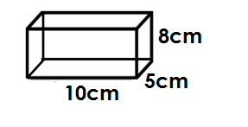

(2)

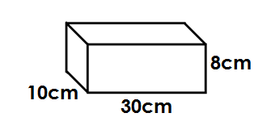

(3)

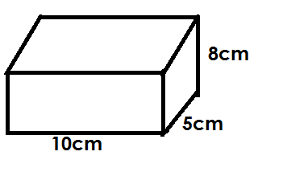

(4)

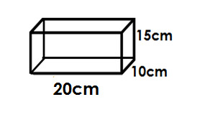

(4)

**FINDING UNKNOWN SIDES OF A CUBOID GIVEN VOLUME.**

**Examples**

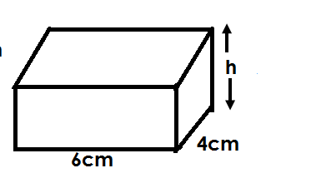Volume of the figure below is 48cm3.

Find its height

**Soln**

L x W x H = Volume

6cm x 4cm x h = 48cm3

12 2

6cm x 4cm x h = 48cm x cm x cm

6cm x 4cm 6cm x 4cm

H = 2cm

Volume of the figure below is 600cm3

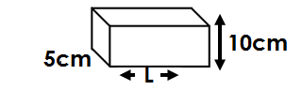

Find the value of L

L x W X h = Volume

L x 5cm x 10cm = 600cm3

L x 5cm x 10cm = 600cm x cm x cm

5cm x 10cm 5cm x 10cm

L = 12cm

**Activity**

1. The volume of a cuboid below is 480cm3.

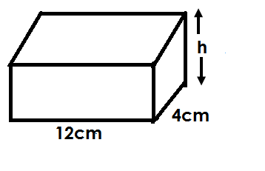

Find the value of h.

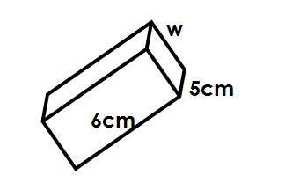2. Find one of the sides of a rectangular prism marked by the letter.

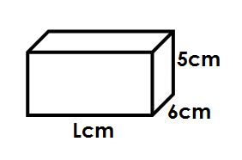

4. Find the height of the prism if the volume is 135cm**3**.

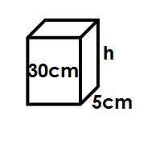

5. Find the length of a box whose volume is 210cm3, height 5cm and width 6cm.

6. The volume of the box below is 168cm3. Find the length.

**FINDING VOLUME AND T.S.A OF A CUBE**

A cube is a square based prism.

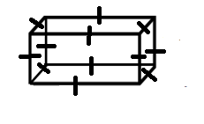All its faces are equal.

-It has all sides equal

-I t has 8 vertices.

-It has 12 edges

Volume = S x S x S x S x S x S

T.S.A = 6 x S x S

= 6S2

**Examples**

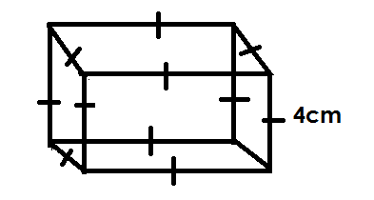Below is acube use it to answer questions that follow.

(a) Find its base area.

Area = S x S

= 4cm x 4cm

= 16cm2

(b) Find its volume

Volume = S x S x S

= 4cm x 4cm x 4cm

= 64cm3

(b) Calculate its total surface area.

Soln

T.S.A = 6S2

= 6 x 4cm x 4cm

= 96cm2

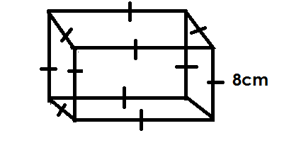Below is a cube, use it to answer questions that follow.

(a) Find its volume

Volume = S x S x S

= 8cm x 8cm x 8cm

= 64cm2 x 8cm

Volume = 512cm3

(b) Work out its volume.

Volume = 6 x S2

= 6 x 8cm x 8cm

= 6 x 64cm2

Volume = 384cm2

**Activity**

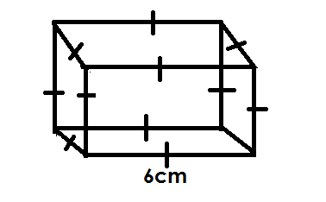Below is a cube, use it to answer the given question.

(a) Calculate its volume

(b) Calculate its T.S.A

**ALGEBRA**

Algebra is a branch of mathematics that deals with the usage of symbols or unknows to represent quantity of things.

**FORMING ALGEBRA EXPRESSSIONS**

Study the following expressions in words and phrases.

1. 4 more than a = a + 4

2. X less than 12 = 12 – x

3. A number added to 10 = 10 + n

4. A number subtracted from 3 = 3 – n

5. A number divided by 2 = X

2

6. A number multiplied by 6 = 6n

7. 3 subtracted from a number = n – 3

8. 2 divided by a number = 2

n

9. Peter is 4 years older than x: x + 4

10. (2 + 4) multipled by 5 = 5 (2 + 4)

11. 10years older than x = x + 10

12. 20 years younger than y = y – 20

13. Three more than x is equal to 7 = x + 3 = 7

**Activity**

1. Write te following algebraic expression.

2. A number mulitped 3 gives 18.

3. A number less than 10.

4. Add nine to a number, the result fourteen.

5. The total of r and 3.

6. A number divided by 12 equals rto 4.

7. The sum of 2x, x, and 12 is 30.

8. When P s multipled by 2 the result is 6.

9. Five boys’ weight is 90kg.

10. X subtractal from 8.

**WRITING ALGEBRAIC SENTENCE FROM ALGEBRAIC EXPRESSION**

1. 2X + 3

Multiply x by 2, then add 3 to the result.

2. 8 - x

Subtract a number from 8.

3. b

4

b divided by 4

4. 2(x + 3)

Add 3 + x the multiply the result by 2.

5. 4y – 7

Multiply y by 4, the subtract from the result.

6. 4(y – 7)

Subtract 7 from y then multiply the result by 4.

7. x + 5

4

Divide x by 4, the add 5 to the result

8. *x* + 5

4

Add 5 to x then divide the result by 4.

**Activity**

Write phrase for the algebraic expressions below.

1. m + 3 2. 5 + a

3. 3p 4. p – 3

5. n

4 6. 12p

7. 3n + 5 8. 3(n + 5)

9. (m + 6) 10. 2a – 1

11. 6(P – 6) 12. 1(n – 3

10

13. t + 13

2

12. b = 20 13. P - 4

5 4

**COLLECTING LIKE TERMS**

**Note**:

Like terms can be added and get one single term.

**Examples**

1. Simplify r + r + r

**Soln**

r + r + r

= 3r

2. Simplify: 3x + 4x + 2x

= 3x + 4x + 2x

= 9x

2. Simplify: 7w + 8w + w

Soln.

= 7w + 8w + w

= 16w

**Activity**

Simplify the following

1. X + X

2. y + y + y + y

3. 2x + 3x + 4x + 5x

4. 3p + p + p + 2p

5. m + m + m + 3m

6. 10w + 2w + w + w

7. 8q + 2q + q

8. 7z + 2z

9. 3a + 4a + 5a + 6a

**MORE ON COLLECTIVE LIKE TERMS**

**Examples**

1. Collect like terms 2. Simplify: x + y + 3x + 5y

Y + y + 2x + 4y **Soln**

**Soln** = x + y + 3x + 5y

y + y + 2x + 4y = x + 3x + y + 5y

= y + y + 4y + 2x = 4x + 6y

= 6y + 2x

3. Simplify: 3x + 6y – x – 2y 4. Simplify: 9p – 4p + 6r

**Soln** **Soln**

= 3x + 6y – x – 2y = 9p – 4p - 6r

= 3x – x + 6y - 2y = 5p + 6r

= 2x + 4y

5. Simplify 6. Write in short

= 4y + 3p - y + 2p 7k – 3p – k – p

= 4y - y + 3p + 2p **Soln**

= 3y + 5p = 7k – 3p – k – p

= 7k – k – 3p – p

= 6k - 4p

**Activity**

Simplify the following terms

1. 4y + 3x – 2y + x 3. 8y + 5r – 3y – 2r

2. 5k – 2m + 2k – m 4. 5c – 2m – 2c – m

5. 2x – 3y + x + 2y 6. 6d + 3c + 3y – 2d + 2c – y

7. p + q + p 8. 2b + 4 – b

9. 3x + 4 + 4x + 5x 10. q + 4p + 3q + 2p

11. 9h + 3k – 4h – k

**SUBSTITUTION**

**Note**:

-To substitute is the replace.

**Examples**

1. If a = 6, find the value of;

(a) a + 8

= a + 8

= 8 + 8

= 14

(b) 7a

= 7a

= 7 x a

= 7 x 6

= 42

2. If Z = 2, Y = 4, Find the value of

(a) z + y (b) 2z + 3y

Soln Soln

Z + y 2Z + 3y

= 6 (2 x 2) + (3 x y)

= 4 + 12

= 16

3. Give that a = 1, b = 3, c = 5 find the value of

(a) a + b + c (b) a bc

**Soln** **Soln**

= a + b + c = a b c

= 1 + 3 + 5 = a x b x c

= 9 = 1 x 3 x 5

= 15

c. 2b + 3a + c d. 5c + 4b – 8a

**Soln** **Soln**

2b + 3a + c 5c + 4b – 8a

= (2 x b) + (3 x a) + c = (5 x c) + ( 4 x b) – ( 8 x a)

= (2 x 3) + (3 x1) + 5 = (5 x 5 ) + ( 4 x 3) – (8 x 1)

= 6 + 3 + 5 = 25 + 12 – 8

= 14 = 37 - 8

= 29

**Activity**

1. If a = 2, b =3, c = 4, find the value of;

a. a + b + c

b. abc

c. 4a + 3b

d. 2a + b + 3c

e. 2a + 3b + c

g. ac – b

2. If m = 4 and n = 6

Find the value of;

(a) m + n

(b) mn

(c) n - m

(d) mn

m

**SOLVING SIMPLE EQUAATIONS**

**Finding the missing number in addition.**

**Examples**

1. Solve: n + 7 = 13 2. Solve: 16 + a = 20

Soln Soln

n + 7 = 13 16 + a = 20

n + 7 – 7 = 13 – 7 16 – 16 = 20 - 16

n = 6 a = 4

**Activity**

Solve the following

a. n + 6 = 13 e. 18 + p = 42

b. n + 7 = 14 f. x + 7 = 19

c. n + 6 = 18 g. 17 + b = 49

d. 16 + m = 35 h. 34 = y + 17

**WORD PROBLEMS**

**Examples**

1. What numbers when added to 5 gives 11?

**Soln**

n + 5 = 11

n + 5 – 5 = 11 – 5

n = 6

2. These are 50 pupils in a class 30 are boys. How many are girls?

**Soln**

g + 30 = 50

g + 30 – 30 = 50 – 30

g = 20

**Activity**

1. ten plus a number given 32. Find the number.

2. Think of a numbe and add 9 to it. The answer is 17. What is the number?

3. What number is the added to 16 gives 30?

4 A box has 12 pens, 5 are red and the others are blue. How many blue pens are in the box?

5. A man had sh 500 and bought a book for sh 150. How much money was left?

6. Out of 30 herds of cattle on Mr. Mukasa’s farm 13 are bulls, how many are cows?

7. 12 of the 30 eggs in a tray are rotten. How many are good?

8. A school received 80 English and Maths books, 46 were English books. Find the number fmaths books.

**SOLVING SIMPLE EQUATIONS BY ADDING**

**Examples**

1. Solve 2. Solve x – 17 = 23

N – 5 = 3 **Soln**

**Soln** x – 17 = 23

 n – 5 = 3 x – 17 + 17 = 23 + 17

 n – 5 + 5 = 5 + 3

x = 40

n = 8

3. Solve 10 – w = 5 4. Solve: 2y - 4 = 12

**Soln Soln**

10 – w = 5 2y - 4

 10 – 10 - w = 5 – 10 2y – 4 + 4 = 12 + 4

-w = - 5 2y = 16

-1 -1 2y = 2

W = 5 y = 8

**Activity**

Solve the following equations

1. n – 8 = 3

2. y – 28 = 10

3. a – 12 = 6

4. 75 – h = 38

5. 35 – n = 26

6. 2w – 2 = 6

7. 5p - 3 = 12

8. n – 7 = 4

9. 8w – 4 = 20

**WORD PROBLEMS**

**Examples**

A boy used 3 of his exercise books and remained with 4 books. How many books did he have at first?

Let the number of books be b

b - 3 = 4

b – 3 + 3 = 4 + 3



b = 7

He had 7 books.

2. When 3 is subtracted from a number the answer is 10. What is the number

**Soln**

Let the number be a

a – 3 = 10

 a – 3 + 3 = 10 + 3

a = 13

**Activity**

1. A woman sold 5 of her hens and remained with 6. How many hens did she have?

2. When 7 is subtracted from a number, the answer is 13. What is the number?

3. I think of a number, when I take away three, the answer is 7. What is the number?

4. A car used 12 litres of petrol and remained with 28 litres. How much fuwl did the care have at first?

5. A teacher marked 15 pupils absent and 35 present. How many pupils are in that class?

**SOLVING EQUATIONS BY DIVIDING**

**Examples**

1. Solve: 5a = 20 15a = 20

**Soln** 5 5

5a = 20 a = 4

Divide each side by 5

2. Solve 12 x = 144 3. Solve: x + x = 24

**Soln** **soln**

12x = 144 x + x + x = 24

12 144 12 3x =24 8

12 12 3 3

x = 12 x = 8

4. Solve: 2p + 5p = 14

**Soln**

2p + 5p = 14

7p =14 2

7 7

P = 2

**Activity**

Solve the following

1. 4x = 16 8. 4y + y = 25

2. 7k = 28 9. a + a + a = 15

3. 8n = 56 10. 7p + p = 32

4. 6 x = 60

5. x + x = 10

6. y + y + y + y = 20

7. 2t + 2t + 2t = 48

**WORD PROBLEMS INVOLVING DIVISION**

**Examples**

1. The length of a rectangle is 9cm and the width (wcm) if its area is 72cm2. Find the width.

L x W = Area

 9 x w = 72cm2

9cm x w = 72cm x cm

9cm 9cm

W = 8cm

2. The area of rectangle of 24cm2. Its length is 6cm. Find the width.

Width = Area

Length

4

Width = 24cm x cm

6cm

Width = 4cm

**Activity**

1. Cherimo collected 40 mangoes in 5 baskests. How many mangoes were in each basket?

2. What number when multipled by 12 gives 60?

3. The widtht of a reactangulargardent is 4 metres, if its length is f meters and area 36cm2. What is its length?

4. One side 7 a rectangle is 6cm. its area is 48cm2. Find the other side.

5. What number when multiplied by 13 gives 39?

6. I thought of a number and multiplies it by 2. If my answer was 30. What was the number?

7. The perimeter of a square is 20cm. Find its sides.

**SOLVING EQUATIONS WITH FRACTIONS (By multiplying)**

**Example**

1. Solve x = 4 2. Solve P = 7

3 7

X = 4

3

3 x X = 4 x 3 P = 7

3 7

X = 12 7 x P = 7 x 7

7

P = 49

3. Solve: 2x = 4 4. Solve: 4p = 4

5 3

**Soln** **Soln**

2 x 2x = 4 x 5 3

5 3 x 4p = 4 x 3

5x = 20 3

x 5 4p = 12

2x = 20 4p = 12 3

2 2 4 4

x = 10 p = 3

**Activity**

Solve the following

1. a = a 5. 4p = 4 9. k x 2 = 4

4 5 3

2. k = 9 6. r = 5 10. m = 12

3 6 4

3. m = 30 7. n = 6

5 6

4. 3x = 3 8. 2a = 6

5 4

**FORMING AND SOLVING EQUATIONS WITH FRACTION**

**Examples**

1. What number when divided by 4 gives 3?

**Soln**

Let the number be y

y = 3

4

4 x y = 3 x 4

y = 12

2. A man divided his money among his 3 children and each child got sh 450. How much money did he give out?

Let the amount be m.

M = 450

3

3 x m = 450 x 3

3

m = sh 1350

**Activity**

1. What number when divided by 7 gives 6?

2. What a mount of money is needed to pay of worker if each workerseachearnsshs 2.200?

3. What number when divided by 9 gives 21?

4. A father divided some money between two children and each got sh 150. How much money did he give out?

5. When a number of sweets is shared among 5 pupil each get 3 sweets. How many sweets are there?

6. 12 men shared a bag of sugar and eacg got 5kg. How much sugar in kg was in that bag?

**FINDING THE UNKNOWN INVOLVING SQUARES**

**Note:**

When multiplying a number by its self, a square number is obtained.

I.e., 1 X 1 = 1, 2 x 2 = 4, 3 x 3 = 9, 4 x 4 = 16, 5 x 5 =25, 6 x 6 = 36. Ect.

**Examples**

1. Solve= x2 = 4 2. Solve a2 = 36

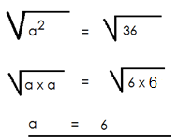Soln Soln

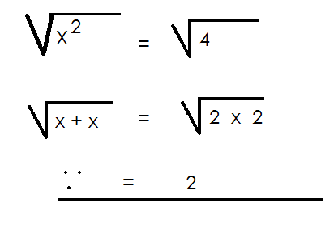

**Activity**

Give the value of the unknown by finding the square root.

a. a2 = 1 f. p2 = 49

b. b2 = 9 g. y2 = 64

c. x2 = 16 h. Find y, if y2 is equal to 144

d. f2 = 25 i. X2 is equal to 100. What is the value of x?

e. k2 = 36

**FINDING ONE SIDE OF A SQUARE USING SQUARE ROOT**

**Examples**

1. The area of a square is 9cm2. Find its sides.

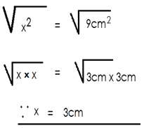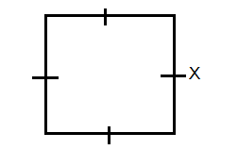

Side x side = Area

x + x = 9cm2

x2 = 9cm2

2. The area of a square compound is 100cm2. Find the sides in metres.

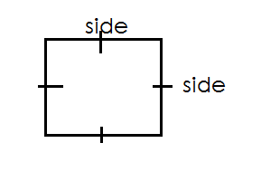 **Soln.**

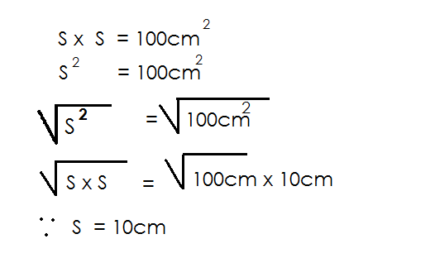 Side x side = Area

**Activity**

1. What is the side of a square whose area is 16cm2.

2. The area of a square is 25cm2. What is the size of one side?

3. Find one side of a square whose area is 81cm2.

4. The area of a square is 9cm2. Find its sides.

5. A square garden has an area of 36m. Find the length of each side of the garden.

**FINDING UNKNOWN SIZE OF A RECTANGLE / SQUARE WHEN PERIMETER IS GIVEN**

**Examples**

1. The perimeter of a square is 36cm. Find its side in centimeters.

 **Soln**

S + S + S + S = P

4S = 36cm

4s = 36cm

4 4

S = 9cm

2. The perimeter of a rectangle is 40cm. If its length is 15cm, find the width.

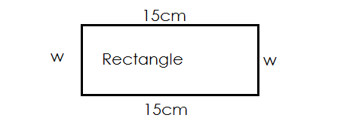

W + W + L + L = Perimeter

2w + 30cm = Perimeter

2w + 30 – 30 = 40cm – 30cm

2w = 10

2w = 10 5

2

W = 5cm

3. The perimeter of a rectangle is 20cm. Its width is 4cm. Find its length.

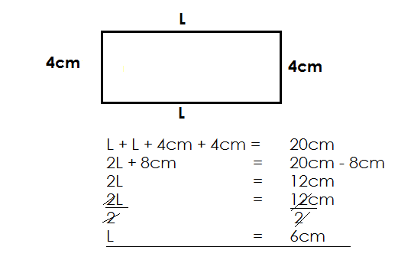 Soln

**Activity**

1. The perimeter a rectangle is 30cm. Its length is 7cm. Work out its width.

2. The perimeter of a square is 24cm. Find its sides.

3. The perimeter of a rectangle is 14cm. Its length is 4cm. Find its width.

4. The perimeter of a square is 16cm. Find its sides.

5. The perimeter of a rectangle is 24cm. Its width is 5cm. Find its length.

**REMOVING SINGLE BRACKETS**

**Note**:

-A number or a term before the brackets multiples every number inside the brackets.

-A negative before the brackets changes all signs inside te brackets.

-A positive before the brackets doesnot change any sign inside the brackets.

**Examples**

1. Simplify: 2 (y + 4) 2. Remove brackets: **-**2 (y + 4)

**Soln Soln.**

2 (y + 4) - 2 (y + 4)

(2 x y) + (2 x 8) -2 x y – 2 x 4

2y + 8 -2y - 8

3. Simplify: +4 (2k – 7) 4. Simplify: -3 (2x – 3)

**Soln**  **Soln**

+4 (2k – 7) -3 (2x – 3)

+4 x 2k + 4 x – 7 -3 x 2x - 3 x -3

8k - 28 -6x + 9

**Activity**

Remove brackets in the following

1. 4 (k + 5) 5. -2(y + 5)

2. 4 (2y + 7) 6. +5 (y + 5)

3. 3 (y – 4) 7. -3 (y – 4)

4. 3 (5 – k)

***CORRECTIONS AND FINDINGS.***

|  |  |
| --- | --- |
| ***CONTENT*** | ***PAGE*** |
|  |  |
|  |  |
|  |  |
|  |  |
|  |  |
|  |  |
|  |  |
|  |  |
|  |  |
|  |  |
|  |  |
|  |  |
|  |  |
|  |  |
|  |  |
|  |  |
|  |  |
|  |  |
|  |  |
|  |  |
|  |  |
|  |  |
|  |  |
|  |  |
|  |  |
|  |  |
|  |  |
|  |  |